H14-2
Honda CBR1000RR 2004-2005

Fitting kit left side: Fitting kit right side:
ID | Description | Cat.N | Qty
1 | Steel box M12 | X2 | 1
2 | Bolt M12x110x1,25 | 910 | 1
3 | Dural.cylinder d=28 | 77 | 1
ID | Description | Cat.N | Qty
1 | Steel box M12 | X2 | 1
2 | Bolt M12x110x1,25 | 910 | 1
3 | Dural.cylinder d=40 | 78 | 1

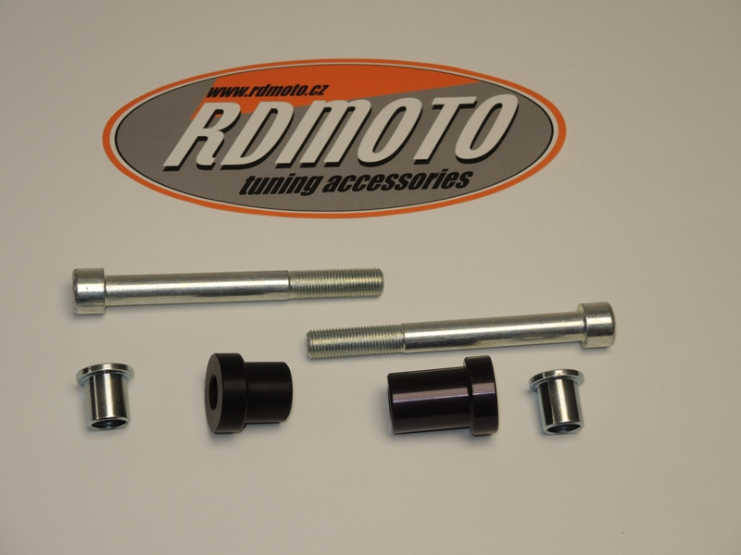

2

2

1

1

3

3

During the installation you will need to drill a hole into the fairing.

Instruction to left side:
- Into the protector insert steel box ID.1 and after bolt ID.2.
- Take the dural.cylinder ID.3 and put it into the frame.
- This kit gripping on the frame (photos).

Instruction to right side:
- Into the protector insert steel box ID.1 and after bolt ID.2.
- Take the dural.cylinder ID.3 and put it into the frame.
- This kit gripping on the frame (photos).

Note: During the installation, we recommend using glue on the threads (blue color).
