H14SDM
Honda CBR1000RR 2004-2005

LEFT SIDE KIT |  |  |  |  | RIGHT SIDE KIT
ID | Description | Cat.no. | Pcs |  |  | ID | Description | Cat.no. | Pcs
1 | SLDM adapter | 537/B | 1 |  |  | 1 | SLDM adapter | 537/B | 1
2 | Bolt M12x90x1,25mm | 919 | 1 |  |  | 2 | Bolt M12x90x1,25mm | 919 | 1
3 | Dural. cylinder 18mm | 81 | 1 |  |  | 3 | Dural. cylinder 30mm | 82 | 1
4 | Bolt M10x40mm | 854 | 1 |  |  | 4 | Bolt M10x40mm | 854 | 1
5 | Bolt M6x16mm | 962 | 1 |  |  | 5 | Bolt M6x16mm | 962 | 1
6 | Poly nut M10 (11mm) | X7 | 1 |  |  | 6 | Poly nut M10 (11mm) | X7 | 1
7 | Poly nut M6 (11mm) | X8 | 1 |  |  | 7 | Poly nut M6 (11mm) | X8 | 1
8 | Dural adapter | 519 | 1 |  |  | 8 | Dural adapter | 519 | 1
9 | Tape 3M |  | 1 |  |  | 9 | Tape 3M |  | 1
10 | Washer M12 | 803 | 1 |  |  | 10 | Washer M12 | 803 | 1
11 | Cylinder adapter 15mm | DV9 | 1 |  |  | 11 | Cylinder adapter 15mm | DV9 | 1
12 | Bolt M6x20 | 1024 | 2 |  |  | 12 | Bolt M6x20 | 1024 | 2
13 | Washer M6 | 1023 | 2 |  |  | 13 | Washer M6 | 1023 | 2
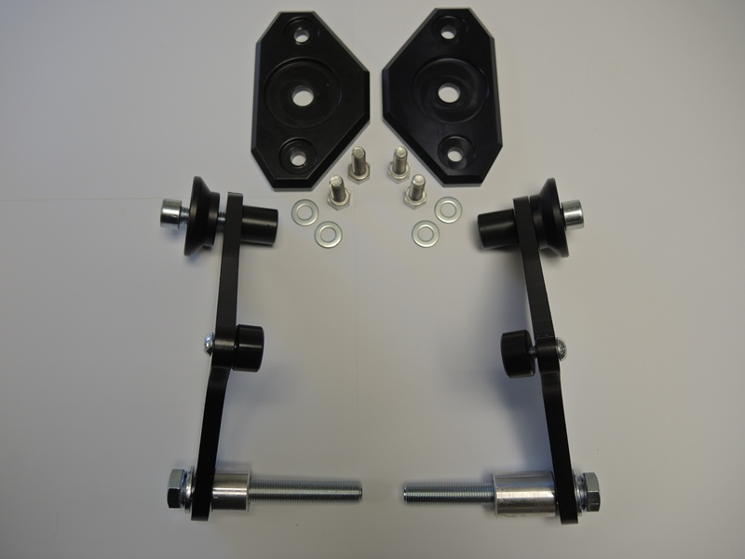

LEFT SIDE INSTRUCTIONS

- Dismantle side fairing and bolt M12 from the frame.
- Fit poly nut ID7 using bolt ID5 on the adapter ID8.
- Stick tape ID9 on the adapter to prevent damage.
- Fit adapter using bolt ID2 and washer ID10. Place cylinder ID3 under adapter.
- Mount fairing back on the bike.
- Insert bolt ID4 through SLD adapter ID1, dural adapter ID8 and cylinder adapter ID11.
- Fit whole kit using poly nut ID6.
- Fit slider using bolts ID12 and washers ID13

We recommend to use safety glue on all threads (medium strong).

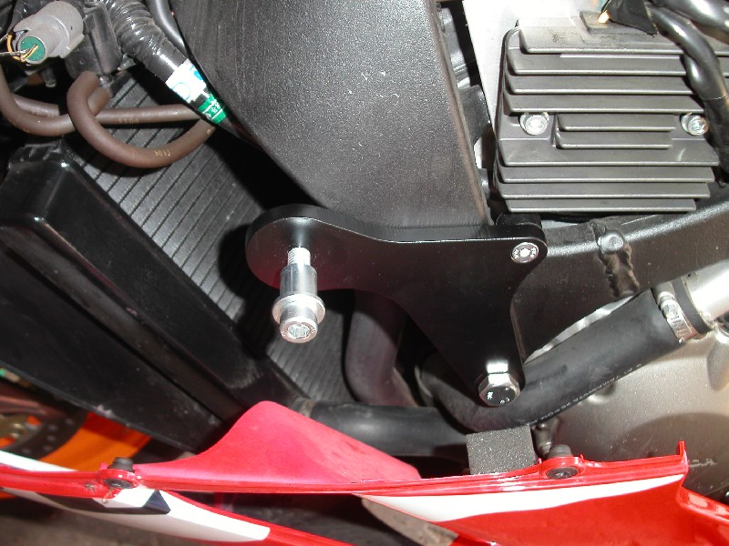

RIGHT SIDE INSTRUCTIONS

- Dismantle side fairing and bolt M12 from the frame.
- Fit poly nut ID7 using bolt ID5 on the adapter ID8.
- Stick tape ID9 on the adapter to prevent damage.
- Fit adapter using bolt ID2 and washer ID10. Place cylinder ID3 under adapter.
- Mount fairing back on the bike.
- Insert bolt ID4 through SLD adapter ID1, dural adapter ID8 and cylinder adapter ID11.
- Fit whole kit using poly nut ID6.
- Fit slider using bolts ID12 and washers ID13

We recommend to use safety glue on all threads (medium strong).

