H14
Honda CBR1000RR 2004-2005

Kit for the left side |  |  |  |  | Kit for the right side
No. | Description | Cat.No | Pcs |  |  | No. | Description | Cat.No | Pcs
1 | Steel box M10 | X1 | 1 |  |  | 1 | Steel box M10 | X1 | 1
2 | Bolt M12x90x1,25mm | 919 | 1 |  |  | 2 | Bolt M12x90x1,25mm | 919 | 1
3 | Dural. cylinder d=18mm | 81 | 1 |  |  | 3 | Dural. cylinder d=30mm | 82 | 1
4 | Bolt M10x40mm | 854 | 1 |  |  | 4 | Bolt M10x40mm | 854 | 1
5 | Bolt M6x16mm | 962 | 1 |  |  | 5 | Bolt M6x16mm | 962 | 1
6 | Poly nut M10 d=11mm | X7 | 1 |  |  | 6 | Poly nut M10 d=11mm | X7 | 1
7 | Poly nut M6 d=11mm | X8 | 1 |  |  | 7 | Poly nut M6 d=11mm | X8 | 1
8 | Duralumin adapter | 519 | 1 |  |  | 8 | Duralumin adapter | 519 | 1
9 | Tape 3M |  | 1 |  |  | 9 | Tape 3M |  | 1
10 | Pad M12 | 803 | 1 |  |  | 10 | Pad M12 | 803 | 1
Installation – the left side:

- remove the original side plastic and bolt M12 in frame of the motorcycle
- compile adapter (No. 8) together, use bolts (No. 5) for gripping of poly nut (No. 7)
- stick on reverse side of adapter tape 3M (No. 9)
- put duralumin cylinder (No. 3) under adapter, use the bolt (No. 2) with pad (No. 10) and screw up adapter to frame of the motorcycle
- check all and then you can mount the original plastic side back
- give steel box (No. 1) in protector together with bolt (No. 4)
- all this set mount to thread on adapter, on the reverse side mount poly nut (No. 6)

Warning – we recommend to use safety glue on threads of all bolts (moderate strong – blue colour).
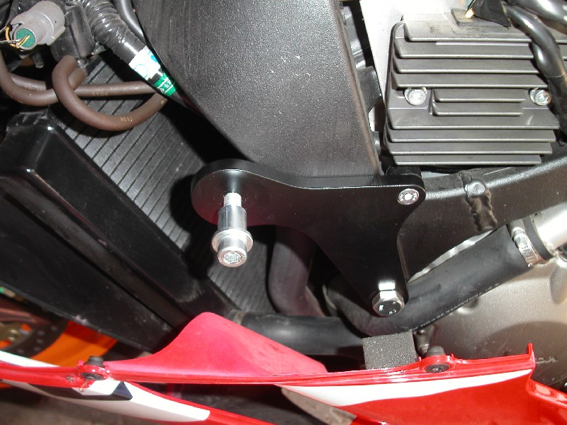

Installation – the right side:

- remove the original side plastic and bolt M12 in frame of the motorcycle
- compile adapter (No. 8) together, use bolts (No. 5) for gripping of poly nut (No. 7)
- stick on reverse side of adapter tape 3M (No. 9)
- put duralumin cylinder (No. 3) under adapter, use the bolt (No. 2) with pad (No. 10) and screw up adapter to frame of the motorcycle
- check all and then you can mount the original plastic side back
- give steel box (No. 1) in protector together with bolt (No. 4)
- all this set mount to thread on adapter, on the reverse side mount poly nut (No. 6)

Warning – we recommend to use safety glue on threads of all bolts (moderate strong – blue colour).
