H15S
Honda VTR1000 Firestorm 1997-

LEFT SIDE KIT | RIGHT SIDE KIT

ID | Description | Cat.no | Pcs
1 | Dural. adapter | 636 | 1
2 | SL adapter | 317 | 1
3 | Dural. cylinder 40mm | 4 | 1
4 | Bolt M10x80 | 857 | 1
5 | Nut M12 | 811 | 1
6 | Washer M12 | 803 | 1
7 | 3M tape |  | 1
8 | Bolt M6x25 | 877 | 3
9 | Bolt M4x16 | 876 | 2
10 | Rod M12x410x30x30 |  | 1
ID | Description | Cat.no | Pcs
1 | Dural. adapter | 637 | 1
2 | SL adapter | 317 | 1
3 | Dural. cylinder 50mm | 5 | 1
4 | Bolt M10x80 | 857 | 1
5 | Nut M12 | 811 | 1
6 | Washer M12 | 803 | 1
7 | 3M tape |  | 1
8 | Bolt M6x25 | 877 | 3
9 | Bolt M4x16 | 876 | 2

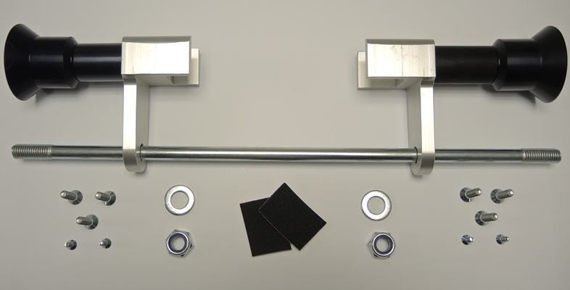

INSTRUCTIONS

- We recommend to use the glue on all threads (medium strong).
- Dismantle original bolt from the frame of motorcycle.
- Put rod ID8 through the frame of motorcycle.
- Place adapters ID1 on the rod.
- Stick 3M tape on the adapters to prevent damage.
- Tighten adapter on the frame using washer ID6 and nut ID5.
- Put SL adapter ID2 and cylinder ID3 on the bolt ID4. Fit this kit on the adapter on motorcycle.
- Fit slider using bolts ID8 and cover using bolts ID9.

