H15
Honda VTR1000 Firestorm 1997-

Fitting kit left side: Fitting kit right side:
ID | Description | Cat.N | Qty
1 | Dural.adapter | 636 | 1
2 | Steel box | X1 | 1
3 | Dural.cylinder d=40 | 4 | 1
4 | Bolt M10x90 | 880 | 1
5 | Nut M12 | 811 | 1
6 | Washer M12 | 803 | 1
7 | 3M Tape |  | 1
8 | Steel bar 12x410x30x30 |  | 1
ID | Description | Cat.N | Qty
1 | Dural.adapter | 637 | 1
2 | Steel box | X1 | 1
3 | Dural.cylinder d=50 | 5 | 1
4 | Bolt M10x90 | 880 | 1
5 | Nut M12 | 811 | 1
6 | Washer M12 | 803 | 1
7 | 3M Tape |  | 1

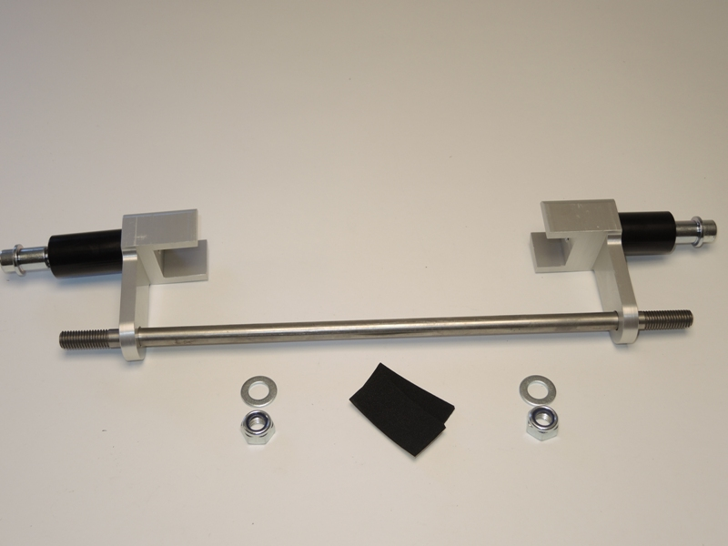

Instruction to assembly:
- Dismantle original bolt from frame- M12.
- Through the frame insert stainless steel bar ID.8.
- Put on it adapter ID.1. Wher the adapter is touching with frame, stick 3M tape.
- Tighten adapter. Use bolt and washer ID.6, ID.5.
- Insert steel box ID.2 inside a protector, through the protector insert bolt ID.4 and put on it dural.cylinder ID.3.
- This set mount on the adapter.

Instruction to assembly-right side:
- Put on steel bar adapter ID.1. Wher the adapter is touching with frame, stick 3M tape.
- Tighten adapter. Use bolt and washer ID.6, ID.5.
- Insert steel box ID.2 inside a protector, through the protector insert bolt ID.4 and put on it dural.cylinder ID.3.
- This set mount on the adapter.

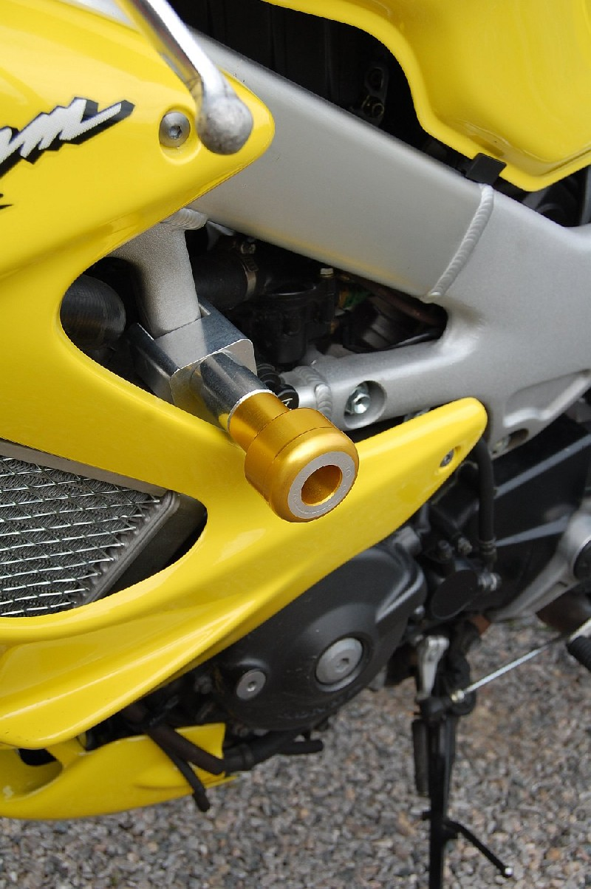
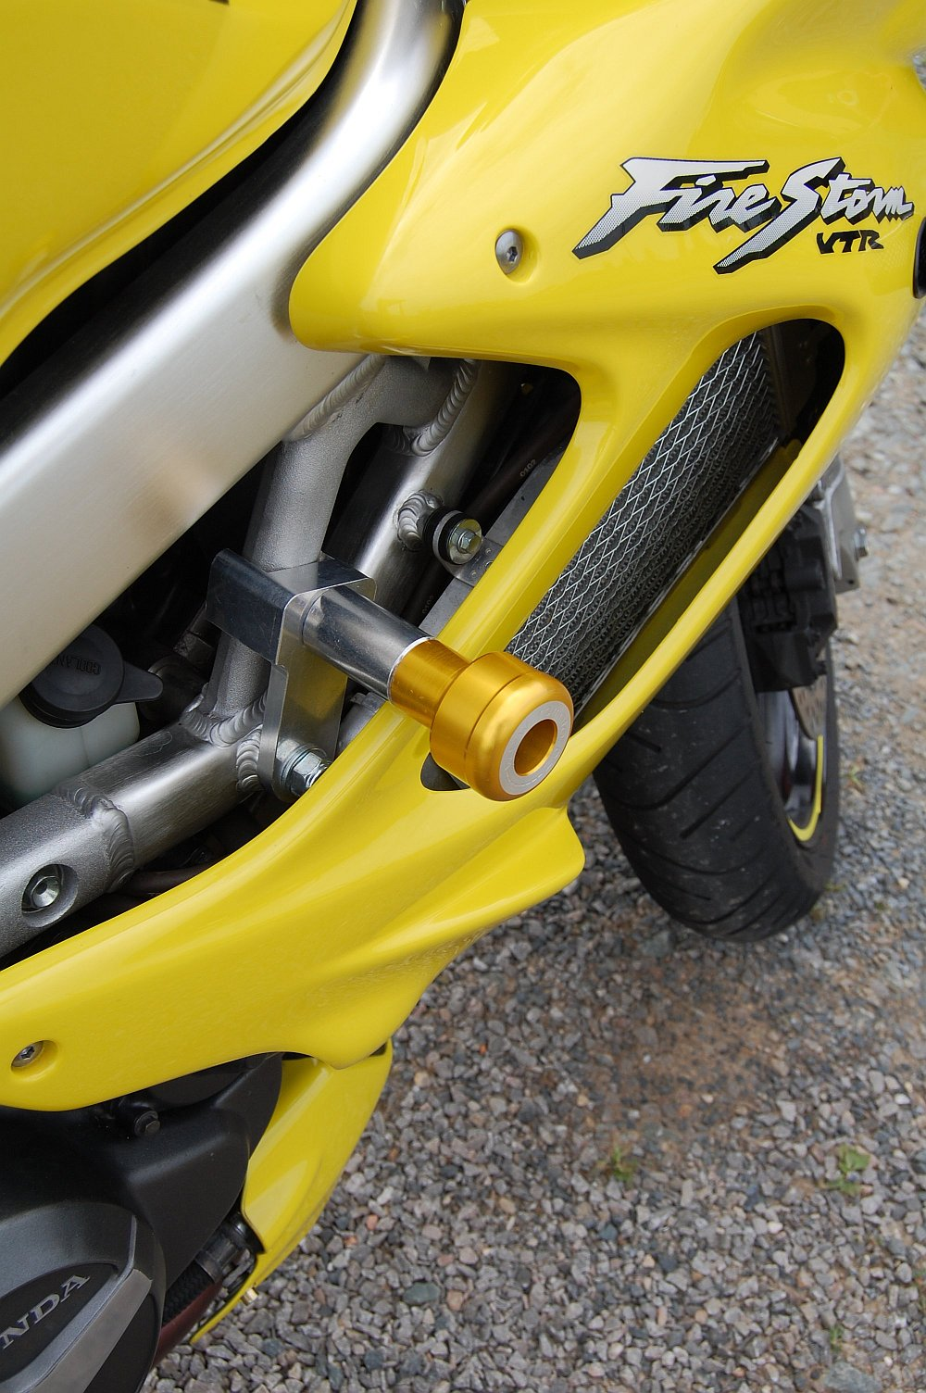
Warning: We recommend use the glue of all threads. Medium strong.

