H16
Honda VTR1000 SP1/SP2
Fitting kit left side: Fitting kit right side:
ID | Description | Cat.N | Qty
1 | Special nut | X12/X2 | 1
2 | Alu. spacer l=102mm | 1186 | 1
3 | M12x(1,25)x480x30x30 | - | 1
ID | Description | Cat.N | Qty
1 | Special nut | X12/X2 | 1
2 | Alu. spacer l=62mm | 1187 | 1

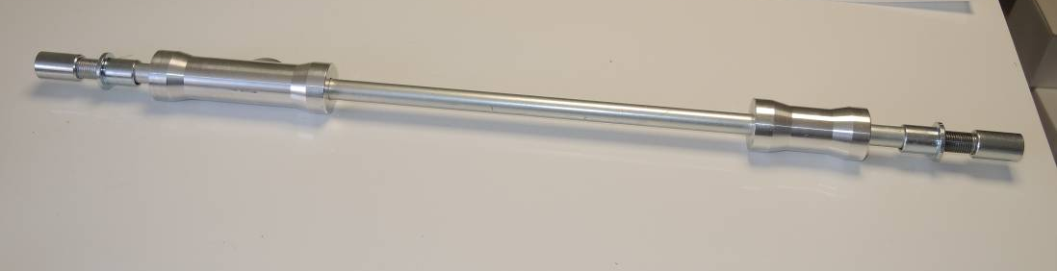

Instruction to assembly:
*Is neceséry to drill hole into the fairing diameter 30mm.

Mounting make to the position by following the attached photo. Remove the original screw. To the hole insert a stainless steel rod, on both sides attach a dural distance rollers. Put protectors and by nuts M12 tighten.

Warning: We recommend use the glue of all threads. Medium strong.
