H17
Honda CB1300 2002-

Kit for th left side |  |  |  |  | Kit for the right side
No. | Description | Cat.No. | Pcs |  |  | No. | Description | Cat.No. | Pcs
1 | Steel box M10 | X1 | 1 |  |  | 1 | Steel box M10 | X1 | 1
2 | Bolt M10x200mm | 889 | 1 |  |  | 2 | Bolt M10x200mm | 889 | 1
3 | Dural. cylinder d=50mm | 5 | 1 |  |  | 3 | Dural. cylinder d=50mm | 5 | 1
4 | Nut M10 | 814 | 1 |  |  | 4 | Nut M10 | 814 | 1

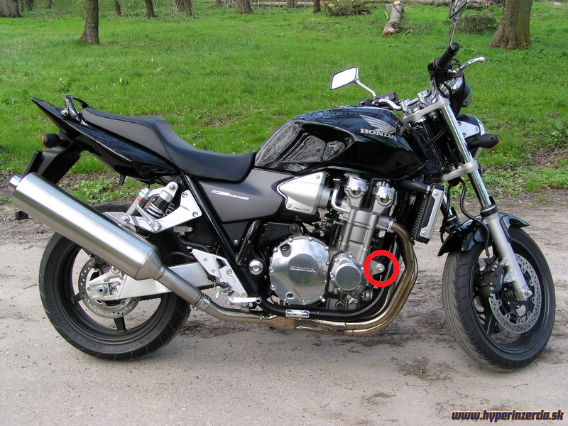

Installation:

Installation of the left and right protector make in gripping about the attached photo above. Give the steel box M10 (No. 1) on both bolts. Put the duralumin cylinder (No. 3) under the protector on the left side and use the bolt (No. 2) with nut (No. 4) for tightening. Put the duralumin cylinder (No. 3) under the protector on the right side and use the bolt (No. 2) with nut (No. 4) for tightening. At first finish the one side and then mount the second side.

Warning – we recommend to use safety glue on threads of all bolts (moderate strong – blue colour).

