H18SD
Honda VFR 800 V-Tec
2004-2009

LEFT SIDE KIT RIGHT SIDE KIT

ID | Description | Cat.No | QT
1 | Steel adapter | 515 | 1
2 | Steel adpater (short) | X48 | 1
3 | Alu. cylinder 10mm | DV124 | 1
4 | Alu. cylinder 25mm | DV88 | 1
5 | Alu. cylinder 27mm | DV123 | 1
6 | Alu. cylinder | DV125 | 2
7 | Bolt M10X50 | 849 | 1
8 | Bolt M8x50 | 837 | 1
9 | Bolt M6x60 | 872 | 1
10 | Bolt M6x30 | 863 | 2
11 | Washer M8 | 802 | 2
12 | Washer M10 | 804 | 2
13 | Washer M6 | 947 | 3
14 | Washer M6 (spring) | 985 | 2
15 | Nut M10 | 814 | 1
16 | Nut M8 | 813 | 1
17 | Washer M12 | 803 | 2
18 | Bolt 12(1,25)x395x30x30 |  | 1
19 | Steel nut | X12 | 1

ID | Description | Cat.No | QT
1 | Steel adapter | 516 | 1
2 | Steel adpater (short) | X76 | 1
3 | Alu. cylinder 25mm | DV122 | 1
4 | Alu. cylinder 15mm | DV121 | 1
5 | Alu. cylinder | DV125 | 2
6 | Bolt M10x30 | 882 | 1
7 | Bolt M8x40 | 828 | 1
8 | Bolt M6x60 | 872 | 1
9 | Bolt M6x30 | 863 | 2
10 | Washer M8 | 802 | 2
11 | Washer M10 | 804 | 2
12 | Washer M6 | 947 | 3
13 | Washer M6 (spring) | 985 | 2
14 | Nut M10 | 814 | 1
15 | Nut M8 | 813 | 1

PROTECTORS FITTING KIT

ID | Description | Cat.No | QT
1 | SLD adapter | 537 | 2
2 | Dural. cylinder | DV9 | 2
3 | Šroub M8x25 | 815 | 4
4 | Washer M8 | 800 | 4
5 | Washer M10 (spring) | 801 | 2
6 | Bolt M10x40 | 854 | 2

We recommend to use medium strong blue to all threads.
MOUNTING KIT INSTRUCTIONS

- Dismantle side fairing of the motorcycle.
- Unbolt bolt M12 from the frame of motorcycle.
- Start on the right side first.
- Mount fitting kit on the bike according to the pictures below.
- Repeat this proces on the left side
- Stick 3M tape on the adapters to prevent damage of fairing.
- Mount fairing back on the motorcycle.

FITTING PROTECTORS

- Put washer ID5, SLD adapter ID1 and dural. cylinder ID2 on the bolt ID6.
- Mount this kit into the steel adapter on the motorcycle.
- Fit protector using two bolts ID3.

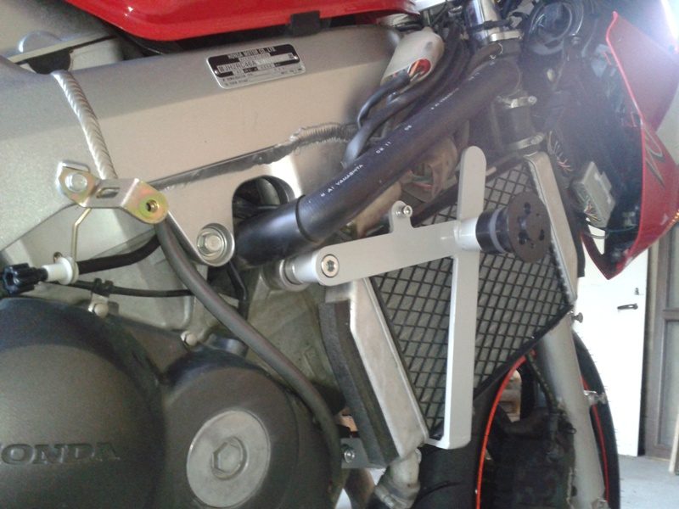

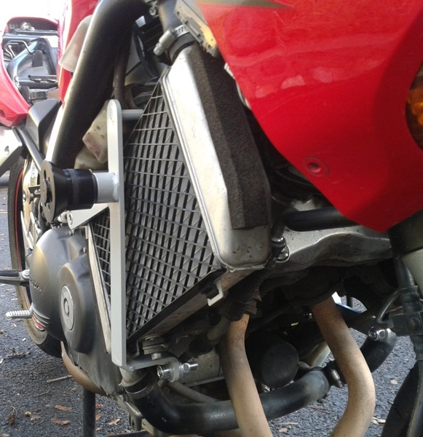

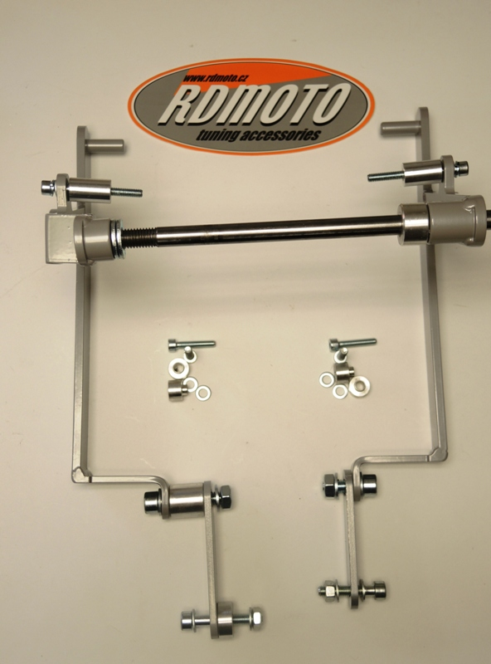

3
5
12,13
13,14
8
5
9
6
1
18
4
17
1
9
15,10
2
6,11
12
10
7,12
7,10
11
14
13
15,12
4
2
3
8,11
11,16

