Mounting kit, left side:

ID | Description | Cat. No. | Pcs
1 | Steel adapter “cross“ | 515 | 1
2 | Steel adapter oval (longer) | X48 | 1
3 | AL cylinder d=10mm | DV124 | 1
4 | AL cylinder d=25mm | DV88 | 1
5 | AL cylinder d=27mm | DV123 | 1
6 | AL cylinder fitted | DV125 | 2
7 | Bolt M10X50 | 849 | 1
8 | Bolt M8x50 | 837 | 1
9 | Bolt M6x60 | 872 | 1
10 | Bolt M6x30 | 863 | 2
11 | Washer M8 | 802 | 2
12 | Washer M10 | 804 | 2
13 | Washer M6 | 947 | 3
14 | Washer spring M6 | 985 | 2
15 | Nut M10 | 814 | 1
16 | Nut M8 | 813 | 1
17 | Washer M12 | 803 | 2
18 | Bolt 12(1,25)x395x30x30 |  | 1
19 | Steel nut | X12 | 1
20 | Polinut d=20mm | X9 | 1
21 | Washer M8 | 802 | 1
22 | Bolt M8x25 | 831 | 1
23 | Insert | X1 | 1
24 | Bolt M10x40 | 854 | 1

H18
Honda VFR 800 V-Tec
2004-2009

Mounting kit, right side:

ID | Description | Cat.No. | Pcs.
1 | Steel adapter “cross“ | 516 | 1
2 | Steel adapter oval (shorter) | X76 | 1
3 | AL cylinder d=25mm | DV122 | 1
4 | AL cylinder d=15mm | DV121 | 1
5 | AL cylinder fitted | DV125 | 2
6 | Bolt M10x30 | 882 | 1
7 | Bolt M8x40 | 828 | 1
8 | Bolt M6x60 | 872 | 1
9 | Bolt M6x30 | 863 | 2
10 | Washer M8 | 802 | 2
11 | Washer M10 | 804 | 2
12 | Washer M6 | 947 | 3
13 | Washer spring M6 | 985 | 2
14 | Nut M10 | 814 | 1
15 | Nut M8 | 813 | 1
20 | Polinut d=20mm | X9 | 1
21 | Washer M8 | 802 | 1
22 | Bolt M8x25 | 831 | 1
23 | Insert | X1 | 1
24 | Bolt M10x40 | 854 | 1

Mounting instructions, right side:
- First, begin with the right side of the motorcycle.
- Remove the motorcycle bonnet and the original M12 bolt from the frame.
- Mount the polyam (ID.20) with the bolt and the M8 washer (ID.21,22) to the cross first, see photo.
- Then insert the M12x395 ID.18 bolt into the adapter ID.1 (Shown in the table for the left side).
- On this bolt, slide the AL cylinder ID.4 and insert it through the frame and engine.
- Insert the AL cylinder ID.3 under the handle over the radiator and fit it using M6x60 ID.8 bolt with the flat washer M6. (ID.12, ID.13). Tighten this bolt only after you have fitted both sides!
- Use the steel flatbed ID2 to secure the bottom. It is mounted to the motor block using ID.7 bolt by attaching flatbed to the adapter with ID.6 bolt.
- Check if the pin on the steel adapter touches the frame above the radiator.
- Use nuts and washers ID.14,15,11,10 to mount the rest.
- Where the bonnet rests on the adapter, stick the 3M tape and use fitted Al cylinders ID.5 with ID.9 bolts to determine clearance.

Mounting instructions, left side:
- Mount the polymatics (ID.20) into the cross using bolt and M8 washer (ID.21,22)
- Attach adapter ID.1 to bolt ID.18 which we already pushed through the frame. Bolt the two M12 ID.17 washers onto this bolt.
- Slide the ID.5 Al cylinder below the radiator handle and use the ID.9 bolt and washers ID.13 and ID.14.
- For the lower grip, use flatbed ID.2. Insert the ID.3 Al cylinder between the flatbed and the motor, use the ID.8 bolt, ID.11 washer and ID.16 nut.
- Then, stick the flatbed to the steel adapter, insert Al cylinder ID.4 and use ID.7 bolt, ID.12 washer and the ID.15 nut.
- Where the bonnet rests on the adapter, stick the 3M tape and use the Al fitted cylinders ID.6 and ID.10 bolts to determine clearance.
- Finally, mount the bonnet on the motorcycle.

!! Attention – after completing the assembly, check all joints and use thread glue !!

Fitting the PH protector:
- Put the steel insert ID.23 into the adapter.
- Using bolt M10x40 ID.24 fit the protectors onto the steel adapter.

!! Attention – For threads of all bolts we recommend to use a medium-strenght protective adhesive (blue) !!

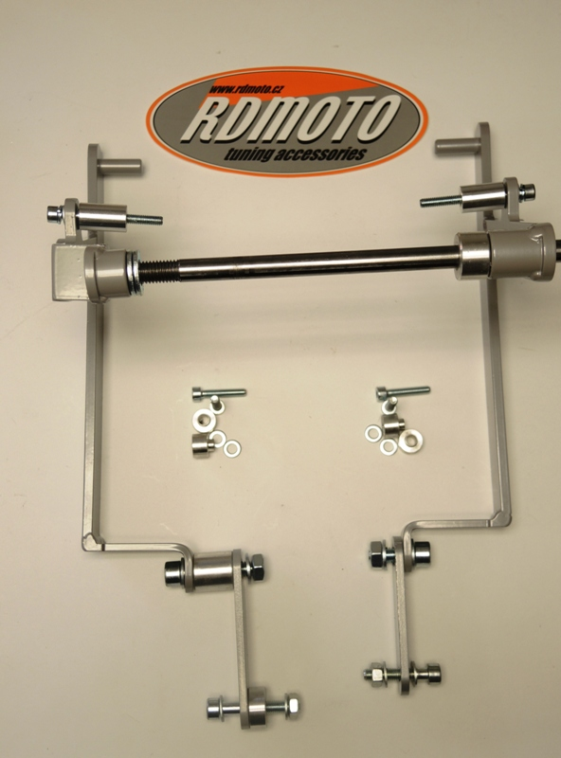
20
21,22
3
20
21,22

12,13
8
5
9

1
18
1
13,14
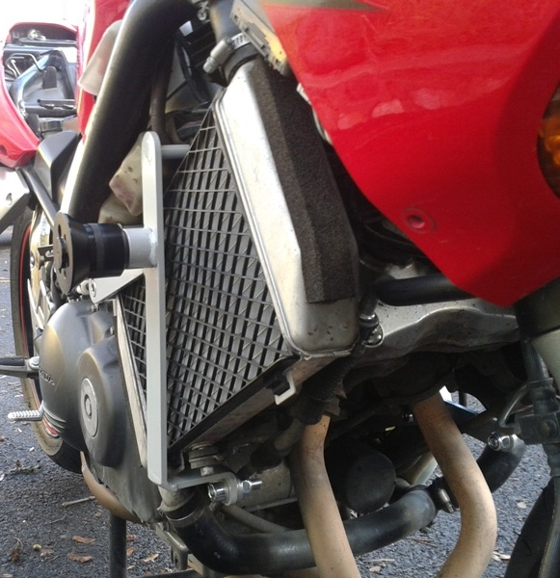

9
4
17
6
5
10

2
6,11
12
7,12
11
14
13
15,12
4
2
15,10
7,10
3
8,11
11,16
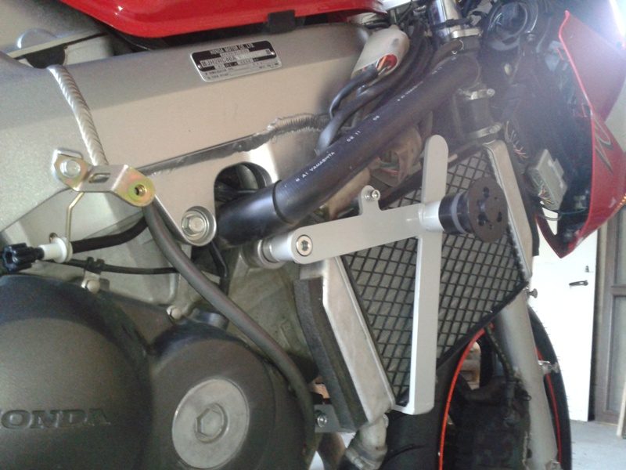
(Ilustr.foto,uchycení pro SL01)

