H21SDM
Honda CBR1000RR 2008-11
WITH ABS

Kit for left side: |  |  |  |  | Kit for right side:
ID. | Description | Cat.NO | QTY |  |  | ID. | Description | Cat.NO |  | QTY
1 | SLDM adapter | 537/B | 1 |  |  | 1 | SLDM adapter | 537/B |  | 1
2 | Bolt M6x20mm | 1024 | 2 |  |  | 2 | Bolt M6x20mm | 1024 |  | 2
3 | Washer M6 | 1023 | 2 |  |  | 3 | Washer M6 | 1023 |  | 2
4 | Bolt M8x25mm (oval) | 831 | 1 |  |  | 4 | Bolt M8x25mm (oval) | 831 |  | 1
5 | Steel adapter | 523 | 1 |  |  | 5 | Steel adapter | 524 |  | 1
6 | Dural.cylinder 50mm | 13 | 1 |  |  | 6 | Dural.cylinder 50mm | 13 |  | 1
7.1 | Dural.cylinder 11mm | 17 | 1 |  |  | 7.2 | Dural.cylinder 2mm | 167 |  | 1
8 | Bolt M10x70 | 851 | 1 |  |  | 8 | Bolt M10x70 | 851 |  | 1
9 | 3M Tape |  | 1 |  |  | 9 | 3M Tape |  |  | 1
10.1 | Bar for connection 8x463x30x30 |  | 1 |  |  | 10.2 | Steel bracket for ABS | X16 |  | 1
11 | Bolt M12x70x1,25mm | 917 | 1
12 | Washer M12 | 803 | 1

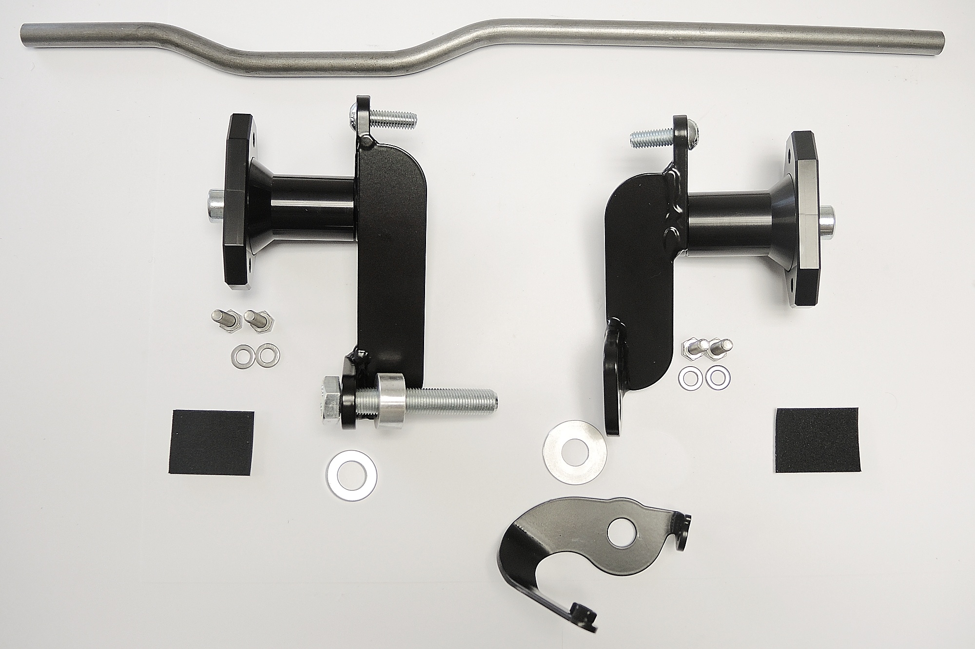
ID1
ID2
ID3
ID4
ID5
ID6
ID7.1
ID8
ID9
ID10.1
ID11
ID12
ID10.2
ID7.2

Instructions:

- Dismantle fairing of motorcycle.
- Dismantle original bolts M12 from the frame.
- Stick 3M tape (ID9) on the frame to prevent damage.
- Fit steel adapters ID5 on the frame of motorcycle. On the left side use bolt ID11, washer ID12 and cylinder ID7.1. On the rigth side use original bolt with cylinder ID7.2 and ABS adapter ID10.2.
- Place connection rod ID10.1 between adapters and fit it using two M8 bolts (ID4).
- Mount fairing back on the motorcycle.
- Fit SLDM adapter ID1 and cylinder ID6 on the steel adapter using M10 bolt (ID8).
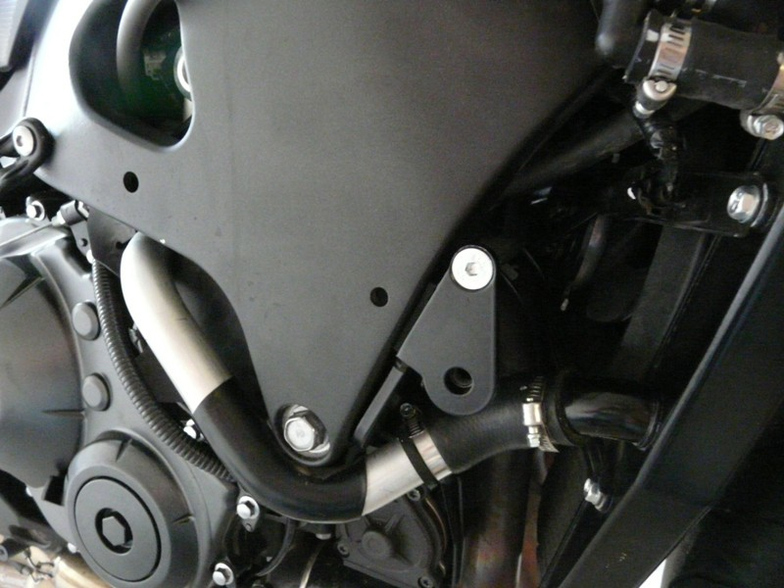
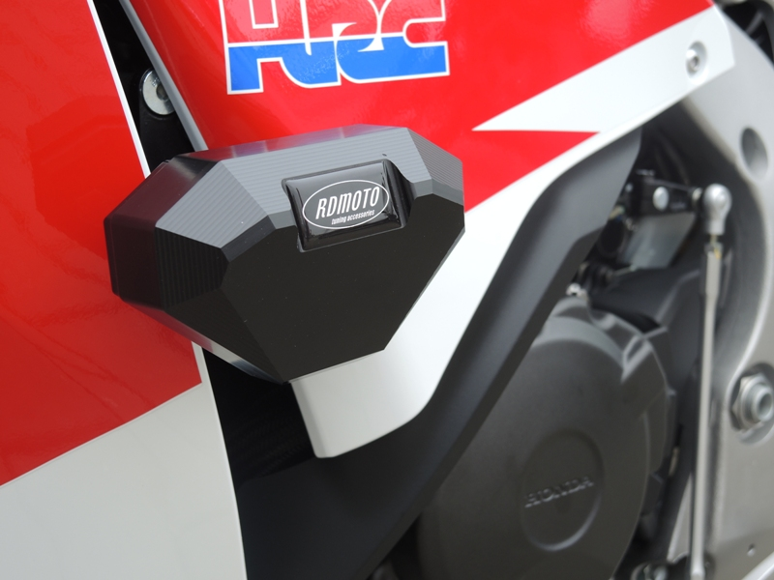
- In the end fit slider using two bolts M8 and washers (ID2 and ID3).

