H21S
Honda CBR1000RR 2008-´12
WITH ABS

Kit for the left side |  |  |  |  | Kit for the right side
No. | Description | Cat.no. | Pcs |  |  | No. | Description | Cat.no. | Pcs
4 | Adapter moto | DV-313 | 1 |  |  | 4 | Adapter moto | DV-313 | 1
7 | Bolt M6x25 | 877 | 3 |  |  | 7 | Bolt M6x25 | 877 | 3
8 | Bolt M4x16 | 876 | 2 |  |  | 8 | Bolt M4x16 | 876 | 2
9 | Bolt M10x25mm | 868 | 1 |  |  | 9 | Bolt M10x25mm | 868 | 1
10 | Bolt M8x25mm | 831 | 1 |  |  | 10 | Bolt M8x25mm | 831 | 1
11 | Steel adapter | 523 | 1 |  |  | 11 | Steel adapter | 524 | 1
12 | Dural. cylinder d=11mm | 17 | 1 |  |  | 12 | Dural. cylinder d=2mm | 167 | 1
13 | Tape 3M |  | 1 |  |  | 13 | Tape 3M |  | 1
14 | Pad M12 | 803 | 1
15 | Bolt M12x70x1,25mm | 917 | 1
16 | Steel bar 8x463x30x30 | - | 1
17 | Steel holder to transfer of ABS | X16 | 1

Instalation:

- remove the complete side cowl
- remove the original bolt M12
- use tape 3M for mounting of the steel adapters for the restricted space between adapter and frame of the motorcycle
- fix steel adapter on the left and right side the motorcycle, give the right adapter between the frame of the motorcycle and use the original bolt for tightening. Don’t forget to give the duralumin spacer between adapter and frame of the motorcycle (No. 12)
- use the bolt (No. 15) for mounting the left adapter, don’t forget to give duralumin cylinder (No. 12) between frame of the motorcycle and adapter
- give stainless steel bar between left and right adapter, use bolts (No. 10) for tightening
- put fairing back the bike
- fix slider holder no.4 by bolt no.9 on the steel holder. Put slide rand use bolt no.7, insert cover and use bolts no.8.

Use a steel holder to transfer of the ABS during installation.

Warning – we recommend to use safety glue on threads of all bolts (moderate strong – blue colour).

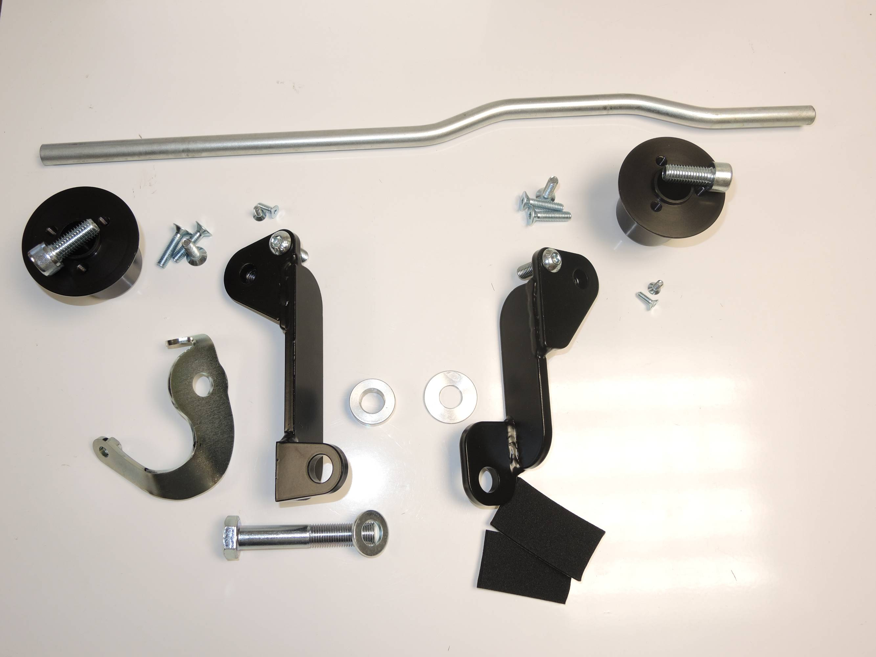
16

7
8
9
7
10
10
4
9
11

12
12
8
4

17
11

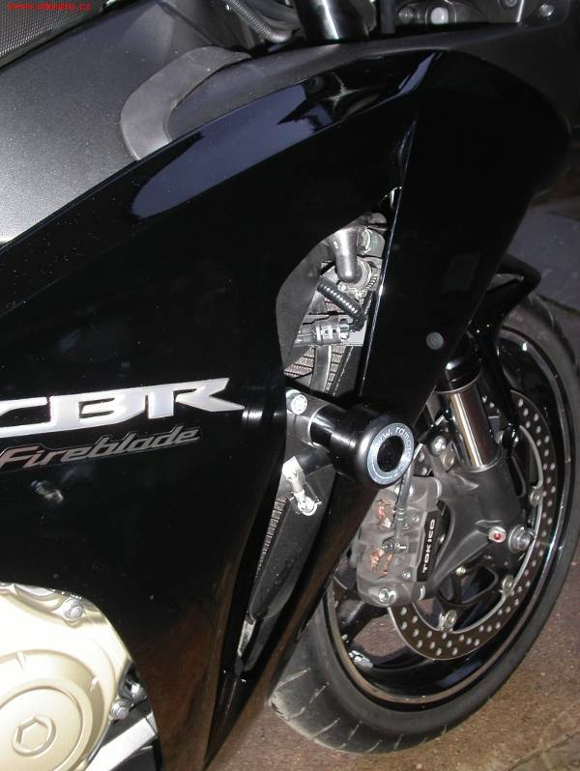
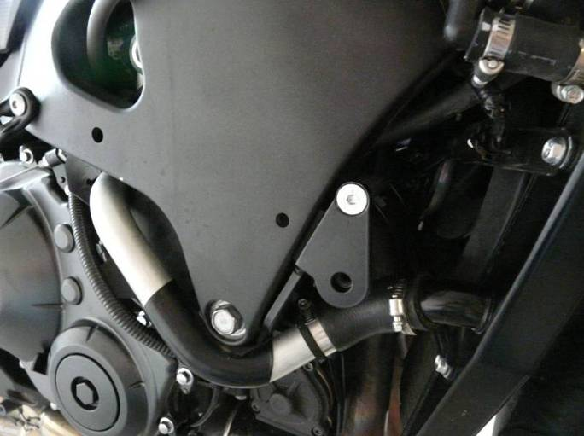
14
15
Ilustr.photo. Newer gripping.

