H21
Honda CBR1000RR 2008-
WITH ABS

Kit for the left side |  |  |  |  | Kit for the right side
No. | Description | Cat.no. | Pcs |  |  | No. | Description | Cat.no. | Pcs
1 | Steel box M10 | X1 | 1 |  |  | 1 | Steel box M10 | X1 | 1
2 | Bolt M12x70x1,25mm | 917 | 1 |  |  | 2 | Dural. cylinder d=15mm | 8 | 1
3 | Dural. cylinder d=15mm | 8 | 1 |  |  | 3 | Bolt M8x25mm | 831 | 1
4 | Bolt M8x25mm | 831 | 1 |  |  | 4 | Bolt M10x60mm | 850 | 1
5 | Bolt M10x60mm | 850 | 1 |  |  | 5 | Steel adapter | 524 | 1
6 | Pad M12 | 803 | 1 |  |  | 6 | Tape 3M |  | 1
7 | Steel adapter | 523 | 1 |  |  | 7 | Dural. cylinder d=2mm | 167 | 1
8 | Tape 3M |  | 1
9 | Stainless steel bar 8x463x30x30 |  | 1
10 | Dural. cylinder d=11mm | 17 | 1
 | Steel holder to transfer of ABS | X16 | 1
 | 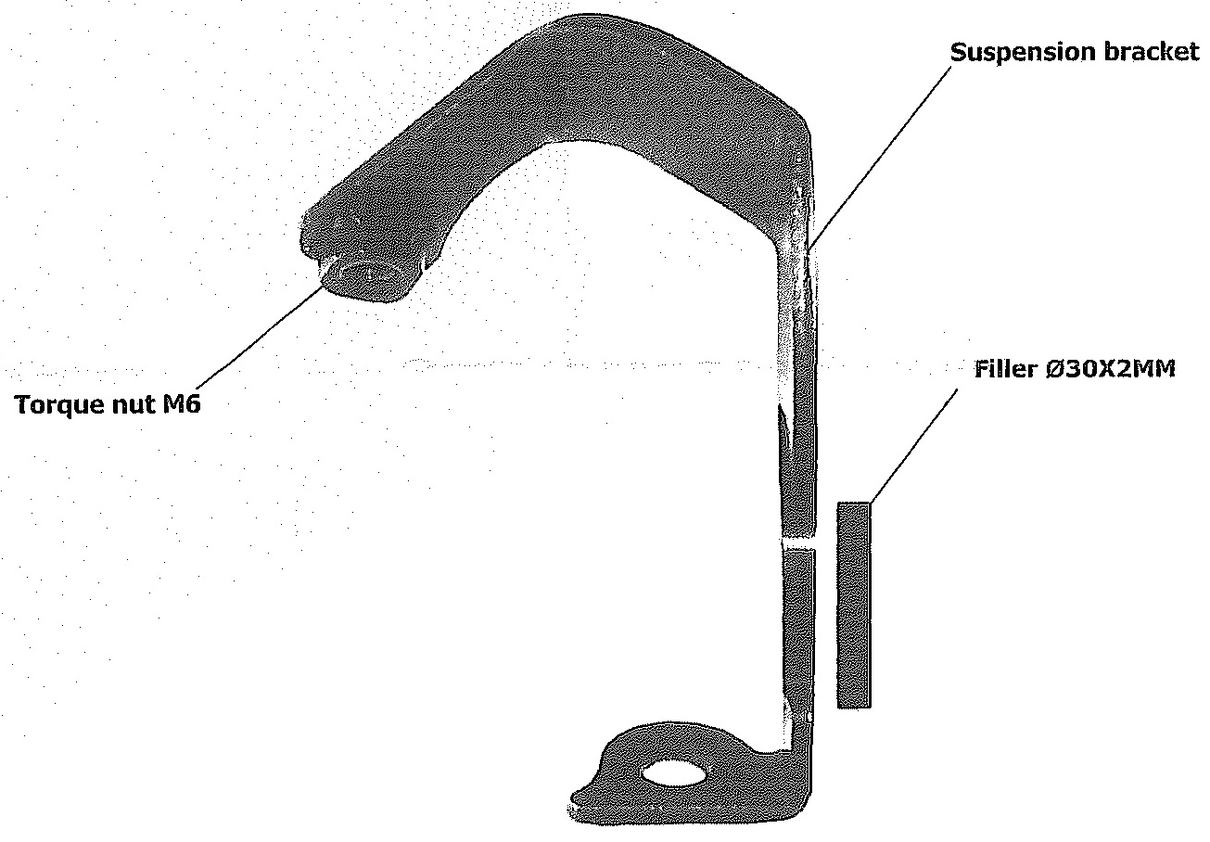

Installation:

- remove the complete side cowl
- remove the original bolt M12
- use tape 3M for mounting of the steel adapters for the restricted space between adapter and frame of the motorcycle
- fix steel adapter on the left and right side of frame of the motorcycle by below listed photos, give the right adapter between the frame of the motorcycle and use the original bolt for tightening. Don’t forget to give the duralumin determinative cylinder between adapter and frame of the motorcycle (No. 7)
- use the bolt (No. 2) for mounting the left adapter, don’t forget to give duralumin cylinder (No. 11) between frame of the motorcycle and adapter
- give stainless steel bar between left and right adapter, use bolts (No. 4) and (No. 3) for tightening
- tighten all carefully and you can mount the side plastics
- put steel box (No. 1) in protector together with botl (No. 5 – the left side) or (No. 6 – the right side), put duralumin cylinder (No. 3 – the left side) or (No. 2 – the right side), duralumin cylinder give on bolt
- all this set mount on adapter
- use the same process on reverse side too

Use a steel holder to transfer of the ABS during installation.

Warning – we recommend to use safety glue on threads of all bolts (moderate strong – blue colour).

