H22S
Honda CB1000R Hornet 2008-2011

Fitting kit left side: Fitting kit right side:
ID | Description | Cat.No | QTY
1 | Dural.adapter | 314 | 1
2 | Bolt M12x75x1,25 | 914 | 1
3 | Bolt M6x25 | 877 | 3
4 | Bolt M4x16 | 876 | 2
ID | Description | Cat.No | QTY
1 | Dural.adapter | 314 | 1
2 | Bolt M12x75x1,25 | 914 | 1
3 | Bolt M6x25 | 877 | 3
4 | Bolt M4x16 | 876 | 2

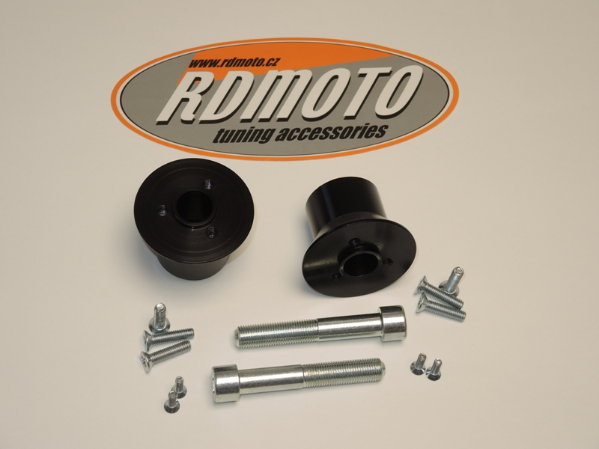
1
1

2

3
3

4
2
4

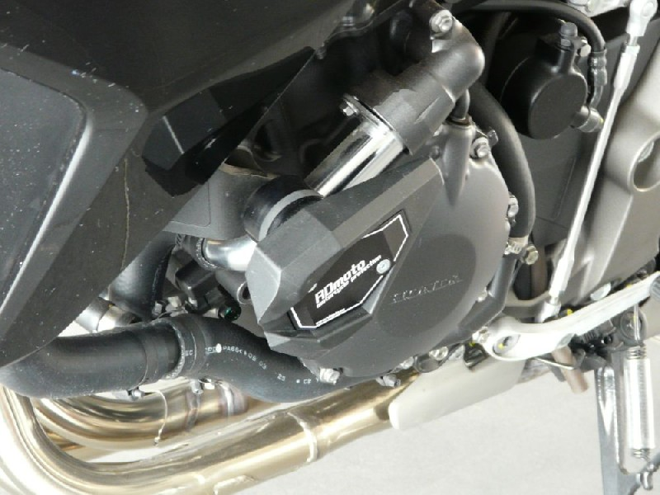

ILUSTRATION PHOTO

Instruction to assembly left side:
- Dismantle original bolt from frame.
- Tighten dural.adapter ID.1 use bolt ID.2.
- Gripping slider, use bolts ID.3.
- Insert colours cover into the slider and use bolts ID.4.

Instruction to assembly right side:
- Dismantle original bolt from frame.
- Tighten dural.adapter ID.1 use bolt ID.2.
- Gripping slider, use bolts ID.3.
- Insert colours cover into the slider and use bolts ID.4.

Warning: We recommend use the glue of all threads. Medium strong.

