H22
Honda CB1000R Hornet 2008-2011

Fitting kit left side: Fitting kit right side:
ID | Description | Cat. | Qty
1 | Steel box | X2 | 1
2 | Bolt M12x100x1,25 | 911 | 1
3 | Dural. cylinder d=15 | 148 | 1
ID | Description | Cat. | Qty
1 | Steel box | X2 | 1
2 | Bolt M12x100x1,25 | 911 | 1
3 | Dural.cylinder d=15 | 148 | 1

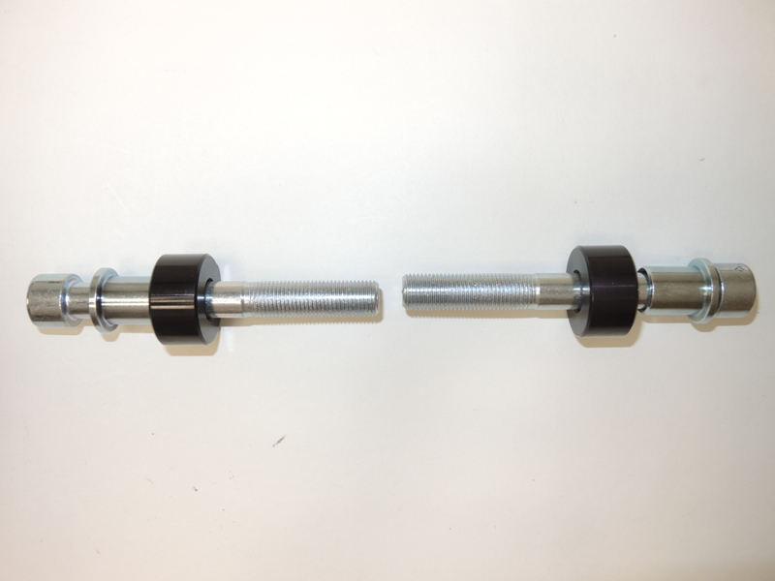

1
1
2
2

3
3

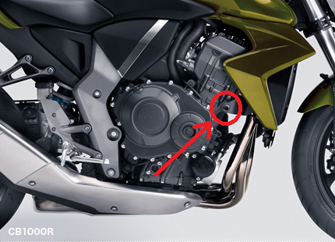

Instruction

- Installation of the left and right protector make in gripping about the attached photo.
- Give the steel box M12 (ID. 1) on both bolts. Put the duralumin cylinder (ID. 3) under the protector on the left side and use the bolt (ID. 2) for tightening.
- Put the duralumin cylinder (ID. 3) under the protector on the right side and use the bolt (ID. 2) for tightening.
- At first finish the one side and then mount the second side.

Warning – we recommend to use safety glue on threads of all bolts (moderate strong – blue colour).

