H23
Honda X11 2000-
Fitting kit:

ID | Description | Cat.N | Qt.
1 | Steel bushes | X1 | 2
2 | Bolt M10x115x1,25 | 894 | 2
3 | Alu. spacer d=20mm | 435 | 2
4 | Alu. spacer d=21mm | 188 | 2

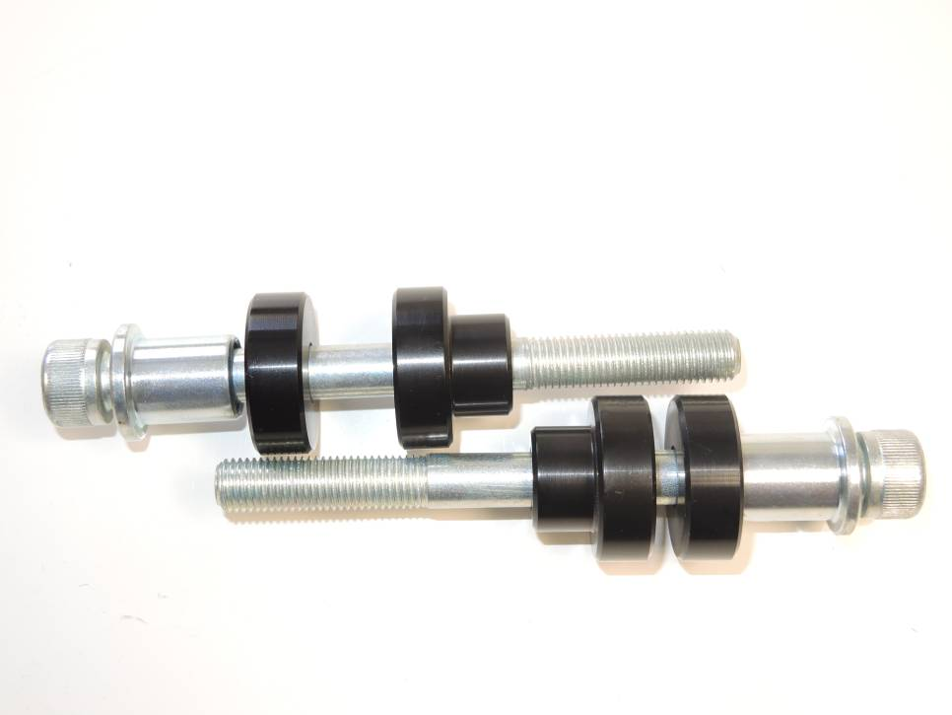
2
1
3
4
2
4
1
3
Installation:

Installation for the left and right side is the same.
1. Remove the original side fairings
2. Remove the original screw in the mounting location
3. On the screw (item 2) attach steel insert (item 1) and this set put through the crash protector
4. On the screw under the protector attach duralumin cylinder (item 4+3)
5. Reinstall the side cover, but do not tighten
6. Take set with the crash protector and put through the plastic
7. From inside the plastic attach the duralumin cylinder (item 3) and mount into the thread in the frame of the motorcycle

Warning – we recommend to use safety glue on threads of all bolts (moderate strong – blue colour).

