H24
Honda CBR1100XX Blackbird

Kit for the left side |  |  |  |  | Kit for the right side
ID | Description | Cat.no. | Pcs |  |  | ID | Description | Cat.no. | pcs
1 | Steel insert | X1 | 1 |  |  | 1 | Steel insert | X1 | 1
2 | Dural spacer – 11mm | DV-97 | 1 |  |  | 2 | Dural spacer – 11mm | DV-97 | 1
3 | Bolt M10x110x1,25mm  ID3  ID1  ID2 | 928 | 1 |  |  | 3 | Bolt M10x105x1,25mm | 928 | 1
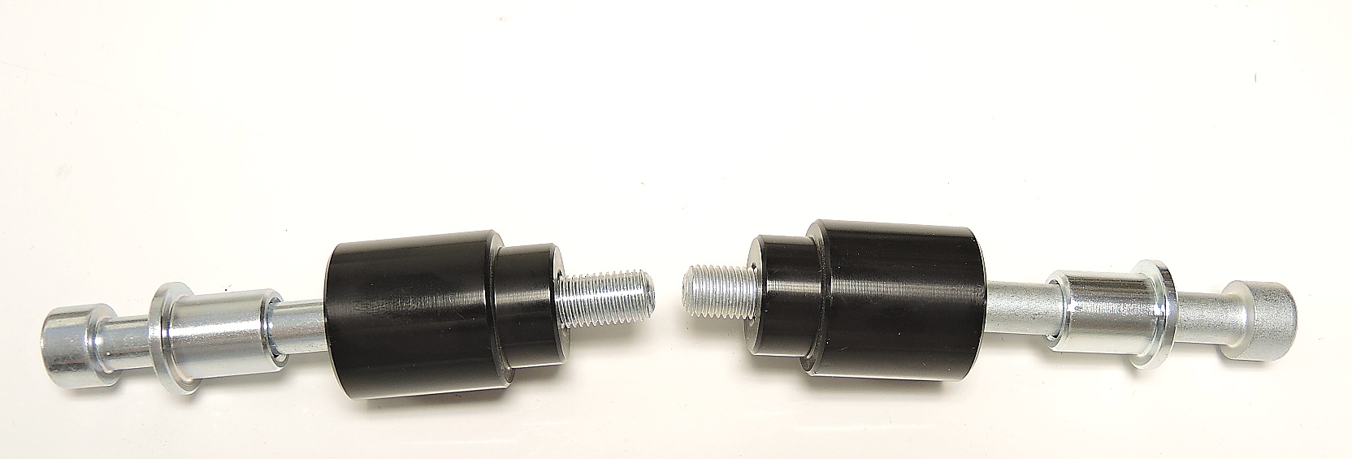
Instructions:

- Remove original bolt from motorcycle.
- Put steel insert (ID1), dural spacer (ID2) on the M10 bolt (ID3).
- Mount this kit on the motorcycle.
- We recommend to use the glue on all threads (medium strong - blue colour).

