H26
Honda CBR600RR 2009-

Kit for left side: Kit for right side:
ID | Description | Cat.N | QTY
1 | Steel box M12 | X2 | 1
2 | Bolt M12x110x1,25 | 910 | 1
3 | Dural.cylinder d=31,5 | 288 | 1
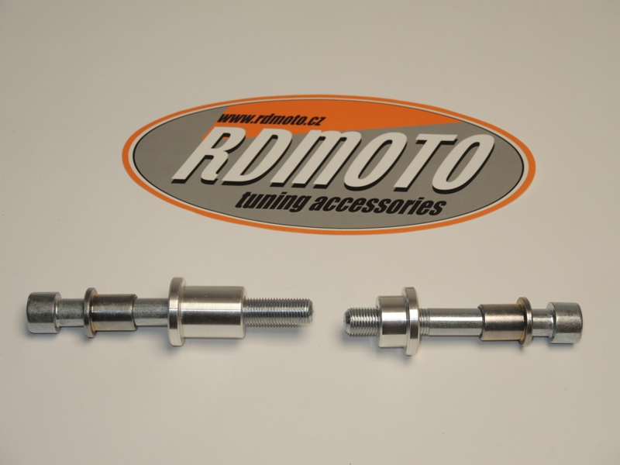
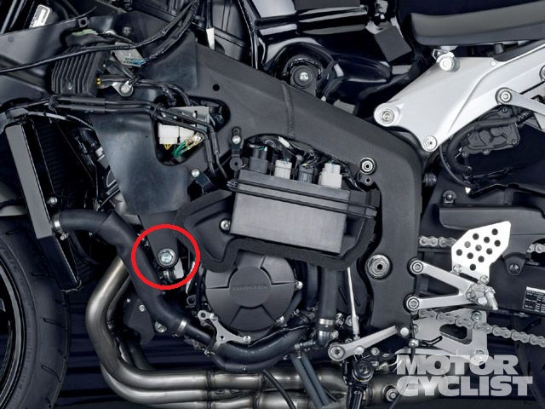
2
1
2
3
1
3
ID | Description | Cat.N | QTY
1 | Steel box M12 | X2 | 1
2 | Bolt M12x90x1,25 | 931 | 1
3 | Dural.cylinder d=16,5 | 289 | 1
You will have to drill the hole in the fairing during installation. It is therefore necessary intervention in the original cowl!
Take out fairing from bike and make a hole.

Instruction to assembly left side:
- Take out original bolt from frame.
- Insert steel box ID.1 into the protector. Under the protector insert dural.cylinder ID.3. This set gripping on the frame.

Instruction to assembly left side:
- Take out original bolt from frame.
- Insert steel box ID.1 into the protector. Under the protector insert dural.cylinder ID.3. This set gripping on the frame.

Warning: We recommend use the glue of all threads. Medium strong.

