H29SD
Honda CBR250R 2011-
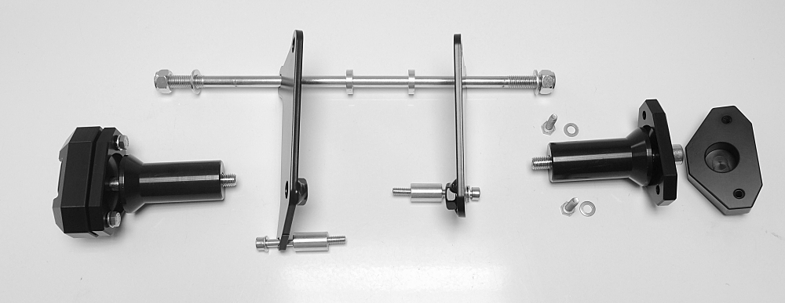
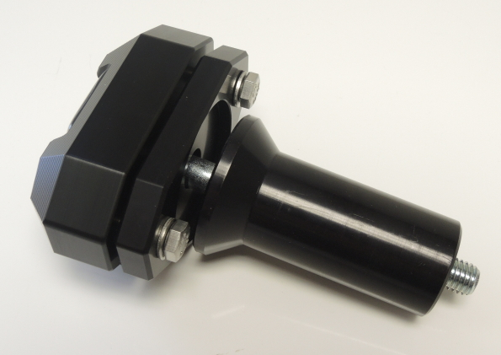
ID1
ID14
ID11
ID9.2
ID9.1
ID13
ID7.2
ID10
ID12
ID7.1
ID8
Kit for the left side |  |  |  |  | Kit for the right side
ID. | Description | Cat.N | Qty |  | ID. | Description | Cat.N | Qty
1 | Slider adapter | 537 | 1 |  | 1 | Slider adapter | 537 | 1
2 | Dural cylinder – 70 mm | DV15 | 1 |  | 2 | Dural cylinder – 70 mm | DV15 | 1
3 | Bolt M10x100 | 885 | 1 |  | 3 | Bolt M10x100 | 885 | 1
4 | Washer M10 | 801 | 1 |  | 4 | Washer M10 | 801 | 1
5 | Bolt M8x25 | 815 | 2 |  | 5 | Bolt M8x25 | 815 | 2
6 | Washer M8 | 800 | 2 |  | 6 | Washer M8 | 800 | 2
7.1 | Dural cylinder - 25mm | 467 | 1 |  | 7.2 | Dural cylinder – 23,5mm | 468 | 1
8 | Bolt M6x60mm | 872 | 1 |  | 8 | Bolt M6x60mm | 872 | 1
9.1 | Steel adapter | 640 | 1 |  | 9.2 | Steel adapter | 641 | 1
10 | Nut M10-insurance | 810 | 1 |  | 10 | Nut M10-insurance | 810 | 1
11 | Washer M10 flat | 804 | 1 |  | 11 | Washer M10 flat | 804 | 1
12 | Washer M6 flat | 947 | 1 |  | 12 | Washer M6 flat | 947 | 1
13 | Dural cylinder - 5mm | 16 | 1 |  | 13 | Dural cylinder - 5mm | 16 | 1
14 | Steel rod 10x300x30x30 |  | 1

ID2

ID5+6
ID3+4

Instructions:

- Fitting kit (according to the first picture)
  - Remove fairing of motorcycle.
  - Remove original bolts from the frame of motorcycle.
  - Insert steel rod (ID14) trough frame of motorcycle.
  - Put dural cylinders (ID13) on the rod from both sides. Put steel adaper (ID9.1 for the left and ID9.2 for the right) on the rod (ID14) and tighten in using nut M10 (ID10+11).
  - Tighten upper part of steel adapter using orginal bolt.
  - For lower part use bolt M6 (ID8+12). Don’t forget to use cylinders (ID7).

- Slider (according to the second picture)
  - Fit slider adapter (ID1) and dural cylinder (ID2) on the steel adapter using bolt M10 (ID3).
  - Fit slider using two M6 bolts (ID5+6).
- We recommended to use glue on all threads (medium strong).

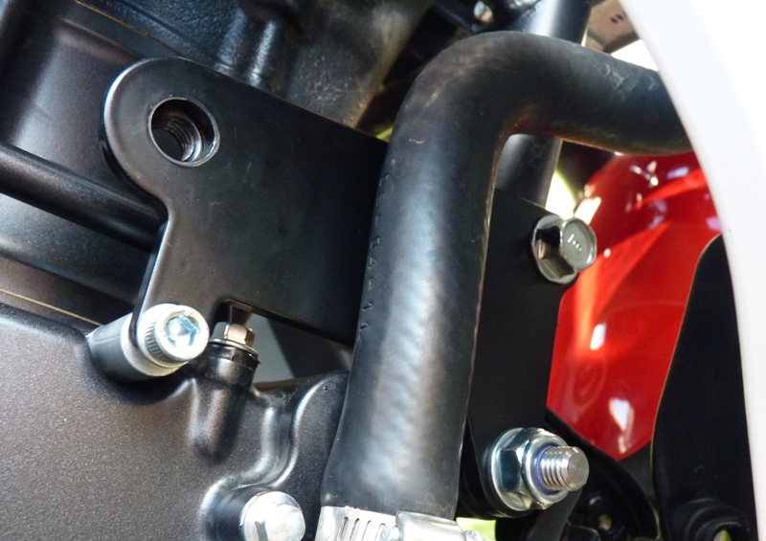
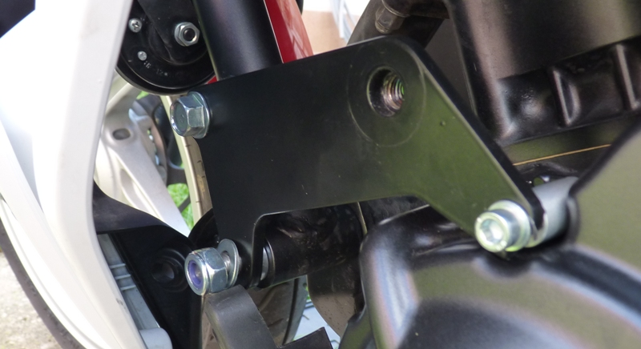
Original bolt

ID8+12
ID10+11+14

