H29
Honda CBR250R 2011-

Kit for the left side |  |  |  |  | Kit for the right side
ID. | Description | Cat.N | Qty |  | ID. | Description | Cat.N | Qty
1 | steel box M10 | X1 | 1 |  | 1 | steel box M10 | X1 | 1
2 | screw M10x90mm | 880 | 1 |  | 2 | screw M10x90mm | 880 | 1
3 | duralumin cylinder d = 50mm | 5 | 1 |  | 3 | duralumin cylinder d = 50mm | 5 | 1
4 | duralumin cylinder d = 25mm | 467 | 1 |  | 4 | duralumin cylinder d=23,5mm | 468 | 1
5 | screw M6x60mm | 872 | 1 |  | 5 | screw M6x60mm | 872 | 1
6 | steel adapter | 640 | 1 |  | 6 | steel adapter | 641 | 1
7 | nut M10-insurance | 810 | 1 |  | 7 | nut M10-insurance | 810 | 1
8 | pad M10 flat | 804 | 1 |  | 8 | pad M10 flat | 804 | 1
9 | pad M6 flat | 947 | 1 |  | 9 | pad M6 flat | 947 | 1
10 | steel rod 10x300x30x30 |  | 1 |  | 10 | duralumin cylinder d = 5mm | 16 | 1
11 | duralumin cylinder d = 5mm | 16 | 1

Mounting :

- remove the original plastic side and screws M10 in the motorcycle frame on the left side
- on the motorcycle frame mount steel adapter (item 6) according to the attached photo below. To this installation use the screw (item 5) with pad (item 9) and duralumin cylinder (item 4), duralumin cylinder insert under the steel adapter
- in the front upper part of the adapter use the original screw
- now remove the original plastic side on the right side and screws M10
- in the front lower part of the adapter on the left side put through the frame a steel bar (item 10)
6. take steel adapter for the right side (item 6) and in the same way as on the left side mount
7. on the steel bar at the bottom of each adapters put pads (item 8) and by nuts (item 7) secure
8. check and tighten everything, you can mount back side plastics
9. to the crash protectors insert steel inserts (item 1) together with screws (item 2), from the back side of crash protectors put on the screws the duralumin cylinders (item 3) and all these assemblies mount into the threads on the steel adapters

Warning - on the threads of the screws is recommended to use premium adhesive moderate (blue color).

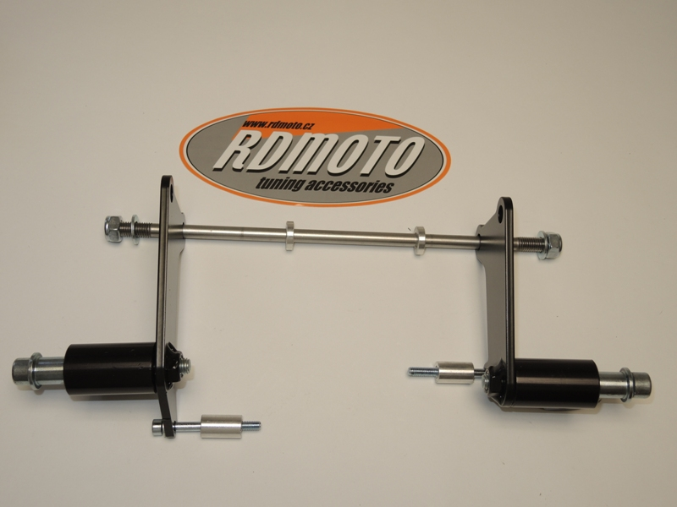
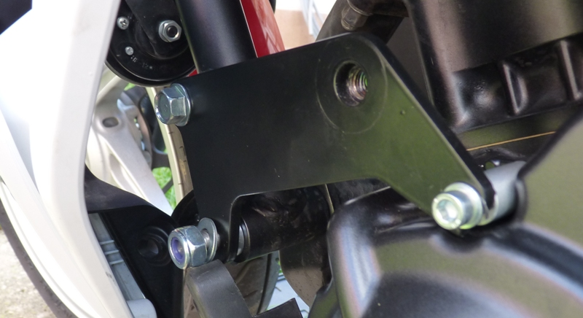
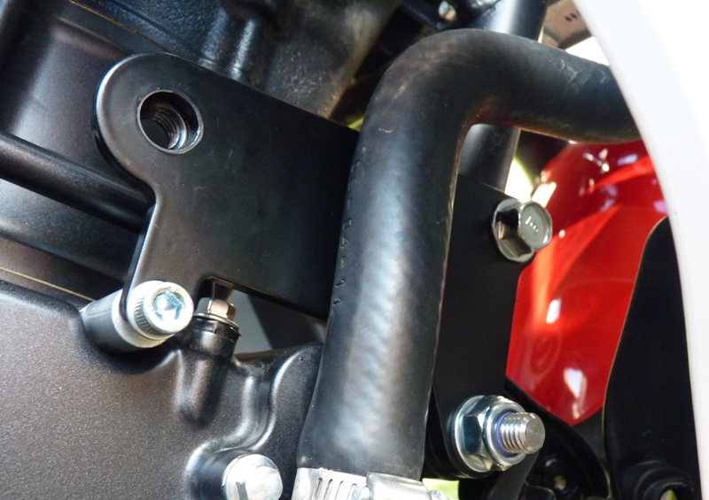

1
2
6
7,8
1
11
10
10
5
4
1
2
3
6
7,8
3
4
5
9

