H2SDM
Honda CB600F Hornet 1998-2006
Honda CBF600(S) 2004-2007

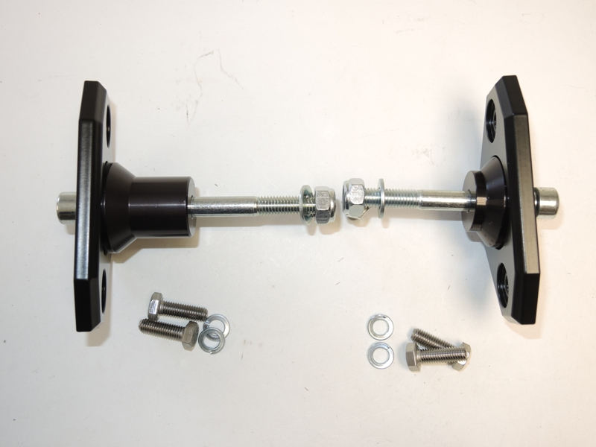
Kit for left side: Kit for right side:
ID | Description | Cat.N | Qt
1 | Dural.bracket for SLDM | 537/B | 1
2 | Bolt M6x20 | 1024 | 2
3 | Washer M6 | 1023 | 2
4 | Dural. spacer d=40mm | 12 | 1
5 | Bolt M10x120 | 881 | 1
6 | Washer M10 | 804 | 1
7 | Nut M10 | 810 | 1
ID | Description | Cat.N | Qt
1 | Dural.bracket for SLDM | 537/B | 1
2 | Bolt M6x20 | 1024 | 2
3 | Washer M6 | 1023 | 2
4 | Dural. spacer d=15mm | 9 | 1
5 | Bolt M10x90 | 880 | 1
6 | Washer M10 | 804 | 1
7 | Nut M10 | 810 | 1

1

1
4

6
6
7
7
4
5

5

2
2
3
3

Instruction to assembly left side:
- Take out original bolt M10 from frame.
- On the bolt ID.5 insert dural. bracket for sld ID.1. Between the dural bracket and frame put dural. spacer ID.4 This kit mounting on the bike, from back side tighten bolt by washer ID.6 and nut ID.7.
- On the bolts ID.2 put washers ID.3 and mounting slider.

Instruction to assembly right side:
- Take out original bolt M10 from frame.
- On the bolt ID.5 insert dural. bracket for sld ID.1. Between the dural bracket and frame put dural. spacer ID.4 This kit mounting on the bike, from back side tighten bolt by washer ID.6 and nut ID.7.
- On the bolts ID.2 put washers ID.3 and mounting slider.

Use glue of all threads. Medimum strong. (blue colour).

