H2S
Honda CB600F Hornet 1998-2006
Honda CBF600(S) 2004-2007

Kit for left side: Kit for right side:
ID | Description | Cat.N | QTY
1 | Adapter moto | 313 | 1
2 | Bolt M6x25 | 877 | 3
3 | Bolt M4x16 | 876 | 2
4 | Bolt M10x85mm | 981 | 1
5 | Nut M10 – safety | 810 | 1
6 | Washer M10 | 804 | 1
ID | Description | Cat.N | QTY
1 | Adapter moto | 292 | 1
2 | Bolt M6x25 | 877 | 3
3 | Bolt M4x16 | 876 | 2
4 | Bolt M10x85mm | 981 | 1
5 | Nut M10 – safety | 810 | 1
6 | Washer M10 | 804 | 1

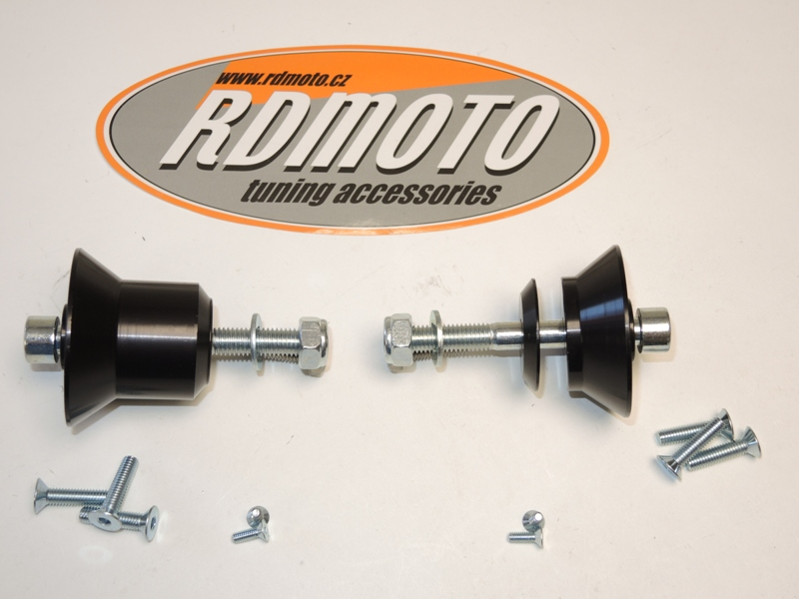
2
4
2
3
1
3
1
6
4
5
6
5

Instruction to assembly left side:
- Remove the original bolt from frame.
- Use bolt ID.4 for gripping of duralumin adapter ID.1, use the nut ID.5 and washer ID.6 for tighten,from back side.
- For gripping slider use bolts ID.2
- Insert cover into slider and use bolts ID.3 for gripping.

Instruction to assembly right side:
- Remove the original bolt from frame.
- Use bolt ID.4 for gripping of duralumin adapter ID.1 bolt put through the frame and engine use the nut ID.5 and washer ID.6 for tighten.
- For gripping slider use bolts ID.2
- Insert cover into slider and use bolts ID.3 for gripping.

Warning – we recommend to use safety glue on threads of all bolts (medium strong – blue colour).
