H30S
Honda VFR1200 F/DCT 2010-

Kit for left side: |  |  |  |  | Kit for right side:
ID | Description | Cat.No | Qt |  |  | ID | Description | Cat.No | Qt
1 | Dural.adapter for SL | DV-313 | 1 |  |  | 1 | Dural.adapter for SL | DV-313 | 1
2 | Bolt M6x25 | 877 | 3 |  |  | 2 | Bolt M6x25 | 877 | 3
3 | Bolt M4x16 | 876 | 2 |  |  | 3 | Bolt M4x16 | 876 | 2
4 | Bolt M12x120x1,25mm | 913 | 1 |  |  | 4 | Bolt M12x80x1,25mm | 908 | 1
5 | Dural.spacer d=15mm | 121 | 1 |  |  | 5 | Dural.spacer d=15mm | 121 | 1
6 | Dural.spacer d=30mm | 3 | 1 |  |  | 6 | Dural.spacer d=40mm | 4 | 1
7 | Bolt M10x50mm | 849 | 1 |  |  | 7 | Bolt M10x60mm | 850 | 1
8 | Dural. CNC bracket | 629 | 1 |  |  | 8 | Dural. CNC bracket | 630 | 1
9 | Tape 3M | 3M | 1 |  |  | 9 | Tape 3M | 3M | 1
10 | OK10, lenght 23mm | X41 | 1

For easy assembly use special tool ID.10

Assembly left side:

- Remove left side fairing of the bike. Remove original bolt M12 of the frame.
- Where the dural CNC bracket is touching with frame, stick stickers 3M (ID9).
- The bolt (ID.4) place into the dural. CNC adapter (ID.8), on the bolt place duralspacer (ID.5), this kit mounting on the bike.
- Put fairing back of the bike.
- Bolt (ID.7) place into the dural. adapter for SL ID.1 and under the adapter put spacer ID.6.
- Slider tighten by bolts ID.2
- Put alu. cover into the slide rand tighten it by bolts ID.3

Assembly right side:

- Remove left side fairing of the bike. Remove original bolt M12 of the frame.
- Where the dural CNC bracket is touching with frame, stick stickers 3M (ID9).
- The bolt (ID.4) place into the dural. CNC adapter (ID.8), on the bolt place duralspacer (ID.5), this kit mounting on the bike.
- Put fairing back of the bike.
- Bolt (ID.7) place into the dural. adapter for SL ID.1 and under the adapter put spacer ID.6.
- Slider tighten by bolts ID.2
- Put alu. cover into the slide rand tighten it by bolts ID.3

Warning- We recommend to use glue of threads, medium strong.
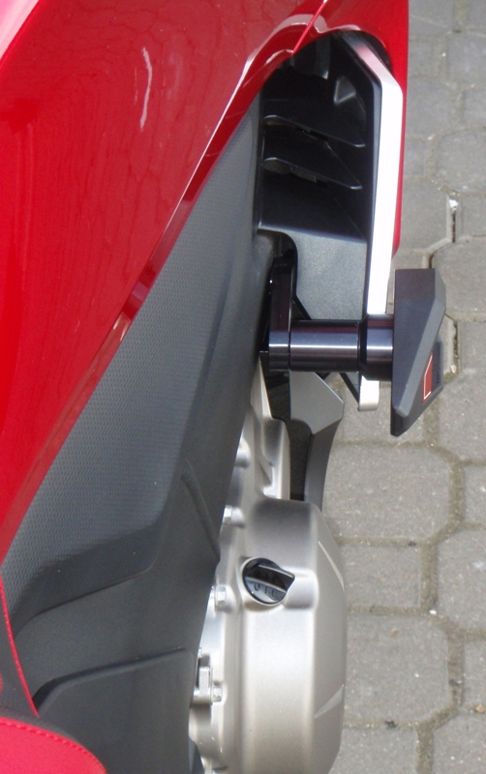
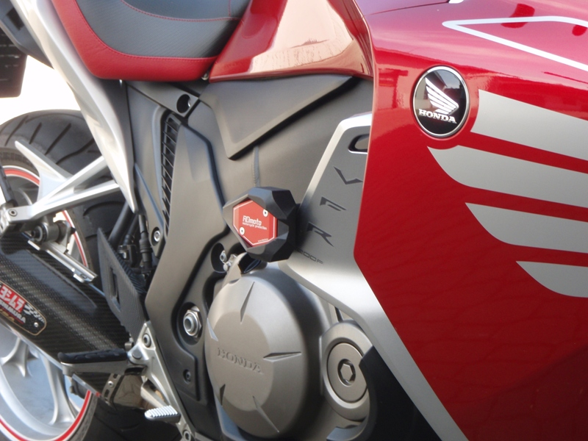

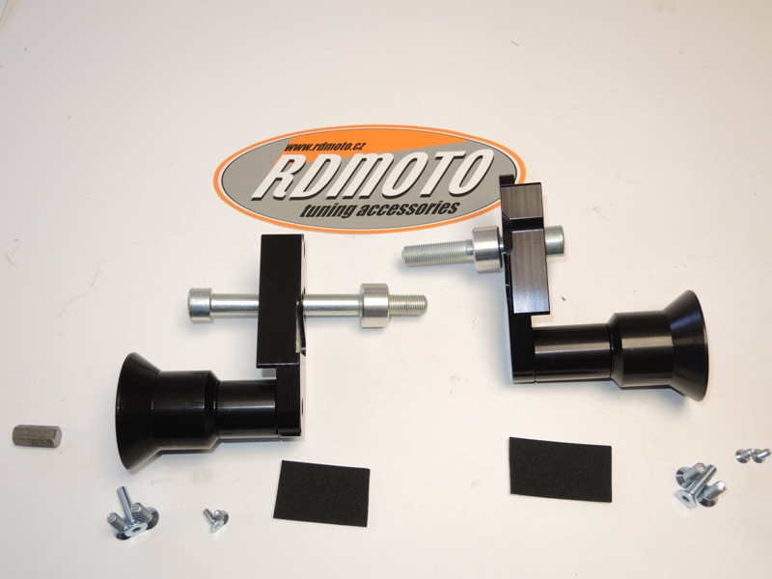

8

5
4
8
6
1
5
4

6
1
7
10
2
3
9
9
2
3
7

