H32
Honda VFR800 X Crossrunner

Kit for the left side |  |  |  |  | Kit for the right side
No. | Description | Cat.no. | Pcs |  |  | No. | Description | Cat.no. | Pcs
1 | Steel box M10 | X1 | 1 |  |  | 1 | Steel box M10 | X1 | 1
2 | Bolt M10x80x1,25mm | 958 | 1 |  |  | 2 | Bolt M10x100x1,25mm | 959 | 1
3 | Duralumin cylinder d=21mm | 416 | 1 |  |  | 3 | Duralumin cylinder d=21mm | 416 | 1
4 | Duralumin cylinder d=40mm | 4 | 1 |  |  | 4 | Duralumin cylinder d=40mm | 4 | 1
5 | Bolt M10x70mm | 851 | 1 |  |  | 5 | Bolt M10x70mm | 851 | 1
6 | Steel adapter | 617 | 1 |  |  | 6 | Steel adapter | 618 | 1
7 | Tape 3M |  | 1 |  |  | 7 | Tape 3M |  | 1

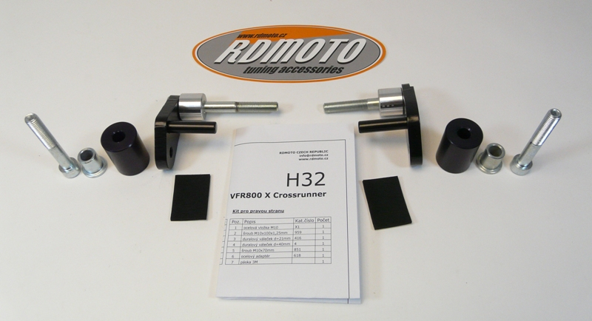
5
1
4
3
2
6
2
3
4
1
5
6

Assembly left side:

- remove the original side plastic and the bolt M10 in the frame of the motorcycle
- use the tape 3M (No. 7) on the frame of the motorcycle in the place of the installation
- give the bolt (No. 2) into the steel adapter (No. 6), the other side of the adapter give the duralumin cylinder (No. 3) on the bolt, all this set mount on the frame of the motorcycle
- screw up and mount the side plastic back
- give the steel box (No. 1) together with the bolt (No. 5) into the protector, the othe side of the protector give the duralumin cylinder (No. 4) on the bolt
- all this set mount on the adapter

Assembly right side:

- remove the original side plastic and the bolt M10 in the frame of the motorcycle
- use the tape 3M (No. 7) on the frame of the motorcycle in the place of the installation
- give the bolt (No. 2) into the steel adapter (No. 6), the other side of the adapter give the duralumin cylinder (No. 3) on the bolt, all this set mount on the frame of the motorcycle
- screw up and mount the side plastic back
- give the steel box (No. 1) together with the bolt (No. 5) into the protector, the othe side of the protector give the duralumin cylinder (No. 4) on the bolt
- all this set mount on the adapter

Warning – we recommend to use safety glue on threads of all bolts (moderate strong – blue colour).

Instalation place
