H33S

Honda CBR600F 2011-
Kit for the left side: |  |  |  |  | Kit for the right side:
ID | Description | Cat.No | QTY |  |  | ID | Description | Cat.No | QTY
1 | Bolt M6x25 | 877 | 3 |  |  | 1 | Bolt M6x25 | 877 | 3
2 | Bolt M12x80x1,25mm | 908 | 1 |  |  | 2 | Bolt M12x70x1,25mm | 937 | 1
3 | Bolt M10x60x1,25mm | 896 | 1 |  |  | 3 | Bolt M10x60x1,25mm | 896 | 1
4 | Bolt M10x60mm | 850 | 1 |  |  | 4 | Bolt M10x60mm | 850 | 1
5 | Dural. cylinder d=15mm | 455 | 1 |  |  | 5 | Dural. cylinder d=16,5mm | 454 | 1
6 | Dural. cylinder d=5mm | 456 | 1 |  |  | 6 | Dural. cylinder d=4mm | 79 | 1
7 | Steel adapter | 624 | 1 |  |  | 7 | Steel adapter | 625 | 1
8 | Washer spring M10 | 801 | 1 |  |  | 8 | Washer spring M10 | 801 | 1
9 | Tape 3M |  | 1 |  |  | 9 | Tape 3M |  | 1
10 | Nut M10 | 810 | 1 |  |  | 10 | Nut M10 | 810 | 1
11 | Bolt M4x16 | 876 | 2 |  |  | 11 | Bolt M4x16 | 876 | 2
12 | Dural. adapter for SL01 | 339 | 1 |  |  | 12 | Dural. adapter for SL01 | 339 | 1
6
3
2
5
6
7
10
9
4
1
8

5
5
3
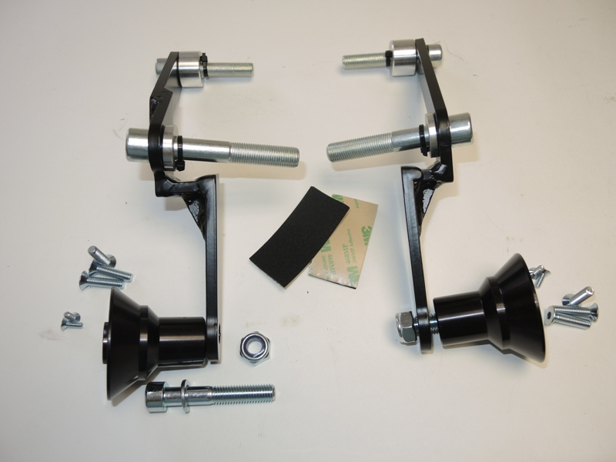
3

2
6
6
2

7
1

11
7

4,8
12
11
10

9
1

10
12
4
8

Instruction to assembly-left side:

- Take off side fairing, bolt M10 and M12 from frame.
- Through adapter ID.7 insert bolts ID.2 and ID.3.
- Under the bolts put dural. cylinders ID.5 a ID.6. from back side the adapter.
- This complete set mounted on the bike.
- During the assembly you can stick 3M tape under the adapter.
- Bolt ID.4 with washer ID.8 insert into the dural adapter ID.12
- This set mounted on the adapter, for fixed use nut ID.10.
- Slider gripping on the dural adapter by bolts ID.1, fit cover inot slider by bolts ID.11
- Put fairing back on bike.

Instruction to assembly-right side:

- Take off side fairing, bolt M10 and M12 from frame.
- Through adapter ID.7 insert bolts ID.2 and ID.3.
- Under the bolts put dural. cylinders ID.5 a ID.6. from back side the adapter.
- This complete set mounted on the bike.
- During the assembly you can stick 3M tape under the adapter.
- Bolt ID.4 with washer ID.8 insert into the dural adapter ID.12
- This set mounted on the adapter, for fixed use nut ID.10.
- Slider gripping on the dural adapter by bolts ID.1, fit cover inot slider by bolts ID.11
- Put fairing back on bike.

Warning – on the threads of the screws is recommended to use premium adhesive moderate (blue color).
