H33

Honda CBR600F 2011-
Kit for the left side: |  |  |  |  | Kit for the right side:
ID | Description | Cat.No | QTY |  |  | ID | Description | Cat.No | QTY
1 | Steel box M10 | X1 | 1 |  |  | 1 | Steel box M10 | X1 | 1
2 | Bolt M12x80x1,25mm | 908 | 1 |  |  | 2 | Bolt M12x70x1,25mm | 937 | 1
3 | Bolt M10x60x1,25mm | 896 | 1 |  |  | 3 | Bolt M10x60x1,25mm | 896 | 1
4 | Bolt M10x50mm | 849 | 1 |  |  | 4 | Bolt M10x50mm | 849 | 1
5 | Dural. cylinder d=15mm | 455 | 1 |  |  | 5 | Dural. cylinder d=16,5mm | 454 | 1
6 | Dural. cylinder d=5mm | 456 | 1 |  |  | 6 | Dural. cylinder d=4mm | 79 | 1
7 | Steel adapter | 624 | 1 |  |  | 7 | Steel adapter | 625 | 1
8 | Dural. cylinder d=10mm | 1 | 1 |  |  | 8 | Dural. cylinder d=10mm | 1 | 1
9 | Tape 3M |  | 1 |  |  | 9 | Tape 3M |  | 1
10 | Nut M10 | 810 | 1 |  |  | 10 | Nut M10 | 810 | 1
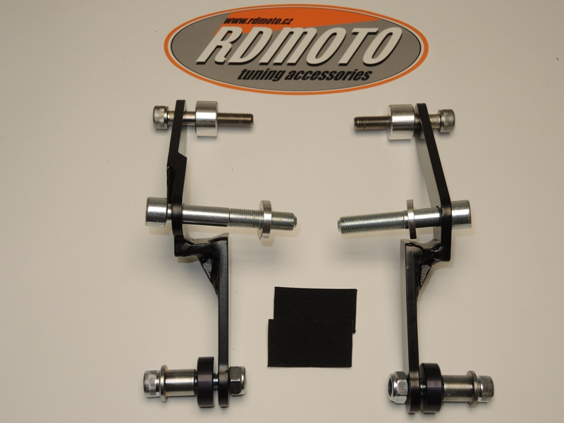
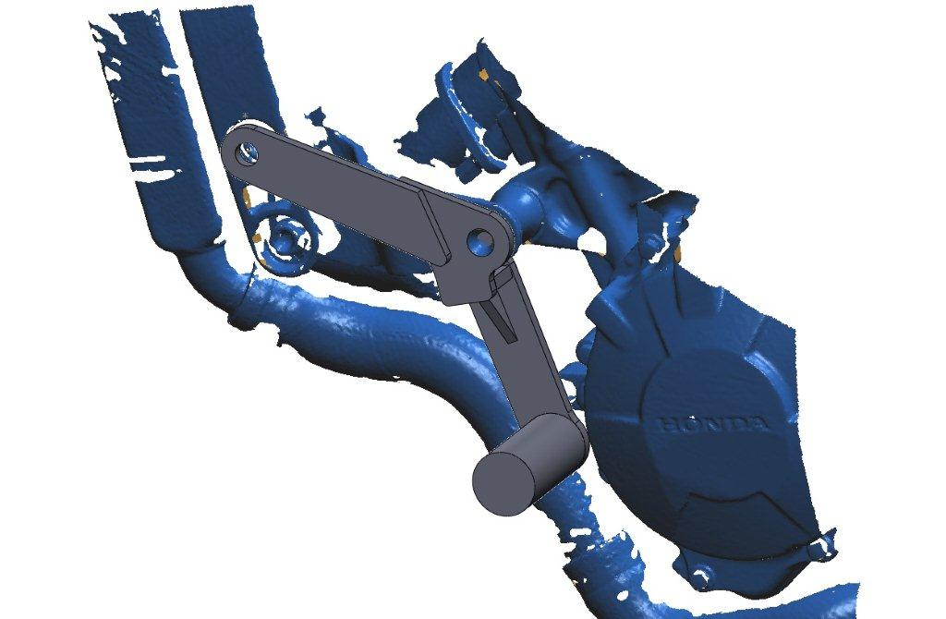
5
3
7
2
6
3
2
5
6
4
7
10
8
1
9
4
1
8
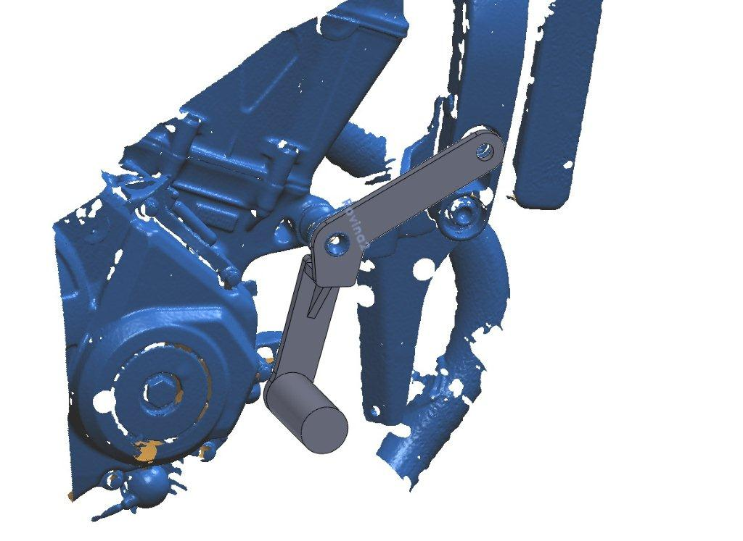
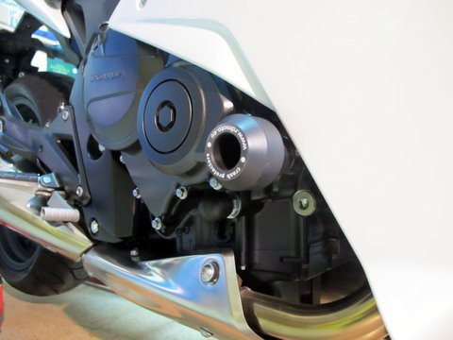
10

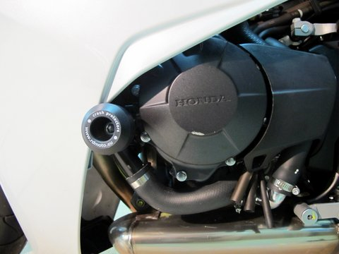

Instruction to assembly-left side:

- Take off side fairing, bolt M10 and M12 from frame.
- Through adapter ID.7 insert bolts ID.2 and ID.3.
- Under the bolts put dural. cylinders ID.5 a ID.6. from back side the adapter.
- This complete set mounted on the bike.
- During the assembly you can stick 3M tape under the adapter.
- Insert steel box ID.1 into the protector together with bolt ID.4.
- Put dural.cylinder ID.8. under the protector.
- This set mounted on the adapter, for fixed use nut ID.10.
- Put fairing back on bike.

Instruction to assembly-right side:

- Take off side fairing, bolt M10 and M12 from frame.
- Through adapter ID.7 insert bolts ID.2 and ID.3.
- Under the bolts put dural. cylinders ID.5 a ID.6. from back side the adapter.
- This complete set mounted on the bike.
- During the assembly you can stick 3M tape under the adapter.
- Insert steel box ID.1 into the protector together with bolt ID.4.
- Put dural.cylinder ID.8. under the protector.
- This set mounted on the adapter, for fixed use nut ID.10.
- Put fairing back on the bike.

Warning – on the threads of the screws is recommended to use premium adhesive moderate (blue color).

