H34SD
Honda CBR125R 2011-
Kit for the left side |  |  |  |  | Kit for the right side
ID | Description | Cat.no. | Pcs |  | ID | Description | Cat.no. | pcs
1.1 | Steel adapter - black | 507 | 1 |  | 1.2 | Steel adapter - black | 506 | 1
2.1 | Dural cylinder – 80mm | 1195 | 1 |  | 2.2 | Dural cylinder - 95mm | 1196 | 1
3.1 | Screw M8x45mm | 820 | 2 |  | 3.2 | Screw M8x25mm | 833 | 2
4 | Steel connection rod | 8x300x15x15 | 1 |  | 4 | - | - | -
5 | Nut M8 | 809 | 1 |  | 5 | Nut M8 | 809 | 1
6 | Washer M8 | 802 | 3 |  | 6 | Washer M8 | 802 | 3
7 | Nut cover M8 | X46 | 1 |  | 7 | Nut cover M8 | X46 | 1
8 | Bolt M10x95 | 822 | 1 |  | 8 | Bolt M10x95 | 822 | 1
10 | Dural cylinder - 70mm | 15 | 1 |  | 10 | Dural cylinder - 70mm | 15 | 1
11 | Nut M10 | 810 | 1 |  | 11 | Nut M10 | 810 | 1
12 | Washer M10 | 804 | 1 |  | 12 | Washer M10 | 804 | 1
13 | Bolt M8x25 | 815 | 2 |  | 13 | Bolt M8x25 | 815 | 2
14 | SLD adapter | 537 | 1 |  | 14 | SLD adapter | 537 | 1
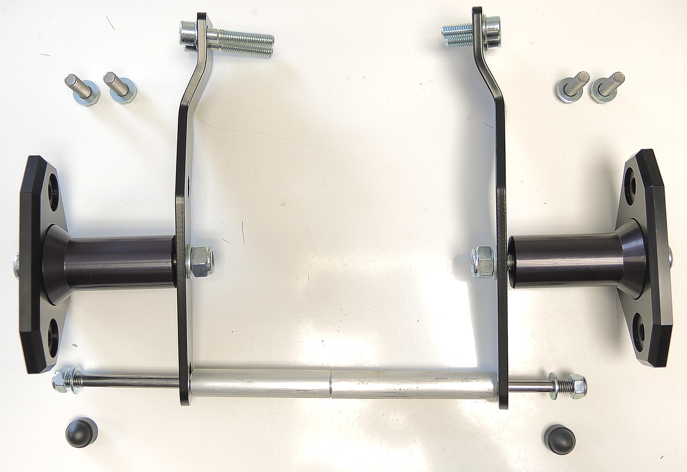
ID3.2
ID3.1

ID13+14
ID1.2
ID1.1

ID10
ID15

ID11+12
ID8+12

ID4
ID5
ID6

ID2.1
ID2.2
ID7
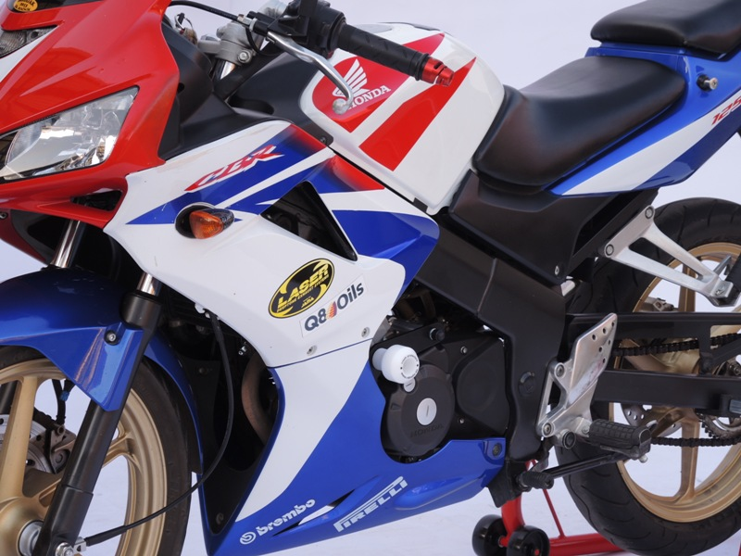
- Remove fairing from both sides.

Instructions for the left side:

- Remove original bolts.
- Fit steel adapter (ID1.1), using bolts (ID3.1) on the frame.
- Insert dural cylinder (ID2.1).
- Insert steel rod M8 (ID4) through adapter, dural cylinder and engine.
- Tighten steel rod M8 using washer (ID6) and nut (ID5).
- Place plastic cover (ID7).
- Fit SLD adapter (ID15) with dural cylinder (ID10) using bolt (ID8+ID12) and nut (ID11+ID12)

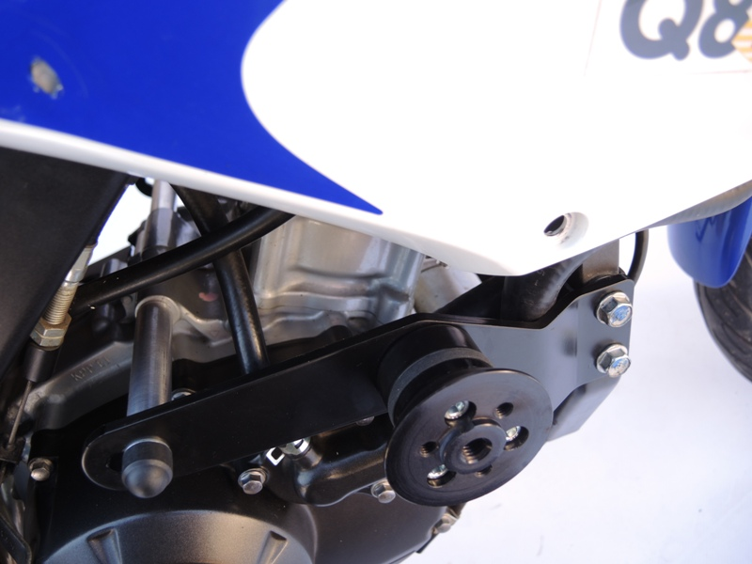
Instructions for the protector:

- Fit protector on the SLD adapter using two bolts ID34 and washers ID14.
(illustrative photo of different protector)

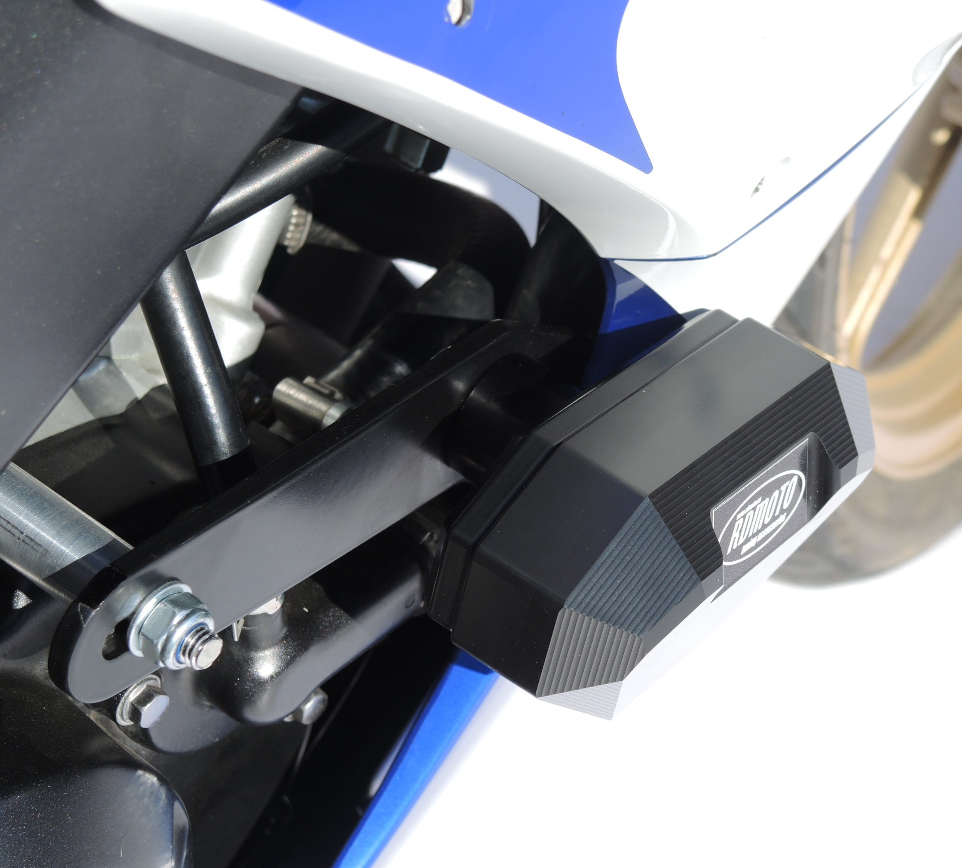

Montáž pravá strana:
Right side:
(Almoast the same as left.)

Differences:
- Insted of adapter ID1.1 use adapter ID1.2
- Insted of dural cylinder ID2.1 use dural cylinder ID2.2
- Insted of bolts ID3.1 use bolts ID3.2

In the end put fairing back.

We recommend to use the glue on all threads (medium strong).

