H34S
Honda CBR125R 2011-

Kit for left side: |  |  |  |  | Kit for right side:
ID | Description | Cat.no. | pcs |  | ID | Description | Cat.no. | pcs
1.1 | Steel protector holder - black | 507 | 1 |  | 1.2 | Steel protector holder - black | 506 | 1
2.1 | Dural roller - 80mm | 1195 | 1 |  | 2.2 | Dural roller - 95mm | 1196 | 1
3.1 | screw M8x45mm | 820 | 2 |  | 3.2 | screw M8x25mm | 833 | 2
4 | Steel connection rod | 8x300x15x15 | 1 |  | - | - | - | -
5 | nut M8 | 809 | 1 |  | 5 | Nut M8 | 809 | 1
6 | Washer M8 | 802 | 1 |  | 6 | washer M8 | 802 | 1
7 | Nut cover M8 | X46 | 1 |  | 7 | Nut cover M8 | X46 | 1
8 | Slider RDmoto | SL | 1 |  | 8 | Slider RDmoto | SL | 1
9 | cover | SLcap. | 1 |  | 9 | cover | SLcap. | 1
10 | Slider adapter - 40mm | 317 | 1 |  | 10 | Slider adapter - 40mm | 317 | 1
11 | screw M10x80 | 852 | 1 |  | 11 | screw M10x80 | 852 | 1
14 | screw M6x25 | 877 | 3 |  | 14 | screw M6x25 | 877 | 3
15 | screw M4x16 | 876 | 2 |  | 15 | screw M4x16 | 876 | 2
16 | Dural roller d=50mm | 5 | 1 |  | 16 | Dural roller d=50mm | 5 | 1
17 | Nut M10 | 810 | 1 |  | 17 | Nut M10 | 810 | 1
18 | Washer M10 | 804 | 1 |  | 18 | Washer M10 | 804 | 1

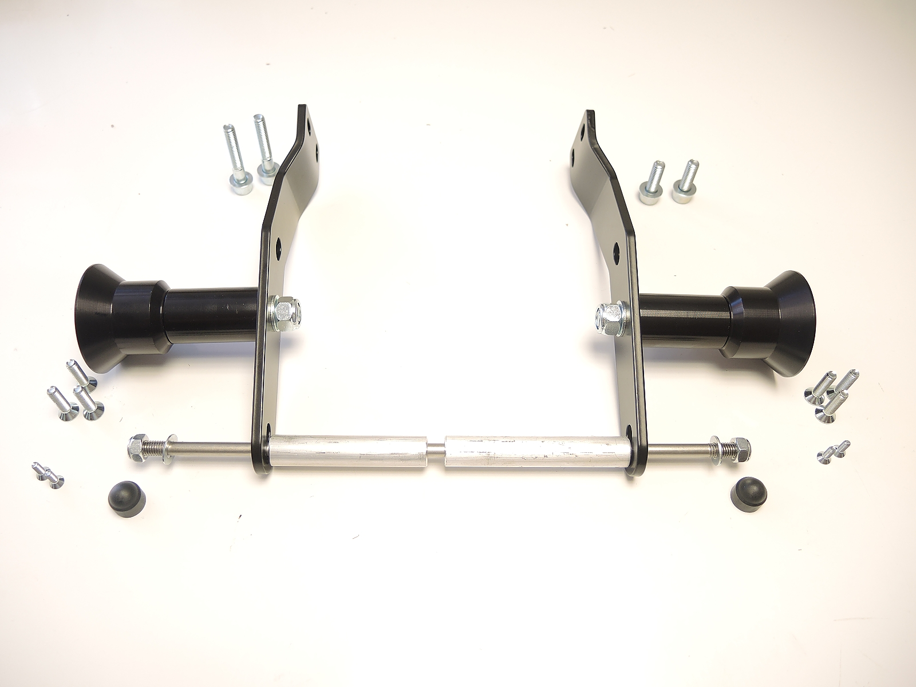
ID1.2
ID4
ID14
ID3.2
ID1.1
ID1
ID7
ID2.1
ID2.2
ID3.1
ID5
ID6
ID10
ID11+17+18
ID15

Assembly left side:

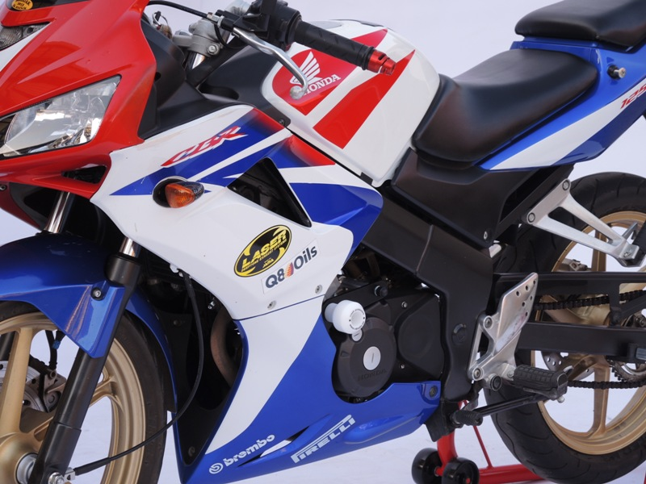
- Remove fairing from both sides.

- Dismantle original bolts from chassi.
- Place steel adapter (ID1.1) and tighten it by bolts (ID3.1).
- Place dural roller (ID2.1).
- Insert connection bar M8 (ID4). through the steel bracket, dural roller and engine.
- Use nut (ID5) and washer (ID6) for tightening.
- Place plastic cover (ID7).

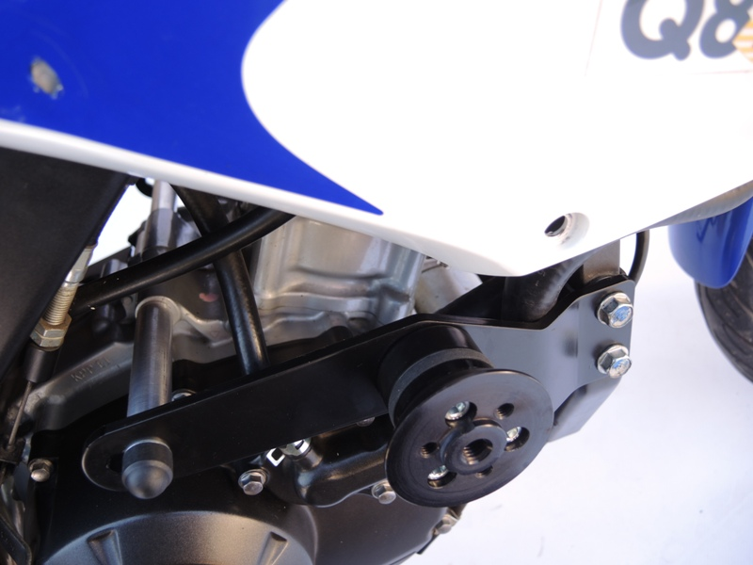
(right hand side)
Instructions for slider:

- Place slider adapter (ID10) on steel adapter with screw M10 (ID11) washer (ID17) and nut (ID18).
- Adjut axis of slider before instalation.
- Tighten screw M10 (ID11).
- Tighten slider (ID8) with 3 screws M6 (ID14).
- Insert alu cover (ID9) with 2 screws (ID15).

Right side assembly:
(almoast the same as on the left side)

There are just few diferences:
- Instead of adapter ID1.1 use ID1.2
- Instead of dural roller ID2.1 use ID2.2
- Instead of screws ID3.1 use screws ID3.2

Place fairing back the bike.

We recommande use medium strong glue for all threads during assembly.

