H34
Honda CBR125R 2011-

Kit for the left side |  |  |  |  | Kit for the right side
ID | Description | Cat.no. | pcs |  | ID | Description |  | Cat.no. | pcs
1.1 | Steel adapter - black | 507 | 1 |  | 1.1 | Steel adapter - black |  | 506 | 1
2.1 | Dural roller – 80mm | 1195 | 1 |  | 2.1 | Dural roller - 95mm |  | 1196 | 1
3.1 | Screw M8x45mm | 820 | 2 |  | 3.1 | Screw M8x25mm |  | 833 | 2
4 | Steel connection rod | 8x300x15x15 | 1 |  | 4 | - |  | - | -
5 | Nut M8 | 809 | 1 |  | 5 | Nut M8 |  | 809 | 1
6 | Washer M8 | 802 | 1 |  | 6 | Washer M8 |  | 802 | 1
7 | Nut cover M8 | X46 | 1 |  | 7 | Nut cover M8 |  | X46 | 1
8 | Screw M10x100 | 885 | 1 |  | 8 | Screw M10x100 |  | 885 | 1
9 | Steel instert | X1 | 1 |  | 9 | Steel insert |  | X1 | 1
10 | Dural roller - 60mm | 6 | 1 |  | 10 | Dural roller - 60mm |  | 6 | 1
11 | Nut M10 | 810 | 1 |  | 11 | Nut M10 |  | 810 | 1
12 | Washer M10 | 804 | 1 |  | 12 | Washer M10 |  | 804 | 1

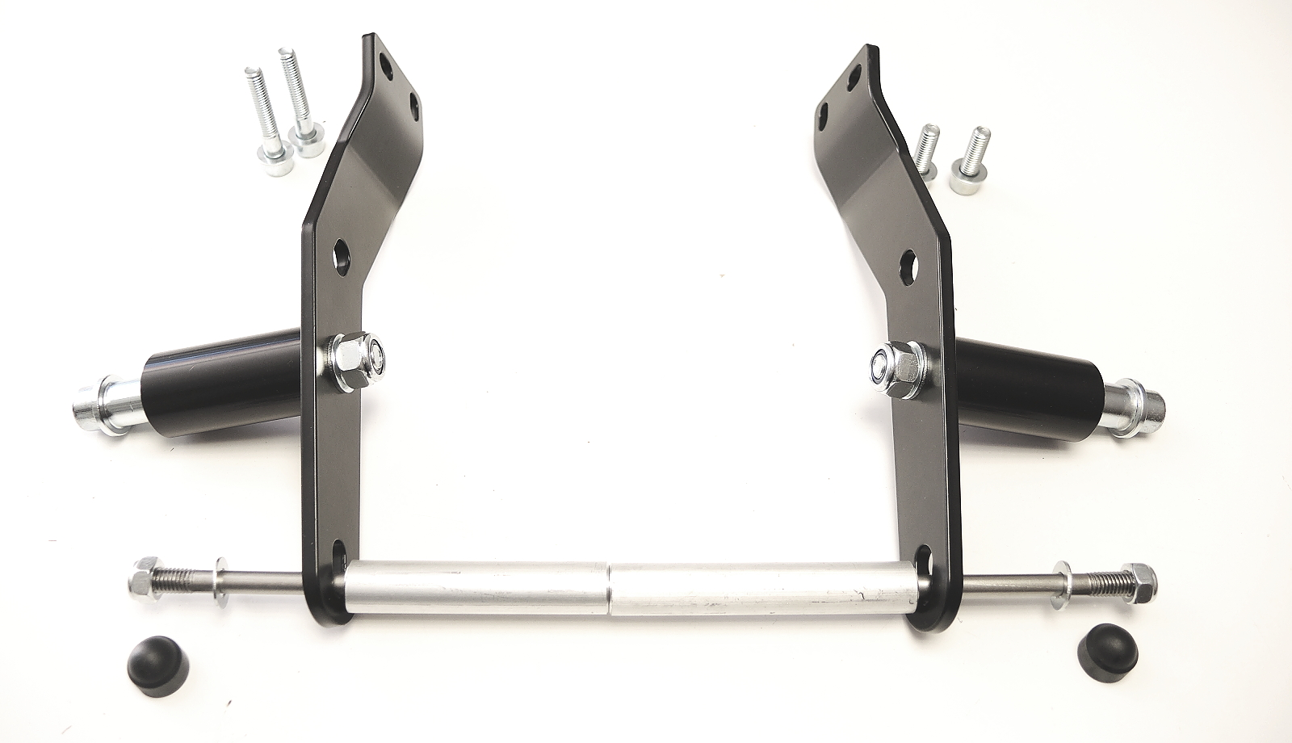
ID1.2
ID4
ID3.2
ID1.1
ID11+12
ID2.1
ID2.2
ID3.1
ID5
ID6
ID10
ID7
ID8+9

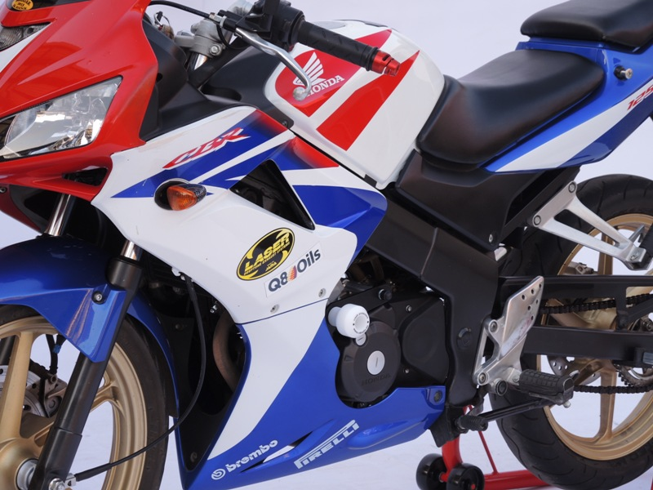
- Remove fairing from both sides.

Assembly of the left side:

- Dismantle original bolts from chassi.
- Place steel adapter (ID1.1) and tighten it by bolts (ID3.1).
- Place dural roller (ID2.1).
- Insert connection bar M8 (ID4). through the steel bracket, dural roller and engine.
- Use nut (ID5) and washer (ID6) for tightening.
- Place plastic cover (ID7).
- (ID7).

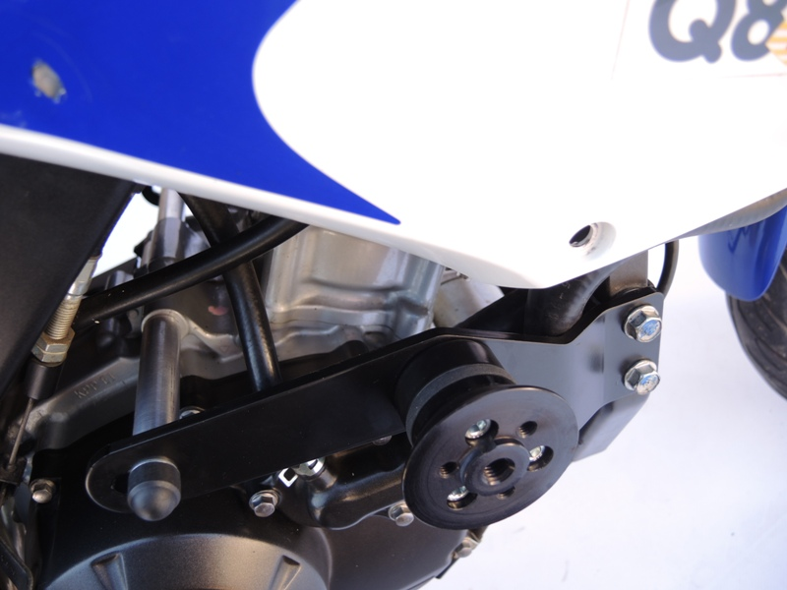
(foto z pravé strany motocyklu)
Assembly of the protector:

- Install crash protector with screw (ID8) and steel insert (ID9) through dural roller (ID10).
- Tighten it with nut (ID11) and washer (ID12).

Montáž pravá strana:
Assembly of the right side:
(almoast the same as on the left side)

There are just few diferences:
- Instead of adapter ID1.1 use ID1.2
- Instead of dural roller ID2.1 use ID2.2
- Instead of screws ID3.1 use screws ID3.2

Place fairing back the bike.

We recommande use medium strong glue for all threads during assembly.

