H35
Honda NC 700

Kit for left side: |  |  |  |  | Kit for right side:
ID. | Description | Cat.No | Qty |  |  | ID. | Description | Cat.No | Qty
1 | Steel box M12 | X2 | 1 |  |  | 1 | Steel boxM12 | X2 | 1
2 | Bolt M12x90x1,25mm | 919 | 1 |  |  | 2 | Bolt M12x80x1,25mm | 891 | 1
3 | Dural.cylinder d=40mm | 1125 | 1 |  |  | 3 | Dural.cylinder d=11mm | 17 | 1
4 | Bolt M12x75 | 807 | 1 |  |  | 4 | Dural. cylinder d=30mm | 170 | 1
5 | Bolt M10x35mm | 976 | 2 |  |  | 5 | Bolt M12x65 | 963 | 1
6 | Steel adapter | 654 | 1 |  |  | 6 | Bolt M10x35mm | 976 | 2
7 | Steel bracket | 656 | 1 |  |  | 7 | Steel adapter | 655 | 1
8 | Washer M12 | 803 | 1 |  |  | 8 | Steel bracket | 659 | 1
9 | Tape 3M |  | 1 |  |  | 9 | Washer M12 | 803 | 1
 |  |  |  |  |  | 10 | Tape 3M |  | 1

Instruction to left side:

- Dismantle fairing and original bolt from frame M12.
- Steel adapter ID.6 mount on the frame use bolt M12x90x1,25mm ID.2 and washer M12 ID.8.
- Stell bracket ID.7 mount by bolts M10x30mm ID.5. Stick on 3M tape ID.9 on frame.
- Use bolt M12x75mm ID.4 and mout crash protector. Insert steel box ID.1 into the protector under the protector put dural. cylinder d=40mm ID.3.

Instruction to right side:

- Take out coolant bottle and original bolt M12 from frame.
- Mount steel adapter ID.7 same so on the left side, but between the frame and adapter inser dural. cylinder d=11mm ID.3.
- Steel bracket with threads ID.8 put on the back side to frame and mount by bolts ID.6.
- Use bolt M12x65mm ID.5 and Mount crash protector M12 ID.1 insert steel box into the protector and under the protector insert dural. cylinder d=30mm ID.4
- Mount back coolant bottle on the bike.

Warning – use glue of all threads- medium strong.
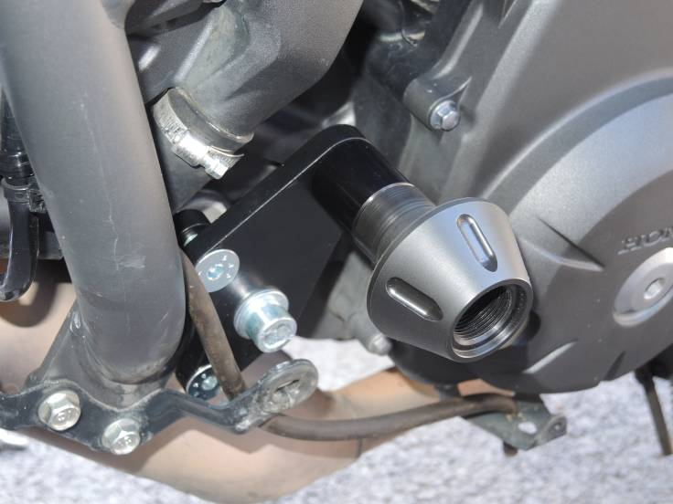
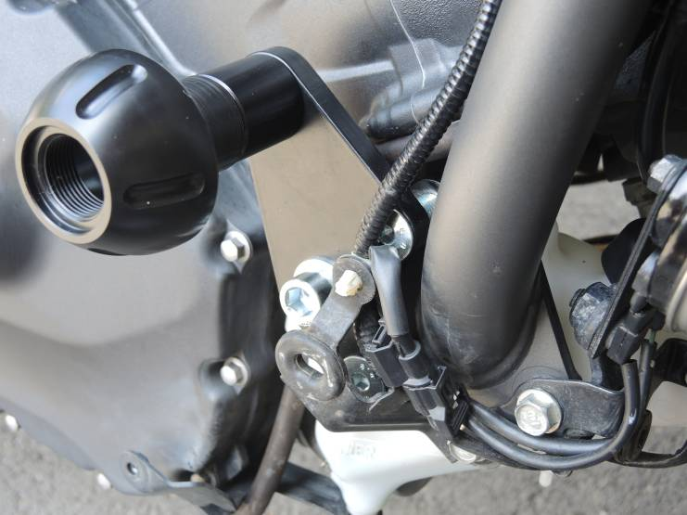

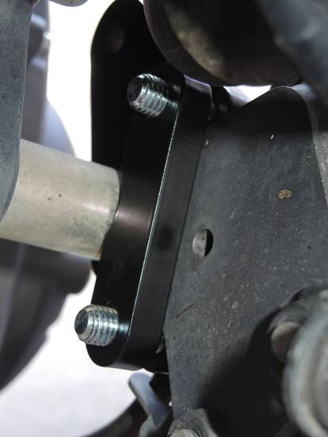

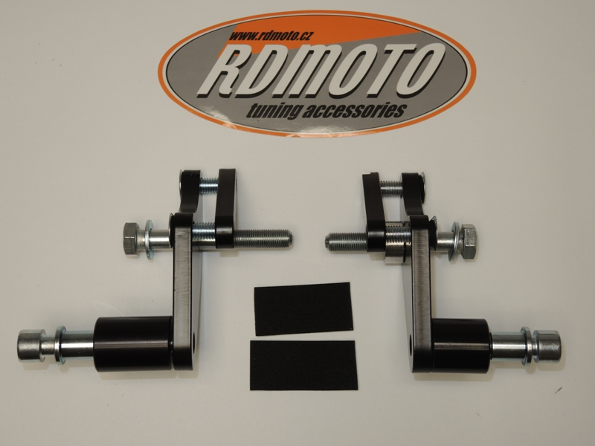
7
5
8
2
6
9,10
3
1
8
2
4
9
3
7
5
1
4

