H36SDM
Honda CBR1000RR 2012-
WITHOUT ABS

Kit for left side |  |  |  |  | Kit for right side
ID. | Description | Cat.NO | QTY |  |  | ID. | Description | Cat.NO |  | QTY
1 | Diamond | SLDM | 1 |  |  | 1 | Diamond | SLDM |  | 1
2 | Steel bracket for SLDM | 537/B | 1 |  |  | 2 | Steel bracket for SLDM | 537/B |  | 1
3 | Bolt M6x20 | 1024 | 2 |  |  | 3 | Bolt M6x20 | 1024 |  | 2
4 | Washer M6 | 1023 | 2 |  |  | 4 | Washer M6 | 1023 |  | 2
5 | Bolt M8x25mm | 832 | 1 |  |  | 5 | Bolt M8x25mm | 832 |  | 1
6 | Bolt M12x70x1,25mm | 917 | 1 |  |  | 6 | Steel adapter | 645 |  | 1
7 | Steel adapter | 644 | 1 |  |  | 7 | Dural. cylinder d=4mm | 119 |  | 1
8 | Steel bar 8x463x30x30 |  | 1 |  |  | 8 | Dural. cylinder d=50 | 13 |  | 1
9 | Dural. cylinder d=11mm | 17 | 1 |  |  | 9 | Bolt M10x70 | 851 |  | 1
10 | Bolt M10x70 | 851 | 1 |  |  | 10 | 3M tape |  |  | 1
11 | Dural. cylinder d=50mm | 13 | 1
12 | 3M tape |  | 1

Instruction to assemble:
- Take out fairings.
- Dismantle original original bolts from frame M12.
- Stick on the frame 3M tape for delimitation space between frame and bracket.
- On the left and right side on frame mounted steel bracket, right adapter (ID.6) insert into the frame and fixed by original bolt. Remind- insert dural. cylinder(ID.7).
- Left adapter (ID. 7) fixed by bolt (ID.6), insert the between the frame and adapter, dural. cylinder (ID 9).
- Between the left and right adapter insert steel bar (ID.8), this bar fixed by bolts (ID.5) for right and left side.
- Check all threads and put on the bike fairing.
- On the bolts (ID 10.-left side and ID.9 right side) put on steel bracket (ID.2) and dural. cylinder (ID.11 left side and ID.8 right side)
- This sets mounted on the steel adapters on the frames.
- By bolts (ID.3) and washers (ID.4) to assembler slider DIAMOND.
- Same process make to diferent side.

Warning – use the glue of all threads. We recommended use the medium strong.

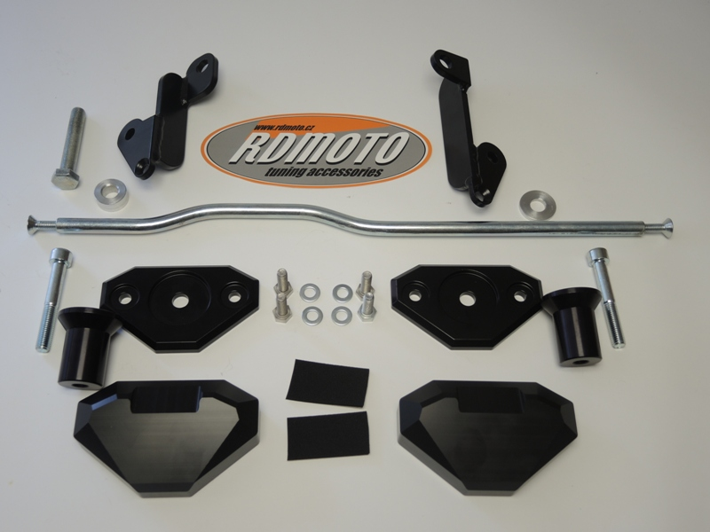
6
7

6

8
9
7
5
5

10
2
3,4
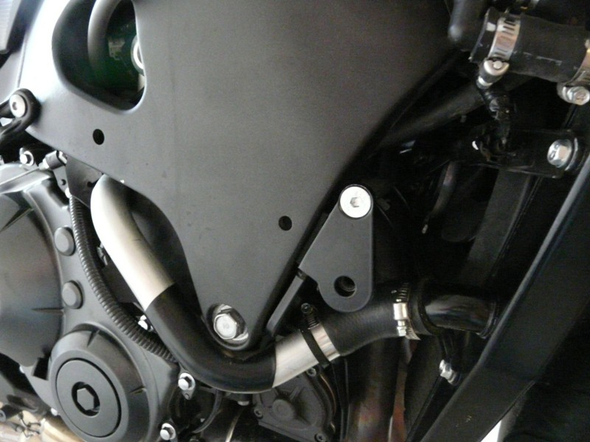
1
2
8
9
1
11

