H36S
Honda CBR1000RR 2012-
Without ABS

Kit for the left side: |  |  |  |  | Kit for the right side:
ID | Description | Cat.no. | pcs |  |  | ID | Description | Cat.no. | pcs
1 | Slider RDmoto | SL | 1 |  |  | 1 | Slider RDmoto | SL | 1
2 | Coloured cover | SLcap.. | 1 |  |  | 2 | Coloured cover | SLcap.. | 1
3 | Dural adapter | DV-339 | 1 |  |  | 3 | Dural adpater | DV-339 | 1
4 | Bolt M6x25 | 877 | 3 |  |  | 4 | Bolt M6x25 | 877 | 3
5 | Bolt M4x16 | 876 | 2 |  |  | 5 | Bolt M4x16 | 876 | 2
6 | Bolt M10x50mm | 849 | 1 |  |  | 6 | Bolt M10x50mm | 849 | 1
7 | Bolt M8x25mm | 832 | 1 |  |  | 7 | Bolt M8x25mm | 832 | 1
8 | Steel adapter | 644 | 1 |  |  | 8 | Steel adapter | 645 | 1
9 | Dural spacer d=11mm | 17 | 1 |  |  | 9 | Dural spacer d=4mm | 119 | 1
10 | Tape 3M |  | 1 |  |  | 10 | tape 3M |  | 1
11 | Washer M12 | 803 | 1
12 | Bolt M12x70x1,25mm | 917 | 1
13 | Steel rod 8x463x30x30 |  | 1

Installation:

- Remove both side fairing of motorcycle.
- Remove original M12 bolts.
- Place protective tape between frame and adapter.
- Fit steel adpaters on both sides according to the picture below. Use original bolt for tightening. Don’t forget to insert dural spacer (ID9) between adapter and frame.
- Tighten left side adapter using bolt (ID12).
- Insert steel rod (ID13) between adapters and tighten it using bolts (ID7).
- Now mount fairing back on the motorcycle.
- Installation of sliders:
  - Fit dural adapter (ID3) on the steel adapter using bolt M10(ID6).
  - Set angle of this adapter.
  - Tighten bolt M10.
  - Fit slider on slider adapter and tighten it using three bolts M6 (ID5).
  - In the end fit coloured cover into slider using two bolts M4 (ID4).
- We recommend to use the glue on all threads

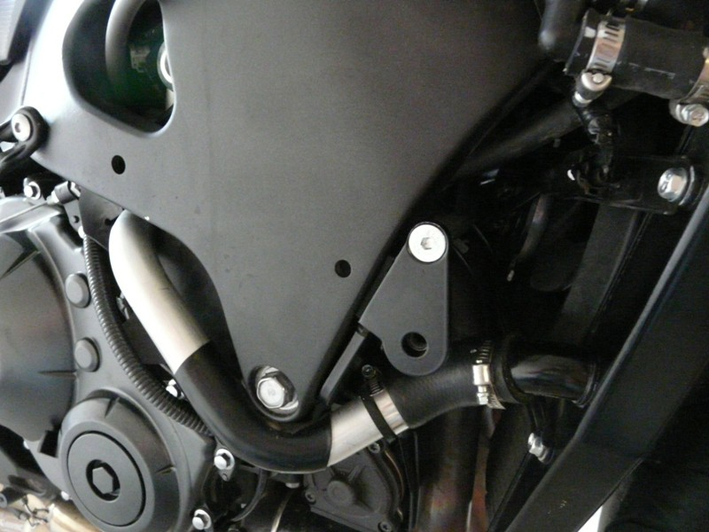
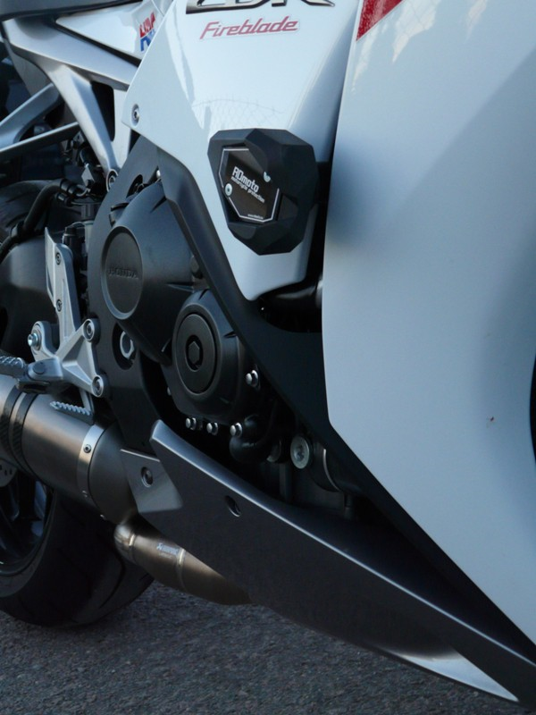

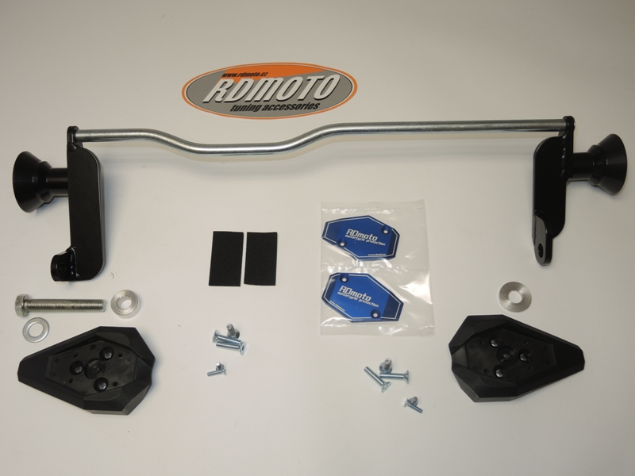
8
9
8
5
9
1
4
5
3
1
11
12
6
6
3
4
10
2
13
7
7

