H37SD
Honda Crosstourer

Mounting Kit Left Side: Mounting Kit Right Side:
ID | Description | Cat.No. | Pcs
1 | Dural. roller | 149 | 1
2 | Dural. adapter | 1124 | 1
3 | Bolt M12x160x1,25 | 949 | 1
4 | Platform SLD | 537 | 1
5 | Bolt M8x25 | 815 | 2
6 | Washer M8 | 800 | 2
ID | Description | Cat.  No. | Pcs
1 | Dural. roller | 149 | 1
2 | Dural. adapter | 1124 | 1
3 | Bolt M12x150x1,25 | 984 | 1
4 | Platform SLD | 537 | 1
5 | Bolt M8x25 | 815 | 2
6 | Washer M8 | 800 | 2

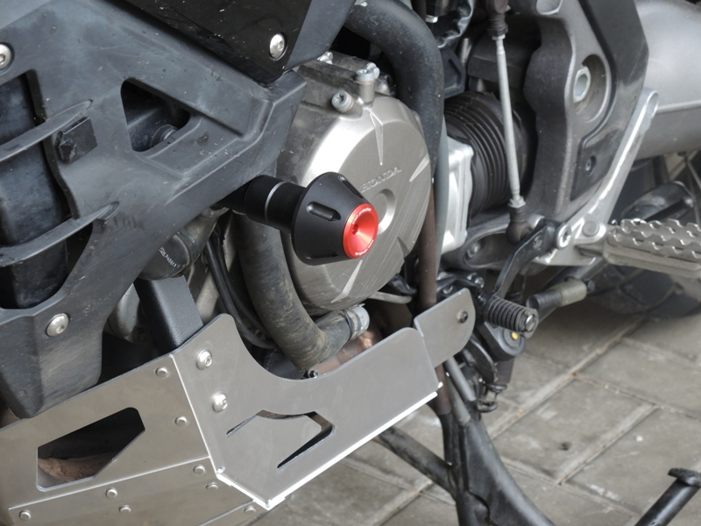
1
6
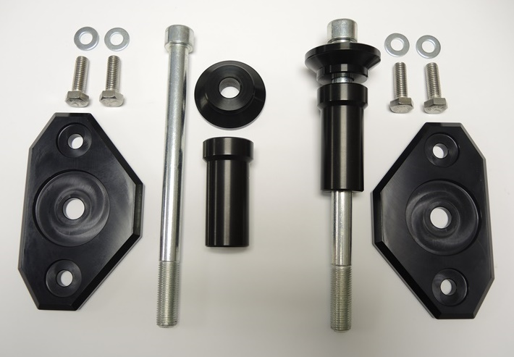
2
4
5
3

Mounting Instructions Left Side:
1
3
- Unscrew the original M12 bolt from frame.
- Put the ID.4 platform onto ID.3 bolt with ID.1 dural. roller and ID.2 dural. adapter.
- Now place this assembly in place of the original bolt.
- Finally, use ID.5 bolts and ID.6 washers to fix the slider.

Mounting Instructions Right Side:
- Unscrew the original M12 bolt from frame.
- Put the ID.4 platform onto ID.3 bolt with ID.1 dural. roller and ID.2 dural. adapter.
- Now place this assembly in place of the original bolt.
- Finally, use ID.5 bolts and ID.6 washers to fix the slider.

Note – We recommend using thread glue during assembly.

