H37S
Honda Crosstourer

Mounting Kit Left Side: Mounting Kit Right Side:
ID | Description | Cat.No. | Pcs
1 | Dural.adapter | 1137 | 1
2 | Dural.roller | 1124 | 1
3 | Bolt M12x160x1,25mm | 949 | 1
4 | Bolt M6x25mm | 877 | 3
5 | Bolt M4x16mm | 876 | 2
ID | Description | Cat.No. | Pcs
1 | Dural.adapter | 1137 | 1
2 | Dural.roller | 1124 | 1
3 | Bolt M12x145x1,25mm | 1072 | 1
4 | Bolt M6x25mm | 877 | 3
5 | Bolt M4x16mm | 876 | 2
Note – We recommend using thread glue during assembly.

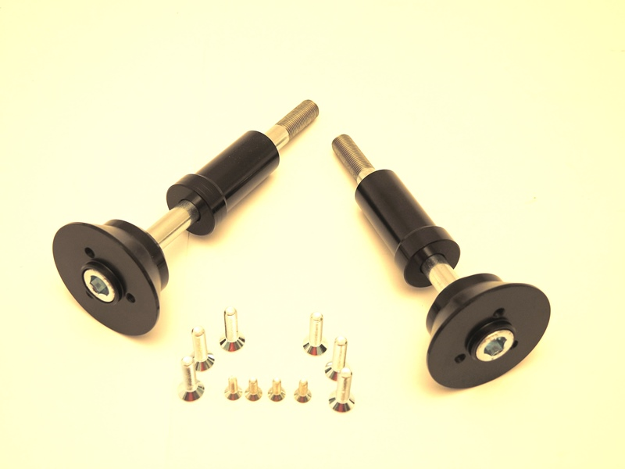
1
1
2
2
3
3
4
4
5

1
1

Mounting Instructions Left Side:

- Unscrew the original M12 bolt from frame.
- Insert screw ID.3 into duralumin adapter ID.1 and duralumin roller ID.2.
- Mount this assembly to the frame.
- Install the slider using the ID.4 screws.
- Insert the cap into the slider and tighten it with the ID.5 screws

Mounting Instructions Right Side:

- Unscrew the original M12 bolt from frame.
- Insert screw ID.3 into duralumin adapter ID.1 and duralumin roller ID.2.
- Mount this assembly to the frame.
- Install the slider using the ID.4 screws.
- Insert the cap into the slider and tighten it with the ID.5 screws

