H37
Honda Crosstourer

Fitting kit left side: Fitting kit right side:
ID | Description | Cat.N | QTY
1 | Steel box M12 | X2 | 1
2 | Dural.adapter | 1124 | 1
3 | Bolt M12x165x1,25 | 983 | 1
ID | Description | Cat.N | QTY
1 | Steel box M12 | X2 | 1
2 | Dural.adapter | 1124 | 1
3 | Bolt M12x150x1,25 | 984 | 1

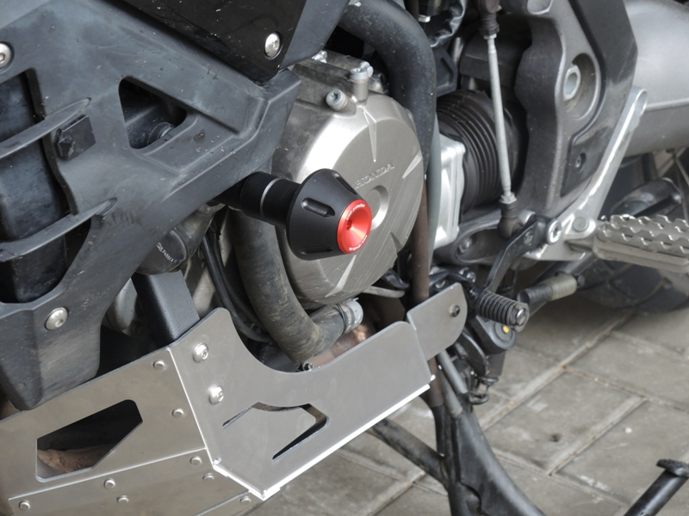
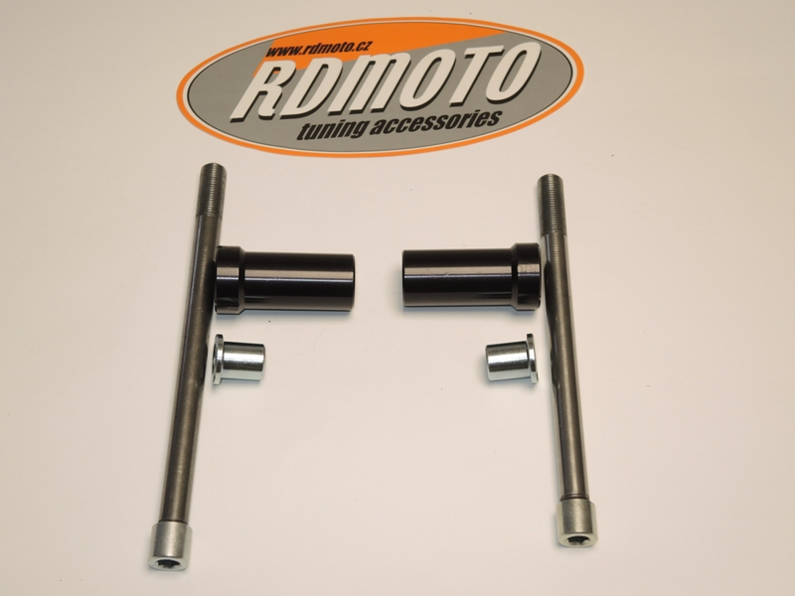
2
3
2
3
1
1

Instruction to assembly- left side:
1
3
- Dismantle original bolt M12 from frame.
- Insert steel box ID.1 into the protector.
- Take bolt ID.3 and insert it into the protector. Put dural.cylinder on the bolt.
- This kit make to assembly on the frame.

Instruction to assembly- right side:
- Dismantle original bolt M12 from frame.
- Insert steel box ID.1 into the protector.
- Take bolt ID.3 and insert it into the protector. Put dural.cylinder on the bolt.
- This kit make to assembly on the frame.

Note: we recommend to use glue on the threads

