H39S

**Honda CB500 X/ CB500 F 2013-**

|  |  |  |  |  |  |  |  |  |  |  |
| --- | --- | --- | --- | --- | --- | --- | --- | --- | --- | --- |
| **Kit for the left side:** | | | | | **Kit for the right side:** | | | | | |
|  |  |  |  |  | |  |  |  |  |  | |
| ID | Description | Cat.No. | Quant. |  | | ID | Description | Cat.No. | pcs |  | |
| 1 | Dural. adaper | 646 | 1 |  | | 1 | Dural. adaper | 647 | 1 |  | |
| 2 | Screw M10x75x1,25mm | 938 | 1 |  | | 2 | Screw M10x75x1,25mm | 938 | 1 |  | |
| 3 | Dural. roller - 20mm | 435 | 1 |  | | 3 | Dural. roller - 20mm | 435 | 1 |  | |
| 4 | Dural. adaptér pro slider-70mm | DV 315 | 1 |  | | 4 | Dural. adaptér pro slider–70mm | DV 315 | 1 |  | |
| 5 | Screw M10x55mm | 1002 | 1 |  | | 5 | Screw M10x55mm | 1002 | 1 |  | |
| 6 | Washer M10 | 804 | 1 |  | | 6 | Washer M10 | 804 | 1 |  | |
| 7 | Screw M6x25mm | 877 | 3 |  | | 7 | Screw M6x25mm | 877 | 3 |  | |
| 8 | Screw M4x16mm | 876 | 2 |  | | 8 | Screw M4x16mm | 876 | 2 |  | |
| 9 | Imbus cover | X4 | 1 |  | | 9 | Imbus cover | X4 | 1 |  | |
| 10 | Nut M10 | 810 | 1 |  | | 10 | Nut M10 | 810 | 1 |  | |

|  |  |  |  |  |  |  |  |  |  |
| --- | --- | --- | --- | --- | --- | --- | --- | --- | --- |
|  |  |  |  |  |  |  |  |  |  |
|  |  |  |  |  |  |  |  |  |  |
|  |  |  |  |  |  |  |  |  |  |

**Instruction:**

Mounting instructions for left and right side are same.

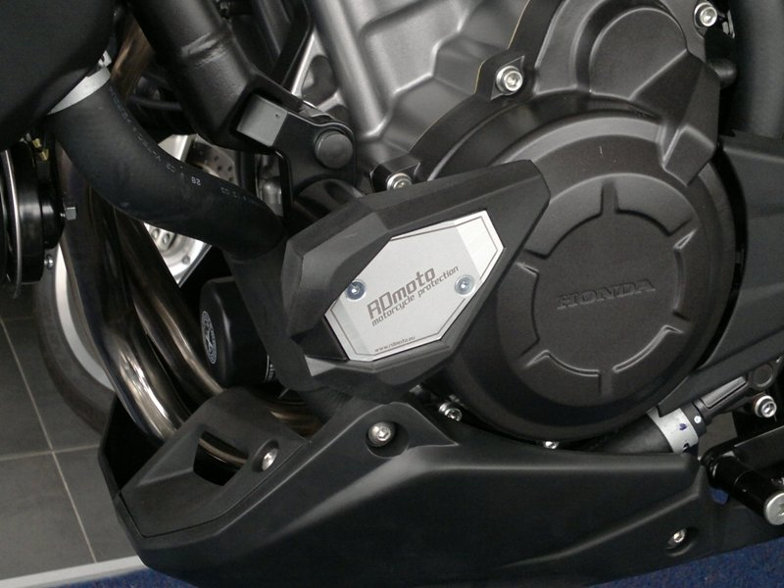

1. Remove original screw.
2. Fit drual adapter (ID1) on the frame of motorcycle using screw M10 (ID2). Insert roller (ID3) between frame and adapter.
3. Cover imbus with plastic cover.
4. Fit slider adapter (ID4) on dural adapter using screw M10 (ID5). Don’t forget to use washer (ID6).
5. Fit slider on slider adapter using three screws M6 (ID7).
6. Fit Colored cover on slider using two screws M4 (ID8).

**Warning - the threads of the screws is recommended to use premium adhesive moderate (blue color).**

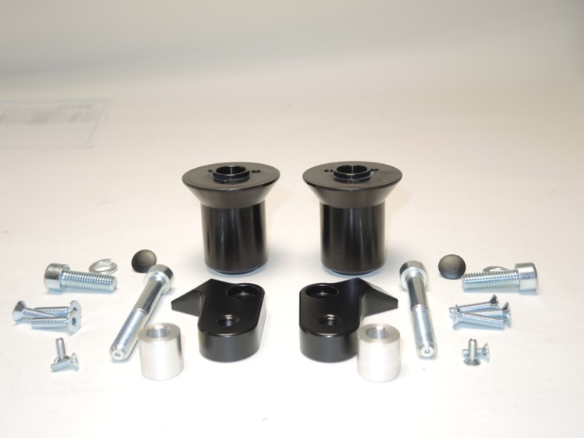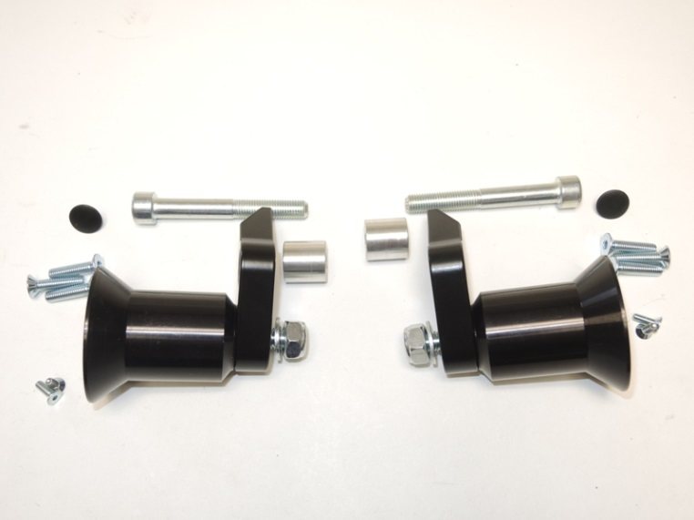**Rubber between the alloy. Adapters pull so to avoid its deformation.**