H39
Honda CB500 X/ CB500 F 2013-

Kit for left side: Kit for right side:
ID | Description | Cat.N | QTY
1 | Duralumin bracket | 646 | 1
2 | Bolt M10x75x1,25 | 938 | 1
3 | Dural. cylinder d= 20mm | 435 | 1
4 | Nut M10 | 810 | 1
5 | Washer M10 | 804 | 1
6 | Cover for imbus bolt | X4 | 1
7 | Duralumin reduction d= 40mm | DV-4 | 1
8 | Steel casing | X1 | 1
9 | Bolt M10x90 | 880 | 1
ID | Description | Cat.N | QTY
1 | Dural. bracket | 647 | 1
2 | Bolt M10x75x1,25 | 938 | 1
3 | Dural. cylinderd= 20mm | 435 | 1
4 | Nut M10 | 810 | 1
5 | Washer M10 | 804 | 1
6 | Cover for imbus bolt | X4 | 1
7 | Duralumin reduction d= 40mm | DV-4 | 1
8 | Steel casing | X1 | 1
9 | Bolt M10x90 | 880 | 1

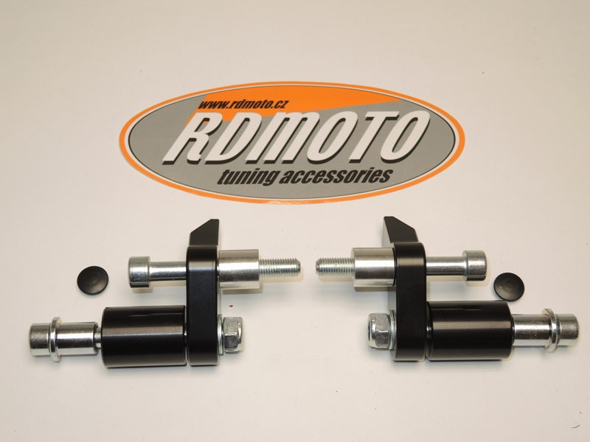

Instruction:

Mounting instruction for left and right side is same.

1. Dismantle orig. bolt from frame.
2. Dural. bracket (note 1) mounting on the frame by bolt M10 (note 2),between frame and bracket insert duralumin cylinder (note 3).
3. Put on the imbus bolt plastic cover (note 6).
4. Insert to the crash protector steel casing (note 8).
5. Throughout the crash protector and duralumin adapter (note 7) Insert the bolt M10 (note 9) and fixed it to the bracket on the frame.
6. From rear side put on the bolt washer (note 5) and nut (note 4).
7. PHV1 and PHV2 protectors mount color cover .

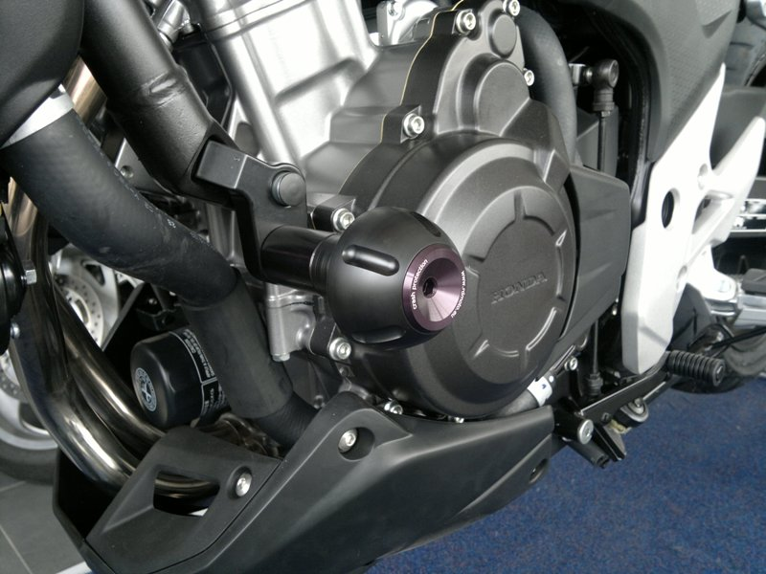

Warning - the threads of the screws is recommended to use safety glue, medium strong (blue color).

