H3SD
Honda CB900F Hornet 2002-

Kit for the left side |  |  |  |  | Kit for the right side
No. | Description | Cat.No. | Pcs |  |  | No. | Description | Cat.No. | Pcs
1 | SLD adapter | 537 | 1 |  |  | 1 | SLD adapter | 537 | 1
2 | Bolt M10x85mm | 981 | 1 |  |  | 2 | Bolt M10x85mm | 981 | 1
3 | Dural. cylinder 30mm | 3 | 1 |  |  | 3 | Dural. cylinder 30mm | 3 | 1
4 | Spring Washer M10 | 801 | 1 |  |  | 4 | Spring Washer M10 | 801 | 1
5 | Bolt M8x25 | 815 | 2 |  |  | 5 | Bolt M8x25 | 815 | 2
6 | Washer M8 | 800 | 2 |  |  | 6 | Washer M8 | 800 | 2
7 | Dural. adapter (cylinder) | 10 | 1 |  |  | 7 | Dural. adapter (cylinder) | 10 | 1
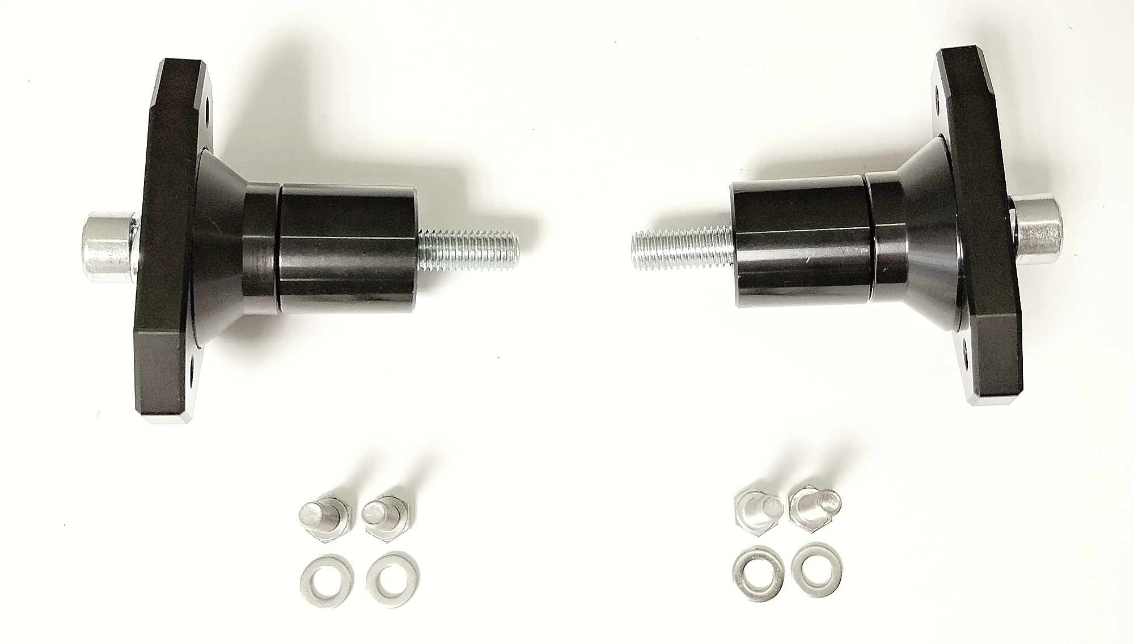

Instructions

- Unbolt original bolt from the frame of motorcycle.
- Put washer ID4, SLD adapter ID1, dural cylinder ID3 and cylinder adapter ID7 on bolt ID2.
- Mount this kit into the frame of motorcycle.
- Fit slider on the SLD adapter using two bolts ID5 and washers ID6.

We recommend to use medium strong glue on all threads.

