H40SDM
Honda CBR500R, 2013-15

Kit for left side: Kit for right side:
ID | Description | Cat.N | Qty
1 | Slider holder | 537/B | 1
2 | Alus pacer d=60 | 14 | 1
3 | Bolt M10x90 | 880 | 1
4 | Steel bracket | 660 | 1
5 | Bolts M6x35mm | 989 | 2
6 | Bolt M10x65x1,25mm | 945 | 1
7 | Washer M10 | 804 | 2
8 | AL cylinder d=19,5mm | 1121 | 1
9 | Nut M10 | 810 | 1
10 | Bolt M6x20 | 1024 | 2
11 | Washer M6 | 1023 | 2
ID | Description | Cat.N | Qty
1 | Slider holder | 537/B | 1
2 | Alu spacer d=70 | 15 | 1
3 | Bolt M10x95 | 822 | 1
4 | Steel bracket | 661 | 1
5 | Bolts M6x35mm | 989 | 2
6 | Bolt M10x100x1,25mm | 892 | 1
7 | Washer M10 | 804 | 2
8 | AL cylinder d=32 | 1120 | 1
9 | Nut M10 | 810 | 1
10 | Bolt M6x20 | 1024 | 2
11 | Washer M6 | 1023 | 2
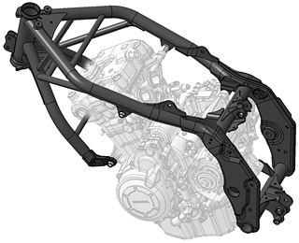
Instruction to assembly left side:
- Take out fairing from moto.
- Dismantle bolts (more on picture).
- On the engine mount steel bracket ID.5 use bolts ID.5.
- Insert AL cylinder ID.8 between the bracket and frame. Use bolt M10x65 and washer ID.7 a ID.6.
- Put fairing back tbe bike.
- Insert steel slider bracket ID.1 on the bolt ID.3 under the bracket place alu spacer ID.2. This kit assembly into the steel holder. From back side place washer and nut M10.
- Tighten slider by bolts ID.10 and washers ID.11.

Instruction to assembly right side:
- It is same process so the left side.
- Warning, the diameter for bolts and dural cylinder is oferent. Bolt is M10x100x1,25

Warning:
Use the glue of all threads, medimum strong.

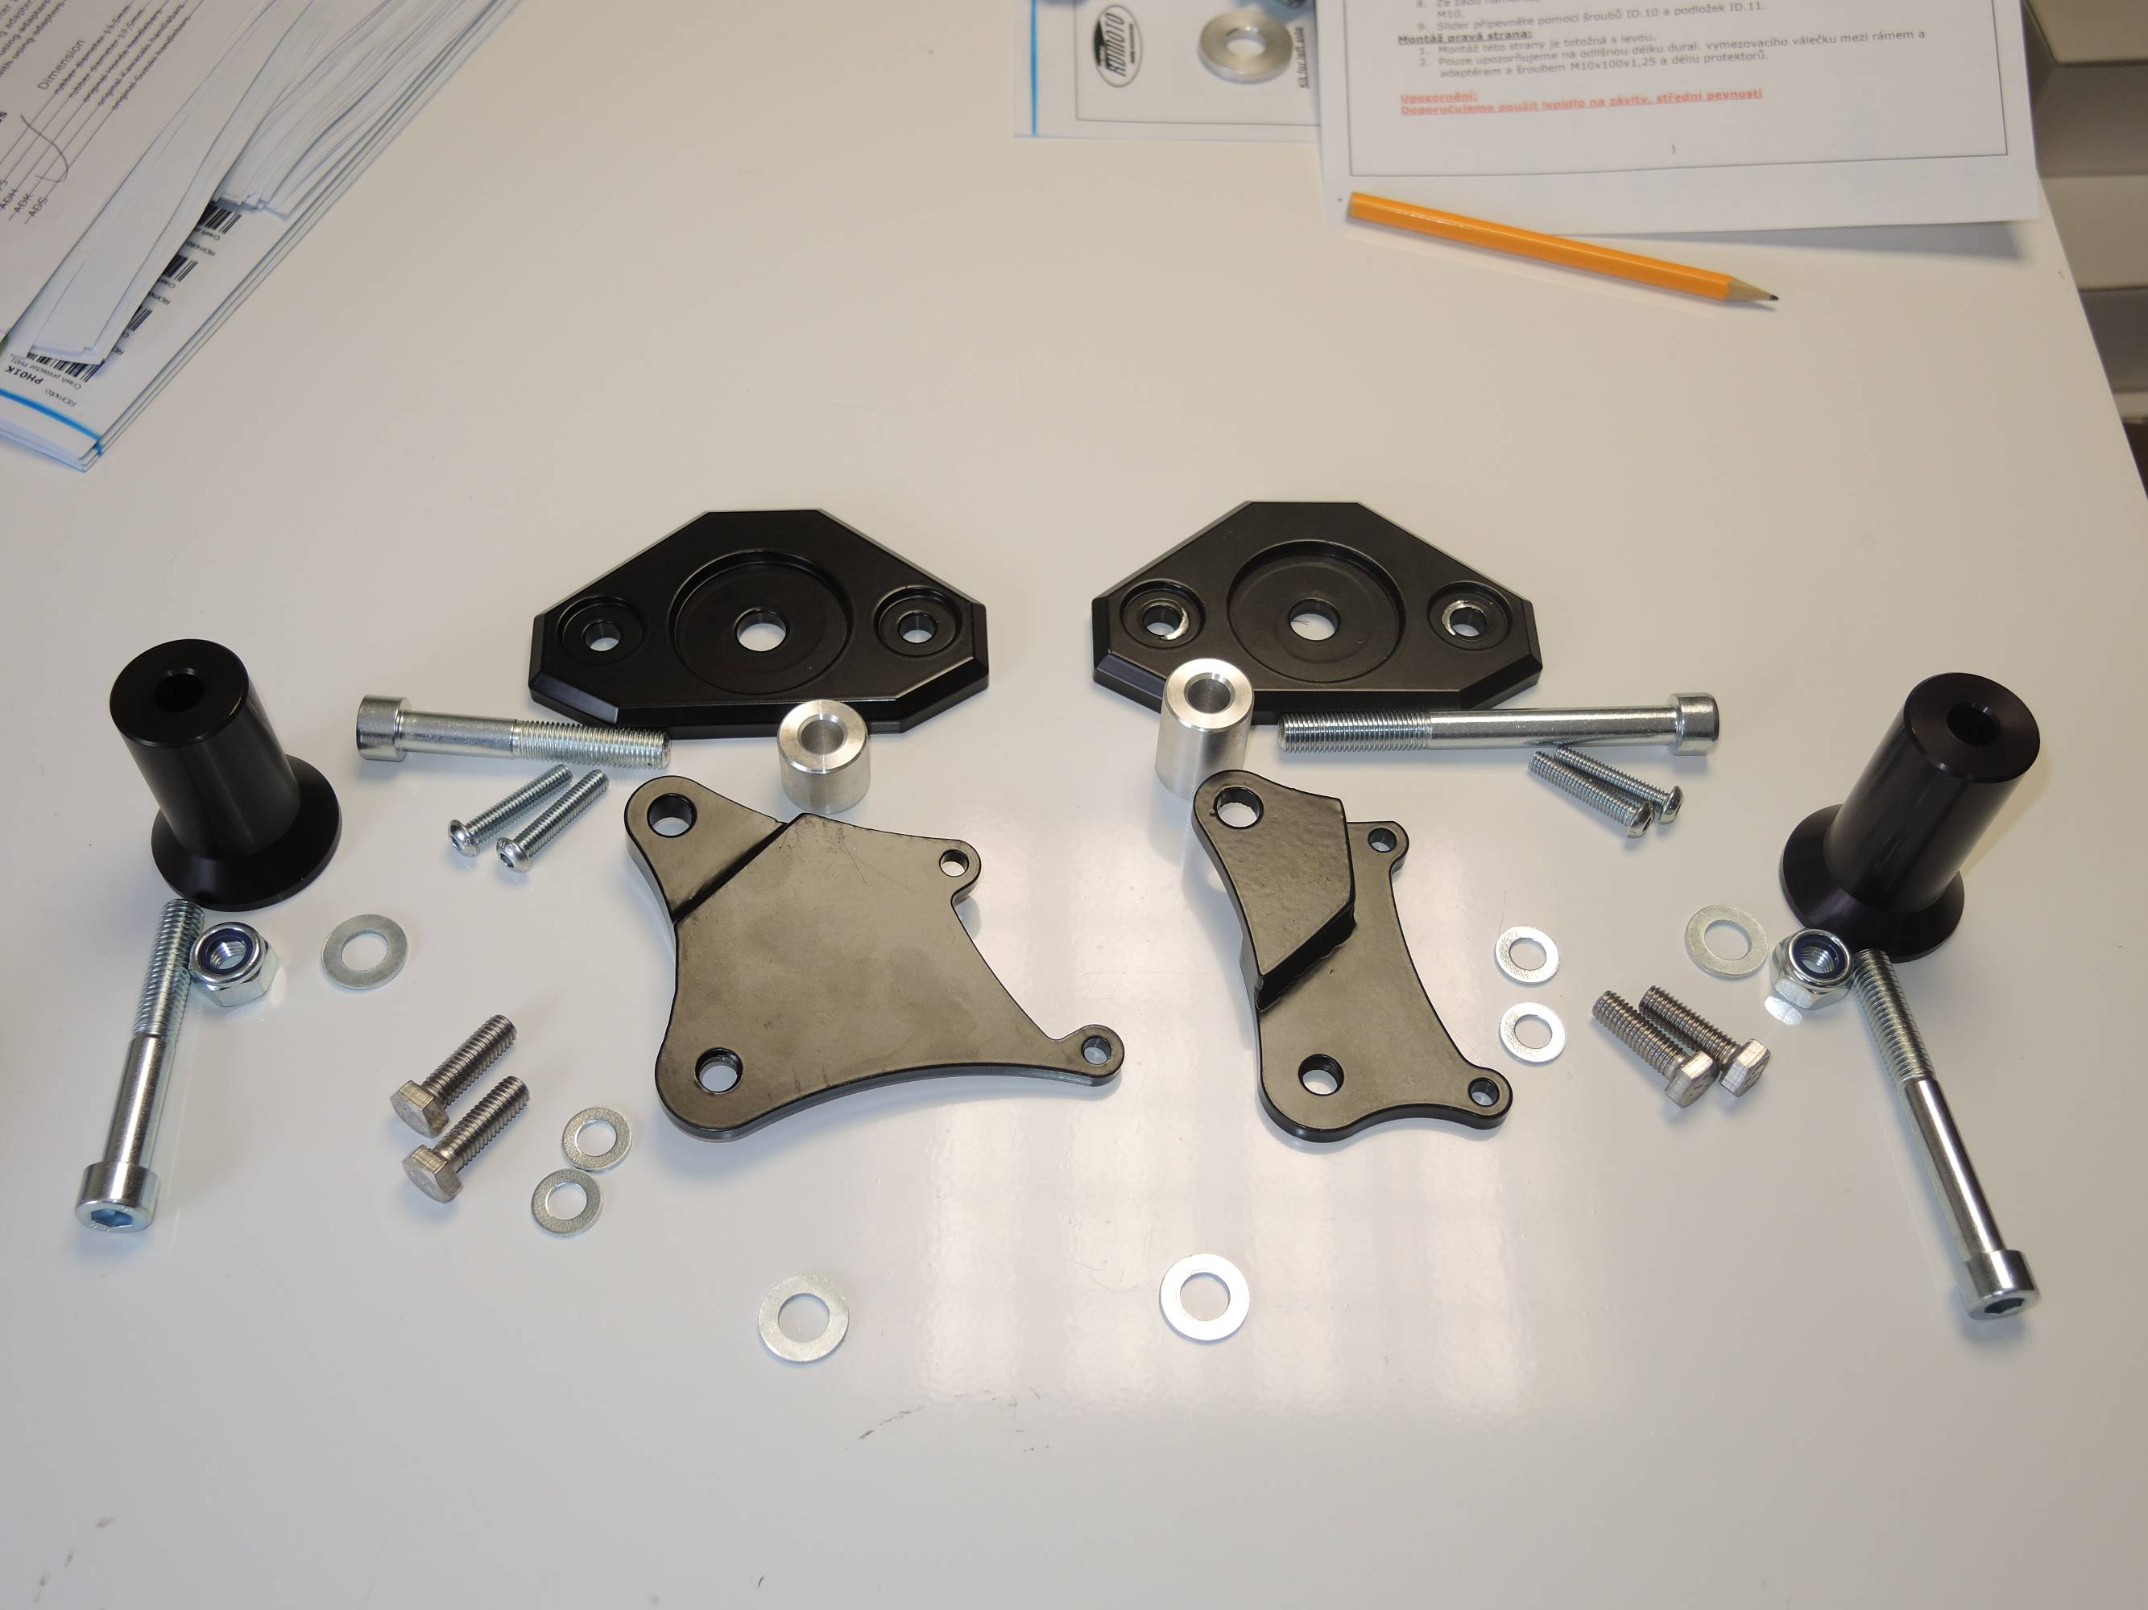
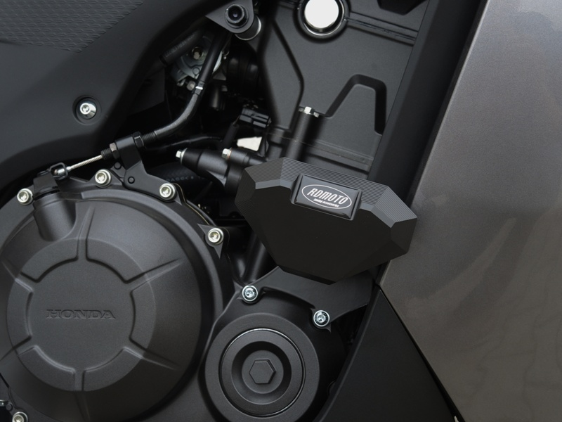
2
3
2
4
3
1
5
6
10
1
5
10
4
8
8

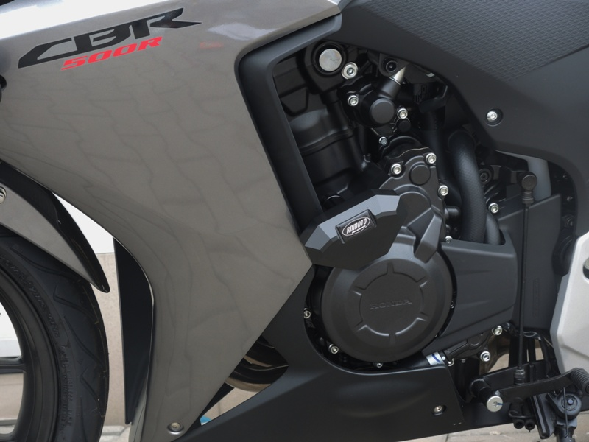
3

