H40S
Honda CBR500R, 2013-15

Kit for the left side: Kit for the right side:
ID | Description | Cat.no | pcs
1 | Dural roller - 90mm | 4 | 1
2 | Dural adapter | 317 | 1
3 | Screw M10x70 | 851 | 1
4 | Steel protector holder | 660 | 1
5 | Screws M6x35mm | 989 | 2
6 | Screw M10x65x1.25mm | 945 | 1
7 | Insert M10 | 804 | 2
8 | ALU roller d=19,5mm | 1121 | 1
9 | Nut M10 | 810 | 1
10 | Screw M6x25 | 877 | 3
11 | Screw M4x16 | 876 | 2
ID | Description | Cat.no | pcs
1 | Dural roller – 40mm | 4 | 1
2 | Dural adapter | 317 | 1
3 | Screw M10x70 | 851 | 1
4 | Steel protector holder | 661 | 1
5 | Screws M6x35mm | 989 | 2
6 | Screw M10x100x1.25mm | 892 | 1
7 | Insert M10 | 804 | 2
8 | ALU roller d=32mm | 1120 | 1
9 | Nut M10 | 810 | 1
10 | Screw M6x25 | 877 | 3
11 | Screw M4x16 | 876 | 2
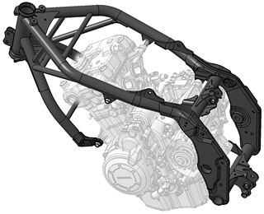
Installation (left side):
- Remove fairing from motorcycle.
- Remove original screws according to the picture.
- Attach steel adapter ID.4 using screws ID.5.
- Between frame and steel adapter insert aluminium roller ID.8. Tighten adapter using screw M10x65 and insert (ID.7 and ID.6).
- Place adapter ID2 on screw ID3 and place also durall roller ID1 under adapter.
- This set attach on steel adapter on motorcycle.
- Fit nut and insert M10 from the backside.
- Fit slider with screws ID10 and isert cover.
- Tighten colored cover using screws ID11.
Installation (right side:
Almost the same as on the left except one diference:
- Dimensions of dural roller and screw M10x100x1.25.

We recommend: use the glue on all threads (medium strong).
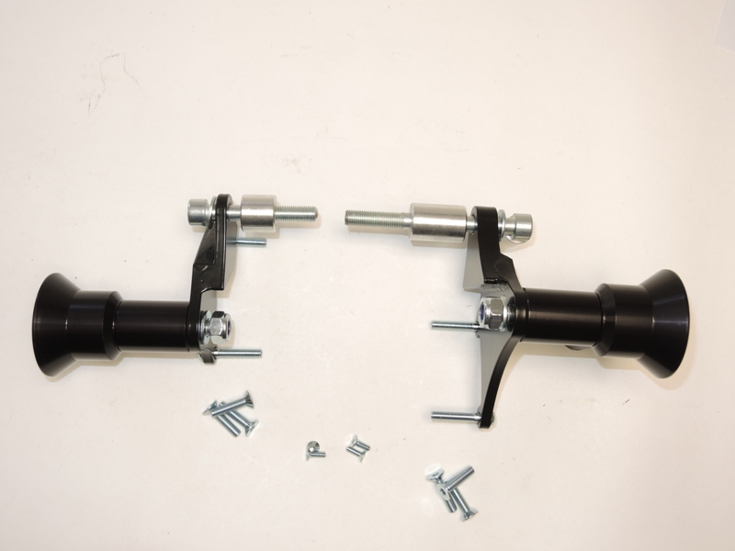
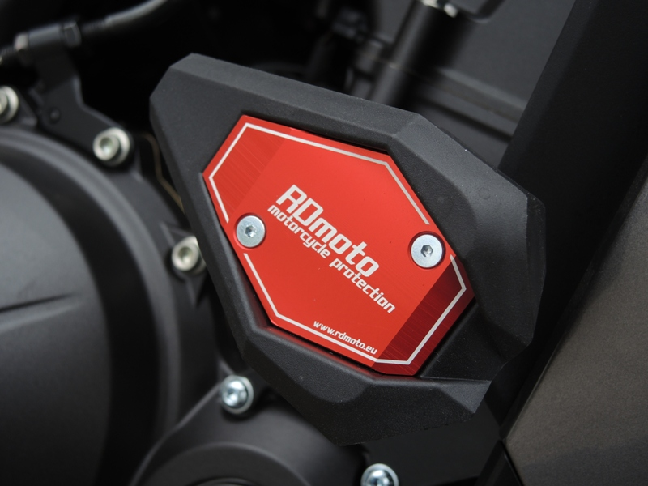
3,9,7
2
3,9,7
1
5
11
10
6
7
1
5
4
8
6
2
5
5
8
10
11
2
4

