H40
Honda CBR500R, 2013-15

Kit for left side: Kit for right side:
ID | Description | Cat.N | Qty
1 | Steel box | X1 | 1
2 | Dural.cylinder d=50mm | 5 | 1
3 | Bolt M10x95mm | 822 | 1
4 | Steel bracket | 660 | 1
5 | Bolts M6x35mm | 989 | 2
6 | Bolt M10x65x1,25mm | 945 | 1
7 | Washer M10 | 804 | 2
8 | AL cylinder d=19,5mm | 1121 | 1
9 | Nut M10 | 810 | 1
ID | Description | Cat.N | Qty
1 | Steel box | X1 | 1
2 | Dural.cylinder d=50mm | 5 | 1
3 | Bolt M10x95mm | 822 | 1
4 | Steel bracket | 661 | 1
5 | Bolts M6x35mm | 989 | 2
6 | Bolt M10x100x1,25mm | 892 | 1
7 | Washer M10 | 804 | 2
8 | AL cylinder d=32 | 1120 | 1
9 | Nut M10 | 810 | 1
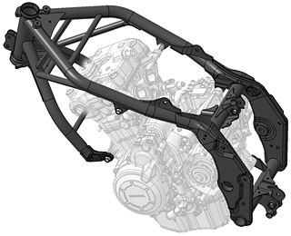
Instruction to assembly left side:
- Take out fairing from moto.
- Dismantle bolts (more on picture).
- On the engine mount steel bracket ID.5 use bolts ID.5.
- Insert AL cylinder ID.8 between the bracket and frame. Use bolt M10x65 and washer ID.7 a ID.6.
- Into the protektor insert steel box ID.1
- Use bolt M10x95 ID.3 and insert dural.cylinder d=50mm between the protektor and bracket.

Instruction to assembly right side:
- It is same process so the left side.
- Warning, the diameter for bolts and dural cylinder is oferent. Bolt is M10x100x1,25

After this assembly, mount the fairing on the bike.

Warning:
Use the glue of all threads, medimum strong.

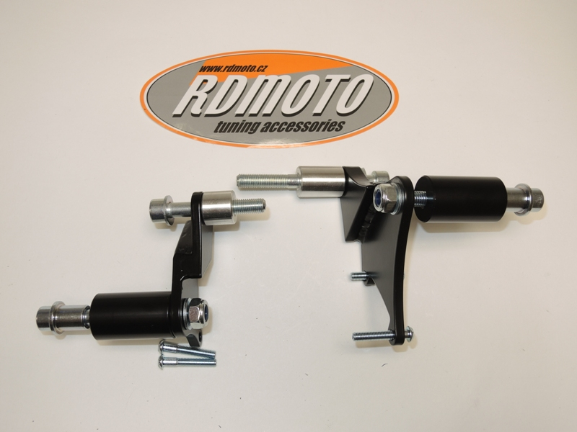

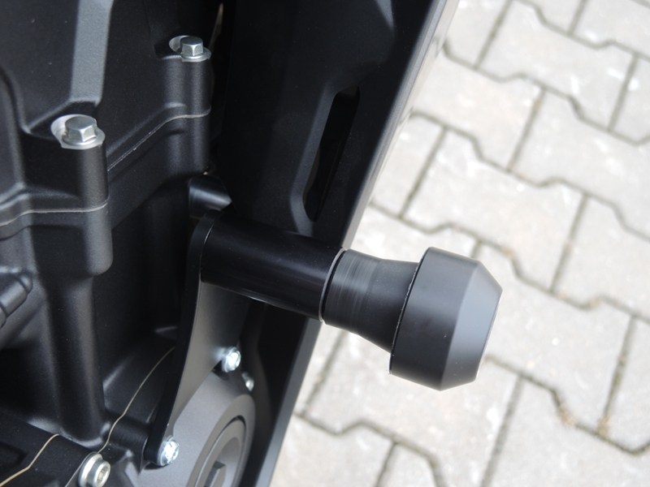
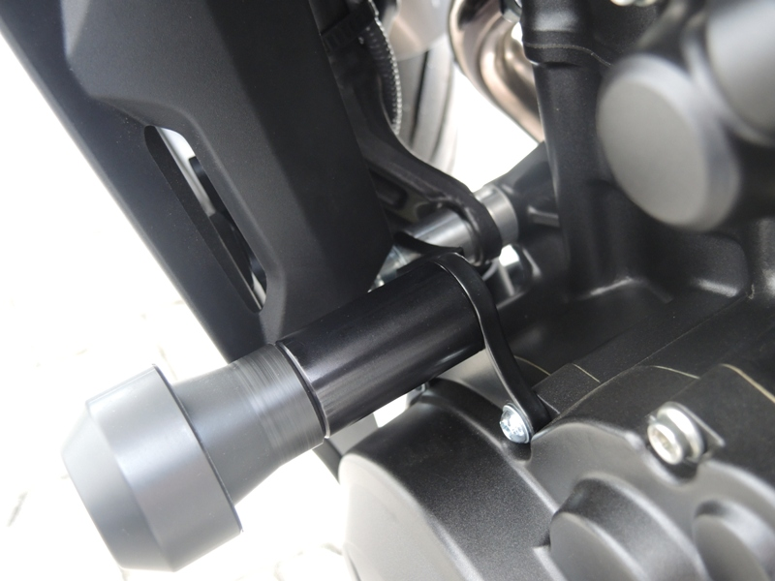
2
4
3

