H41S
Honda CBR 600RR-´14

Fitting kit left side: Fitting kit right side:
ID | Description | Cat.n | Qt
2 | Dural.adapter | DV317 | 1
3 | Dural. spacer | 1122 | 1
4 | Bolt M10x50 | 849 | 1
5 | Steel adapt. | 668 | 1
6 | Washer M12 | 803 | 1
7 | Bolt M12x80x1,25 | 891 | 1
8 | Alu.spacer | 1123 | 1
9 | 3M Tape | 3M | 2
10 | Bolt M6x25 | 877 | 3
11 | Bolt M4x16 | 876 | 2
ID | Popis | Kat.č. | Ks
2 | Dural.adapter | DV317 | 1
3 | Dural. spacer | 1122 | 1
4 | Bolt M10x50 | 849 | 1
5 | Steel adapter | 669 | 1
6 | Washer M12 | 803 | 1
7 | Bolt M12x80x1,25 | 891 | 1
8 | Alu. spacer | 1123 | 1
9 | 3M Tape | 3M | 2
10 | Bolt M6x25 | 877 | 3
11 | Bolt M4x16 | 876 | 2

Fitting instruction:
- Dismantle lower fairing from your Honda.
- Start to assembly left side first and after this done right side. Process is same.
- Take off oringal bolt M12 from frame.
- Stick 3M tape on the frame ID.9, mounting steel adapter ID.5 from out of frame. Insert alu spacer ID.8 Tighten it by bolt ID.7 and washer ID.6.
- Make same process on the right side.
- Put fairing back the bike.
- Insert bolt ID.4 into the dural.adapter ID.2. Place spacer ID.3. This kit mount on the steel adapter.By bolts ID.10 mount slider,place cover ant use bolts ID.11.

Note: During installation, we recommend using glue on the threads.

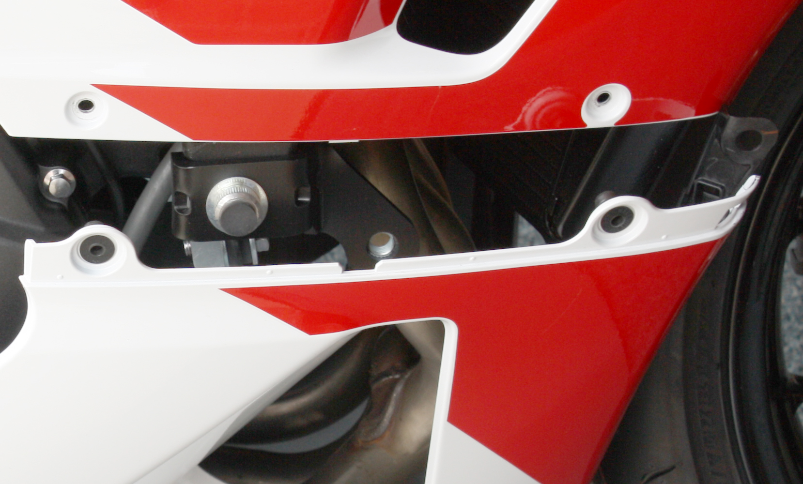
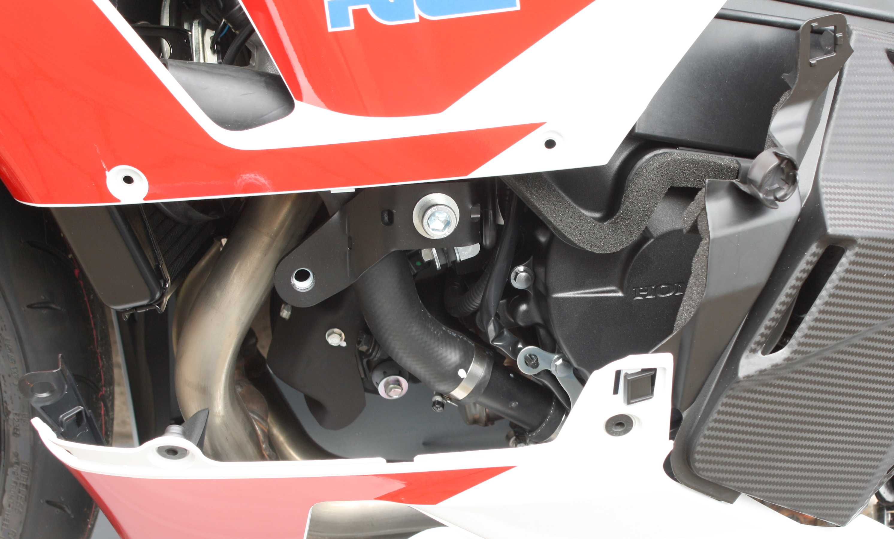
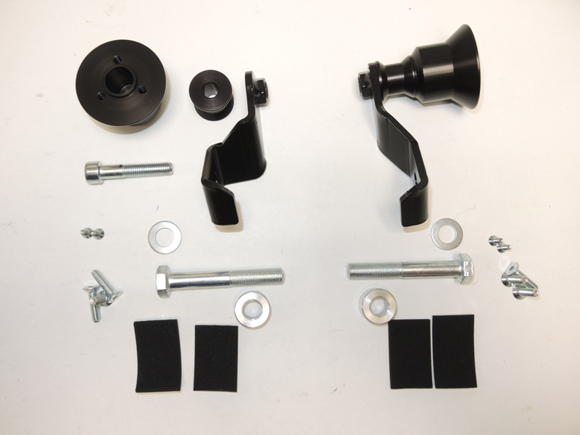
13
12
11
10
9
8
7
6
5
4
3
2
2
10
11
3
4
5
6
7

