H42SDM
Honda CB1100 2013-

Fitting kit left side: Fitting kit right side:
ID | Description | Cat.n | QTY
1 | Dural. adapter | 676 | 1
2 | Bolt M10x110 | 879 | 2
3 | Washer M10 | 804 | 3
4 | Nut M10 | 810 | 2
5 | Plastic´s cover | X4 | 2
6 | Dural.bracket for SLD | 537/B | 1
7 | Dural.cylinder d=70 | - | 1
8 | Bolt M12x100 | 986 | 1
9 | Bolt M6x20 | 1024 | 2
10 | Washer M6 | 1023 | 2
11 | Dural.cylinder d=14,5 | 1160 | 2
ID | Description | Cat.n | QTY
1 | Dural. adapter | 677 | 1
2 | Bolt M10x110 | 879 | 2
3 | Washer M10 | 804 | 3
4 | Nut M10 | 810 | 2
5 | Plastic´s cover | X4 | 2
6 | Dural.bracket for SLD | 537/B | 1
7 | Dural.cylinder d=50 | 208 | 1
8 | Bolt M12x80 | 956 | 1
9 | Bolt M6x20 | 1024 | 2
10 | Washer M6 | 1023 | 2

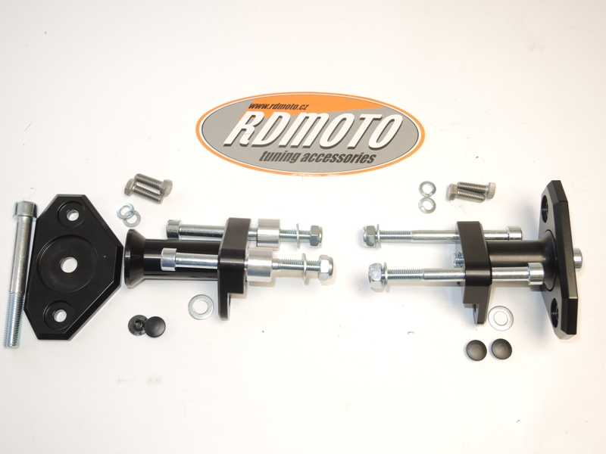
3
5
6
1
2
1
7
3
5
2
2
2
3
3
3
3
3
4
7
6
4
9,10
8
9,10
11
8
Instruction to assembly-left side:
- Take out orignal bolts from frame and engine.
- Insert bolts ID.2 into the duralumin adapter ID.1. Under the adper insert dural.cylinders ID.11. This set mounting on frame. Thighten it by nuts ID.4 and washers ID.3.
- Take orignial bolt from engine M10, insert washer ID.3 on this bolt and make assebly.
- Put plastic covers into the bolts (see photo).
- Insert dural.bracket ID.6 together with dural.cylinder ID.7 on the bolt ID.8.
- This kit mounting on dural. adapter.
- For fixing slider use bolts with washers ID.10 and ID.9.

Instruction to assembly-right side:

- Take out orignal bolts from frame and engine.
- Insert bolts ID.2 into the duralumin adapter ID.1. This set mounting on frame. Thighten it by nuts ID.4 and washers ID.3.
- Take orignial bolt from engine M10, insert washer ID.3 on this bolt and make assebly.
- Put plastic covers into the bolts (see photo).
- Insert dural.bracket ID.6 together with dural.cylinder ID.7 on the bolt ID.8.
- This kit mounting on dural. adapter.
- For fixing slider use bolts with washers ID.10 and ID.9.

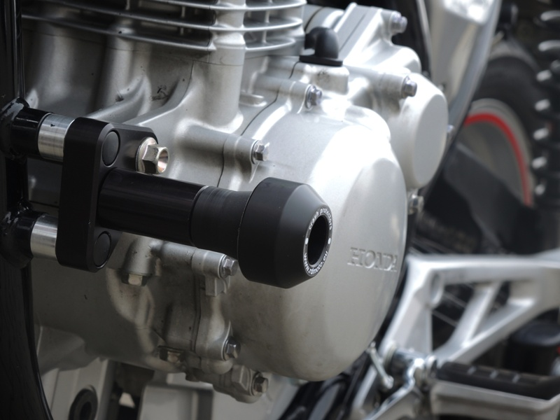
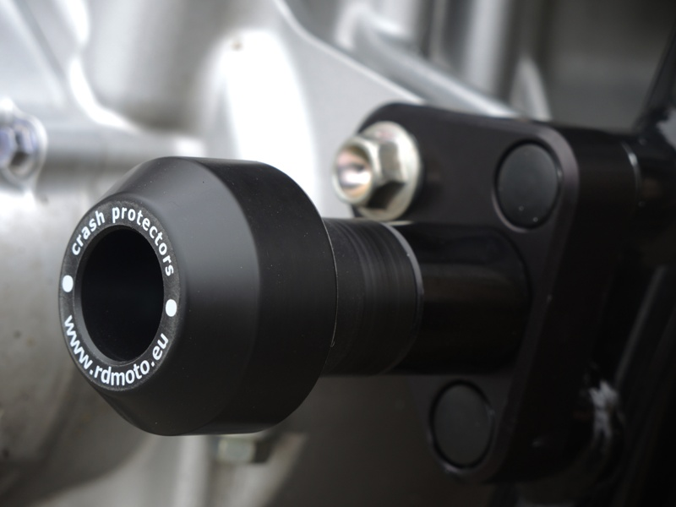
Warning: We recommend use the glue of all threads. Medium strong.
Illustration photos, only for plac for gripping duralumin adapters.

