H42
Honda CB1100 2013-

Fitting kit left side: Fitting kit right side:
ID | Description | Cat.n | QTY
1 | Dural. adapter | 676 | 1
2 | Bolt M10x110 | 879 | 2
3 | Washer M10 | 804 | 3
4 | Nut M10 | 810 | 2
5 | Plastic´s cover | X4 | 2
6 | Steel box | X2 | 1
7 | Dural.cylinder d=50 | 209 | 1
8 | Bolt M12x90 | 808 | 1
9 | Dural.cylinder d=14,5 | 1160 | 2
ID | Description | Cat.n | QTY
1 | Dural. adapter | 677 | 1
2 | Bolt M10x110 | 879 | 2
3 | Washer M10 | 804 | 3
4 | Nut M10 | 810 | 2
5 | Plastic´s cover | X4 | 2
6 | Steel box | X2 | 1
7 | Dural.cylinder d=30 | 170 | 1
8 | Bolt M12x70 | 977 | 1

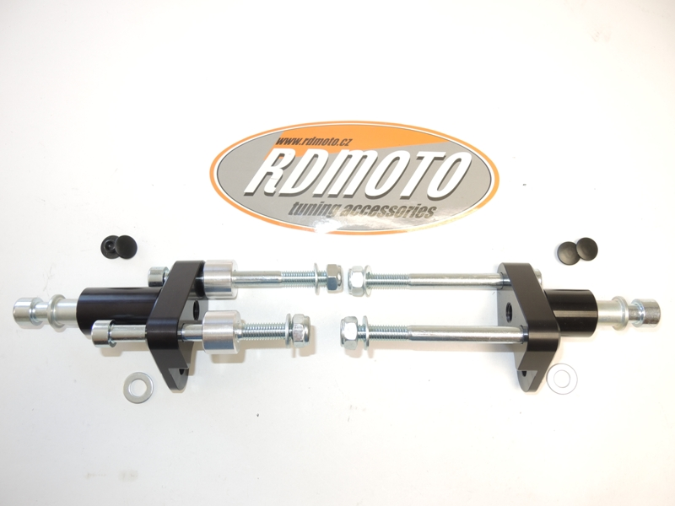
3
5
6
1
6
1
7
3
5
2
2
3
3
3
3
4
7
4
8
9
8
2
2

Instruction to assembly-left side:
- Take out orignal bolts from frame and engine.
- Insert bolts ID.2 into the duralumin adapter ID.1. Under the adper insert dural.cylinders ID.9. This set mounting on frame. Thighten it by nuts ID.4 and washers ID.3.
- Take orignial bolt from engine M10, insert washer ID.3 on this bolt and make assebly.
- Put plastic covers into the bolts (see photo).
- Insert steel box ID.6 into the protector with bolt ID.8.
- This kit mounting on dural. adapter.

Instruction to assembly-right side:

- Take out orignal bolts from frame and engine.
- Insert bolts ID.2 into the duralumin adapter ID.1. This set mounting on frame. Thighten it by nuts ID.4 and washers ID.3.
- Take orignial bolt from engine M10, insert washer ID.3 on this bolt and make assebly.
- Put plastic covers into the bolts (see photo).
- Insert steel box ID.6 into the protector with bolt ID.8.
- This kit mounting on dural. adapter.

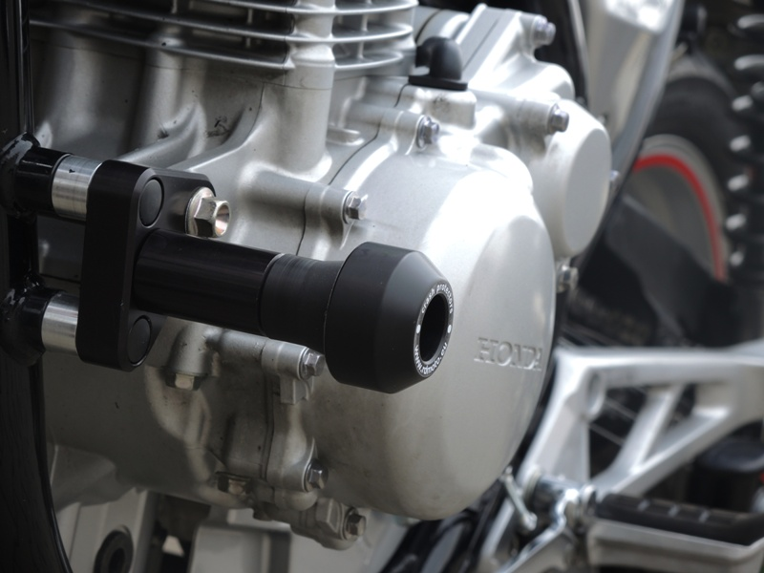
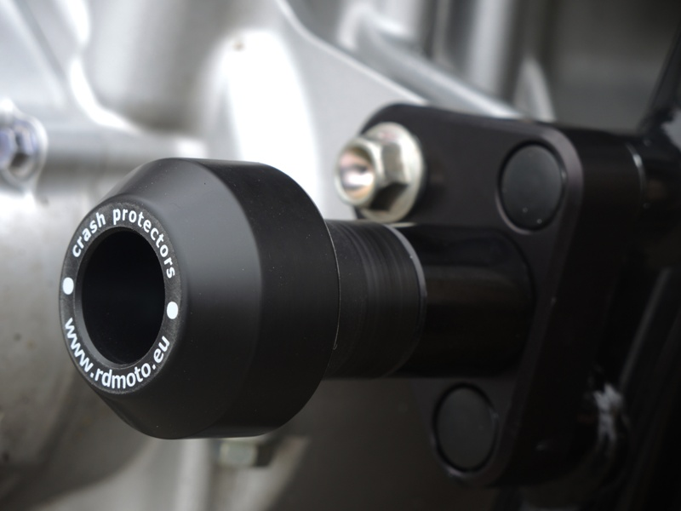
Warning: We recommend use the glue of all threads. Medium strong.

