H43SD
Honda CBR650F 2014-

Left side mounting kit: Right side mounting kit:
ID | Descritpion | Cat.no | Pcs
1 | Steel adapter | 674 | 1
2 | Dural. cylinder 20mm | 1152 | 1
3 | Dural. cylinder 28mm | 1151 | 1
4 | Bolt M10x65x1,25 | 945 | 1
5 | Washer M10 | 804 | 1
6 | Dural. adapter 20mm | 10 | 1
7 | Dural adapter for SLD | 537 | 1
8 | Bolt M10x60 | 850 | 1
9 | Bolt M8x25 | 815 | 2
10 | Washer M8 | 800 | 2
ID | Description | Cat.no | Pcs
1 | Steel adapter | 675 | 1
2 | Dural. cylinder 28 mm | 1151 | 1
3 | Bolt M10x65x1,25 | 945 | 1
4 | Washer M10 | 804 | 1
5 | Dural. adapter 20mm | 10 | 1
6 | Dural adapter for SLD | 537 | 1
7 | Bolt M12x50x1,25 | 990 | 1
8 | Bolt M10x40 | 854 | 1
9 | Bolt M8x25 | 815 | 2
10 | Washer M8 | 800 | 2
Left side instructions:
- Remove original bolt M10 and M12 from the frame of motorcycle.
- Fit steel adapter on the frame. Use original bolt and cylinder ID2 for front thread. Use Bolt ID4 and washer ID5 and cylinder ID3 for rear thread.
- Using bolt ID8 mount dural adapter ID6 and dural adapter for SLD ID7 on the steel adapter.
- Fit slider using two M8 bolts and washers.

Left side instructions:
- Remove original bolt M10 and M12 from the frame of motorcycle.
- Fit steel adapter on the frame. Use M12 bolt (ID7) for front thread. Use Bolt ID3 and washer ID4 and cylinder ID2 for rear thread.
- Using bolt ID8 mount dural adapter ID5 and dural adapter for SLD ID6 on the steel adapter.
- Fit slider using two M8 bolts and washers.

We recommend to use the glue on all threads (medium strong).

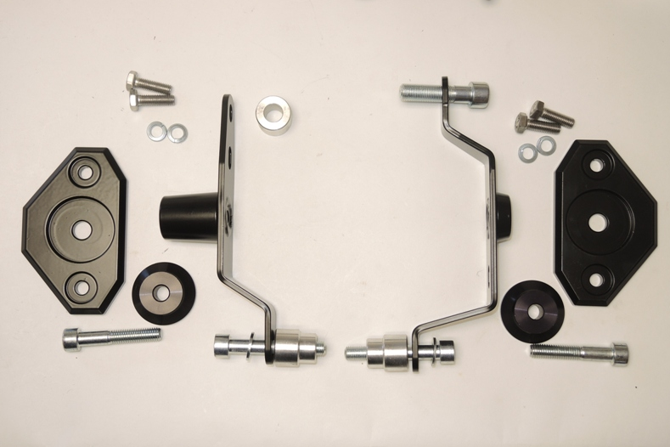
9,10
7
2
9,10

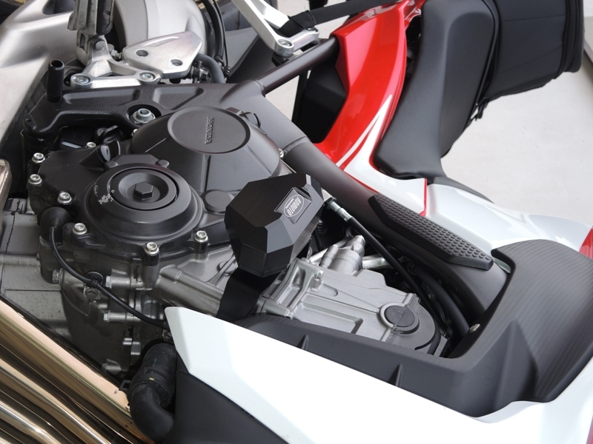
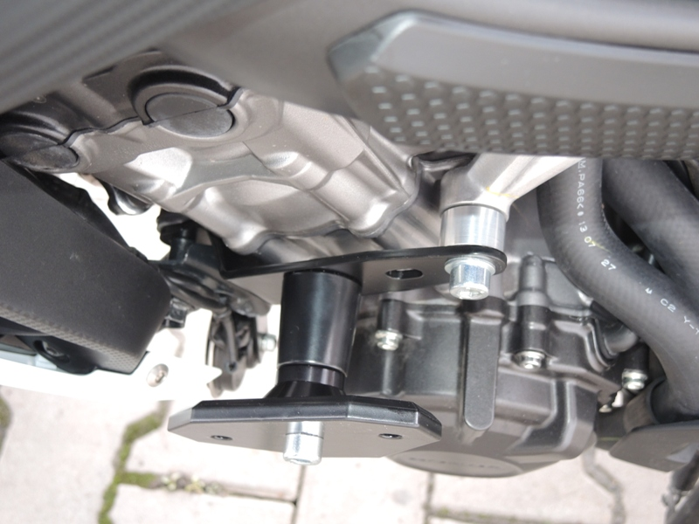
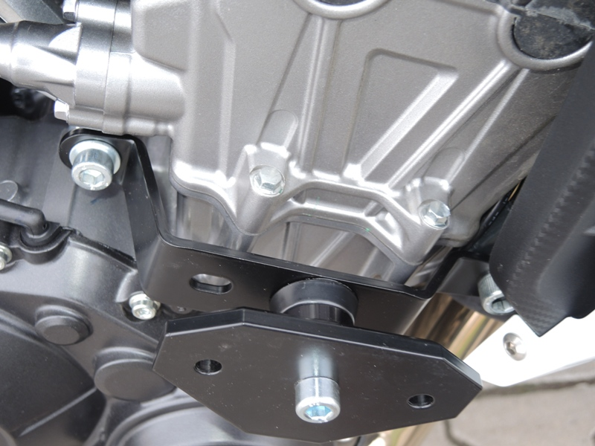
4
5
7
3
1
4
3
2
5
8
6
1
8
6

