H43S
Honda CBR650F 2014-

Fitting kit left side: Fitting kit right side:
ID | Description | Cat.n | Qt
1 | Steel adapter | 674 | 1
2 | Dural. spacer d=20 | 1152 | 1
3 | Dural.spacer d=28 | 1151 | 1
4 | Bolt M10x65x1,25 | 945 | 1
5 | Washer M10 | 804 | 1
6 | Dural. adapter | 292 | 1
7 | Bolt M6x25 | 877 | 3
8 | Bolt M4x16 | 876 | 2
9 | Bolt M10x40 | 854 | 1
10
ID | Description | Cat.n | Qt
1 | Steel adapter | 675 | 1
2 | Dural.spacer d=28 | 1151 | 1
3 | Bolt M10x65x1,25 | 945 | 1
4 | Washer M10 | 804 | 1
5 | Dural. adapter | 292 | 1
6 | Bolt M12x50x1,25 | 990 | 1
7 | Bolt M6x25 | 877 | 3
8 | Bolt M4x16 | 876 | 2
9 | Bolt M10x30 | 882 | 1
10
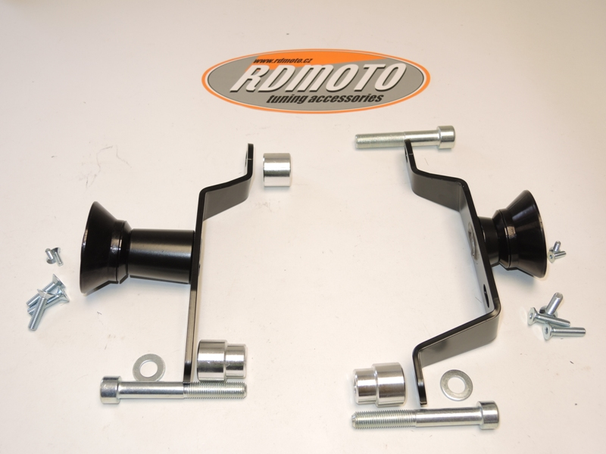

6
2
1
5
6
1
9
9

8
8

7
5
3
7
2

4
4
3

Instruction to assembly left side:
- Take out original bolts from frame (arrows on the pictures).
- Insert dural. spacer ID.2 between the steel bracket and engine, front part of motorbike. For mounting use original bolt torque moment 55Nm.
- For rear gripping use dural. spacer ID.3. Spacer insert into the frame and put washer ID.5 on the bolt ID.4. Mounting steel bracket. Torque moment 40 Nm.
- Insert dural.adapter ID.7 on the bolt ID.9.
- This kit mounting on the steel adapter.
- The bolts ID.7 are for mounting slider. Into the protector insert alu. cover use bolts ID.8

Instruction to assembly right side:
- Take out original bolts from frame (arrows on the pictures).
- For mounting in front part use original bolt torque moment 55Nm ID.6.
- For rear gripping use dural. spacer ID.2. Spacer insert into the frame and put washer ID.4 on the bolt ID.3. Mounting steel bracket. Torque moment 40 Nm.
- Insert dural.adapter ID.5 on the bolt ID.9.
- This kit mounting on the steel adapter.
- The bolts ID.7 are for mounting slider. Into the protector insert alu. cover use bolts ID.8

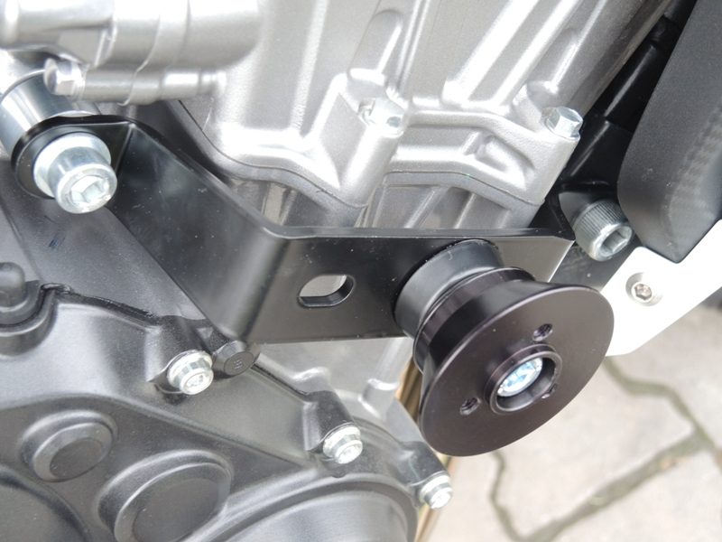
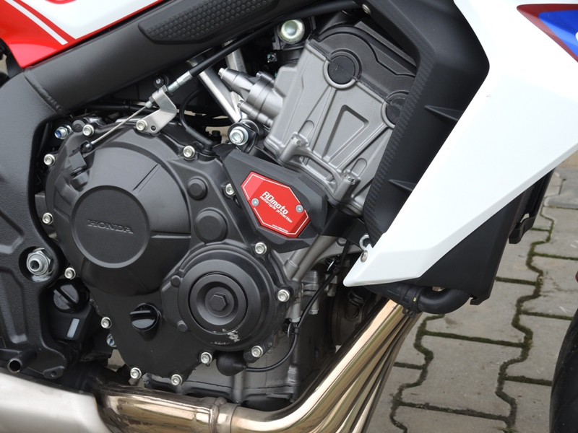
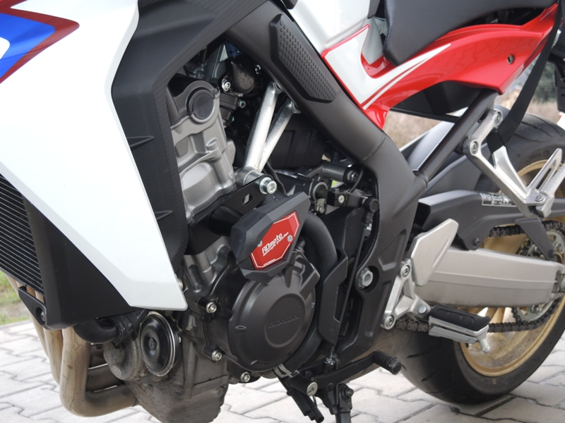
Caution: When installing, we recommend using glue on the threads (blue color).

