H43
Honda CBR650F 2014-

Fitting kit left side: Fitting kit right side:
ID | Description | Cat.N | Qt
1 | Steel bracket | 674 | 1
2 | Dural. spacer d=20 | 1152 | 1
3 | Dural.spacer d=28 | 1151 | 1
4 | Bolt M10x65x1,25 | 945 | 1
5 | Washer M10 | 804 | 1
6 | Steel box | X1 | 1
7 | Bolt M10x45 | 848 | 1
ID | Description | Cat.N | Qt
1 | Steel bracket | 675 | 1
2 | Dural.spacer d=28 | 1151 | 1
3 | Bolt M10x65x1,25 | 945 | 1
4 | Washer M10 | 804 | 1
5 | Steel box | X1 | 1
6 | Bolt M10x35 | 847 | 1
7 | Bolt M12x50x1,25 | 990 | 1
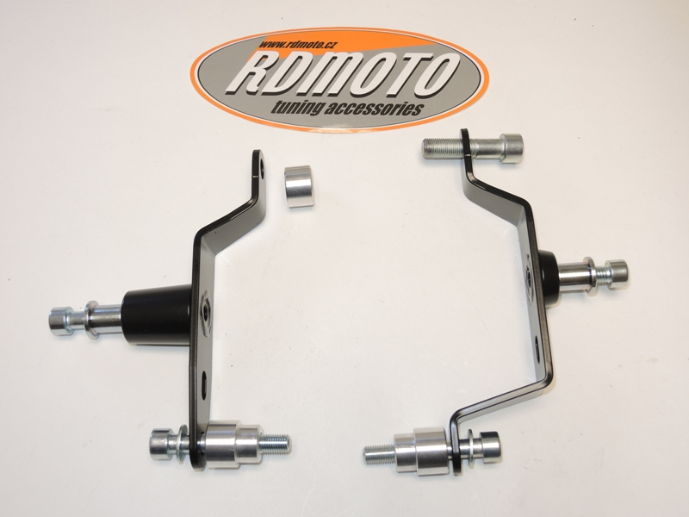
2
7
6
1
4
3
1
5,4
33
2
7
5
6
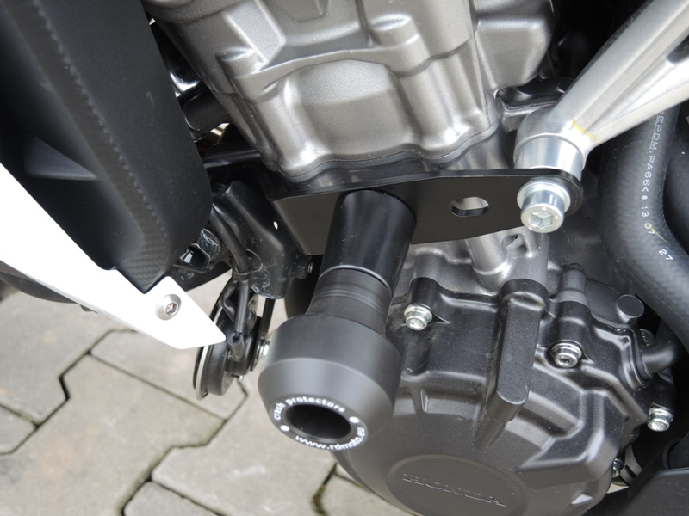
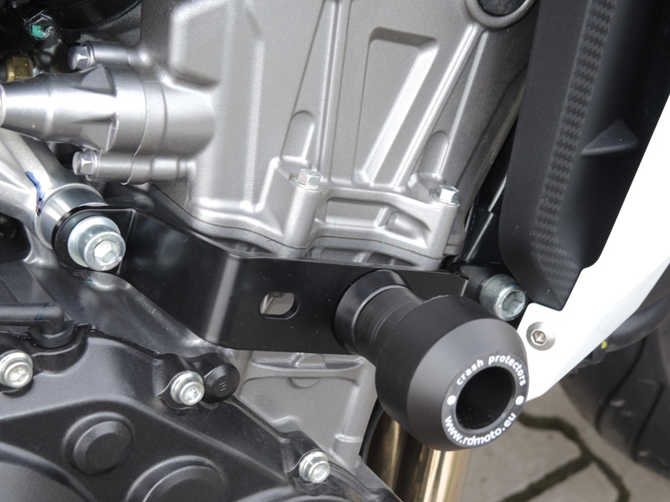
ID.7

Instruction to assembly left side:
- Take out original bolts from frame (arrows on the pictures).
- Insert dural. spacer ID.2 between the steel bracket and engine, front part of motorbike. For mounting use original bolt torque moment 55Nm.
- For rear gripping use dural. spacer ID.3. Spacer insert into the frame and put washer ID.5 on the bolt ID.4. Mounting steel bracket. Torque moment 40 Nm.
- Into the protector insert ID.6 and tighten protector by bolt ID.7

Instruction to assembly right side:
- Take out original bolts from frame (arrows on the pictures).
- For mounting in front part use original bolt torque moment 55Nm ID.7.
- For rear gripping use dural. spacer ID.2. Spacer insert into the frame and put washer ID.4 on the bolt ID.3. Mounting steel bracket. Torque moment 40 Nm.
- Into the protector insert ID.5 and tighten protector by bolt ID.6

Caution: When installing, we recommend using glue on the threads (blue color).

