H44SDM
Honda CB650F 2014-

Left side mounting kit: Right side mounting kit:
ID | Description | Cat.no | Pcs
1 | Steel adapter | 674 | 1
2 | Dural. cylinder 16mm | 1150 | 1
3 | Dural. cylinder 28mm | 1151 | 1
4 | Bolt M10x65x1,25 | 945 | 1
5 | Washer M10 | 804 | 1
6 | SLDM adapter | 537/B | 1
7 | Bolt M10x60 | 850 | 1
8 | Dural. cylinder 20mm | 10 | 1
9 | Bolt M6x20 | 1024 | 2
10 | Washer M6 | 1023 | 2
ID | Description | Cat.no | Pcs
1 | Steel adapter | 675 | 1
2 | Dural. cylinder 28mm | 1151 | 1
3 | Bolt M10x65x1,25 | 945 | 1
4 | Washer M10 | 804 | 1
5 | Bolt M10x40 | 854 | 1
6 | SLDM adapter | 537/B | 1
7 | Bolt M12x50x1,25 | 990 | 1
8 | Dural. cylinder 20mm | 10 | 1
9 | Bolt M6x20 | 1024 | 2
10 | Washer M6 | 1023 | 2

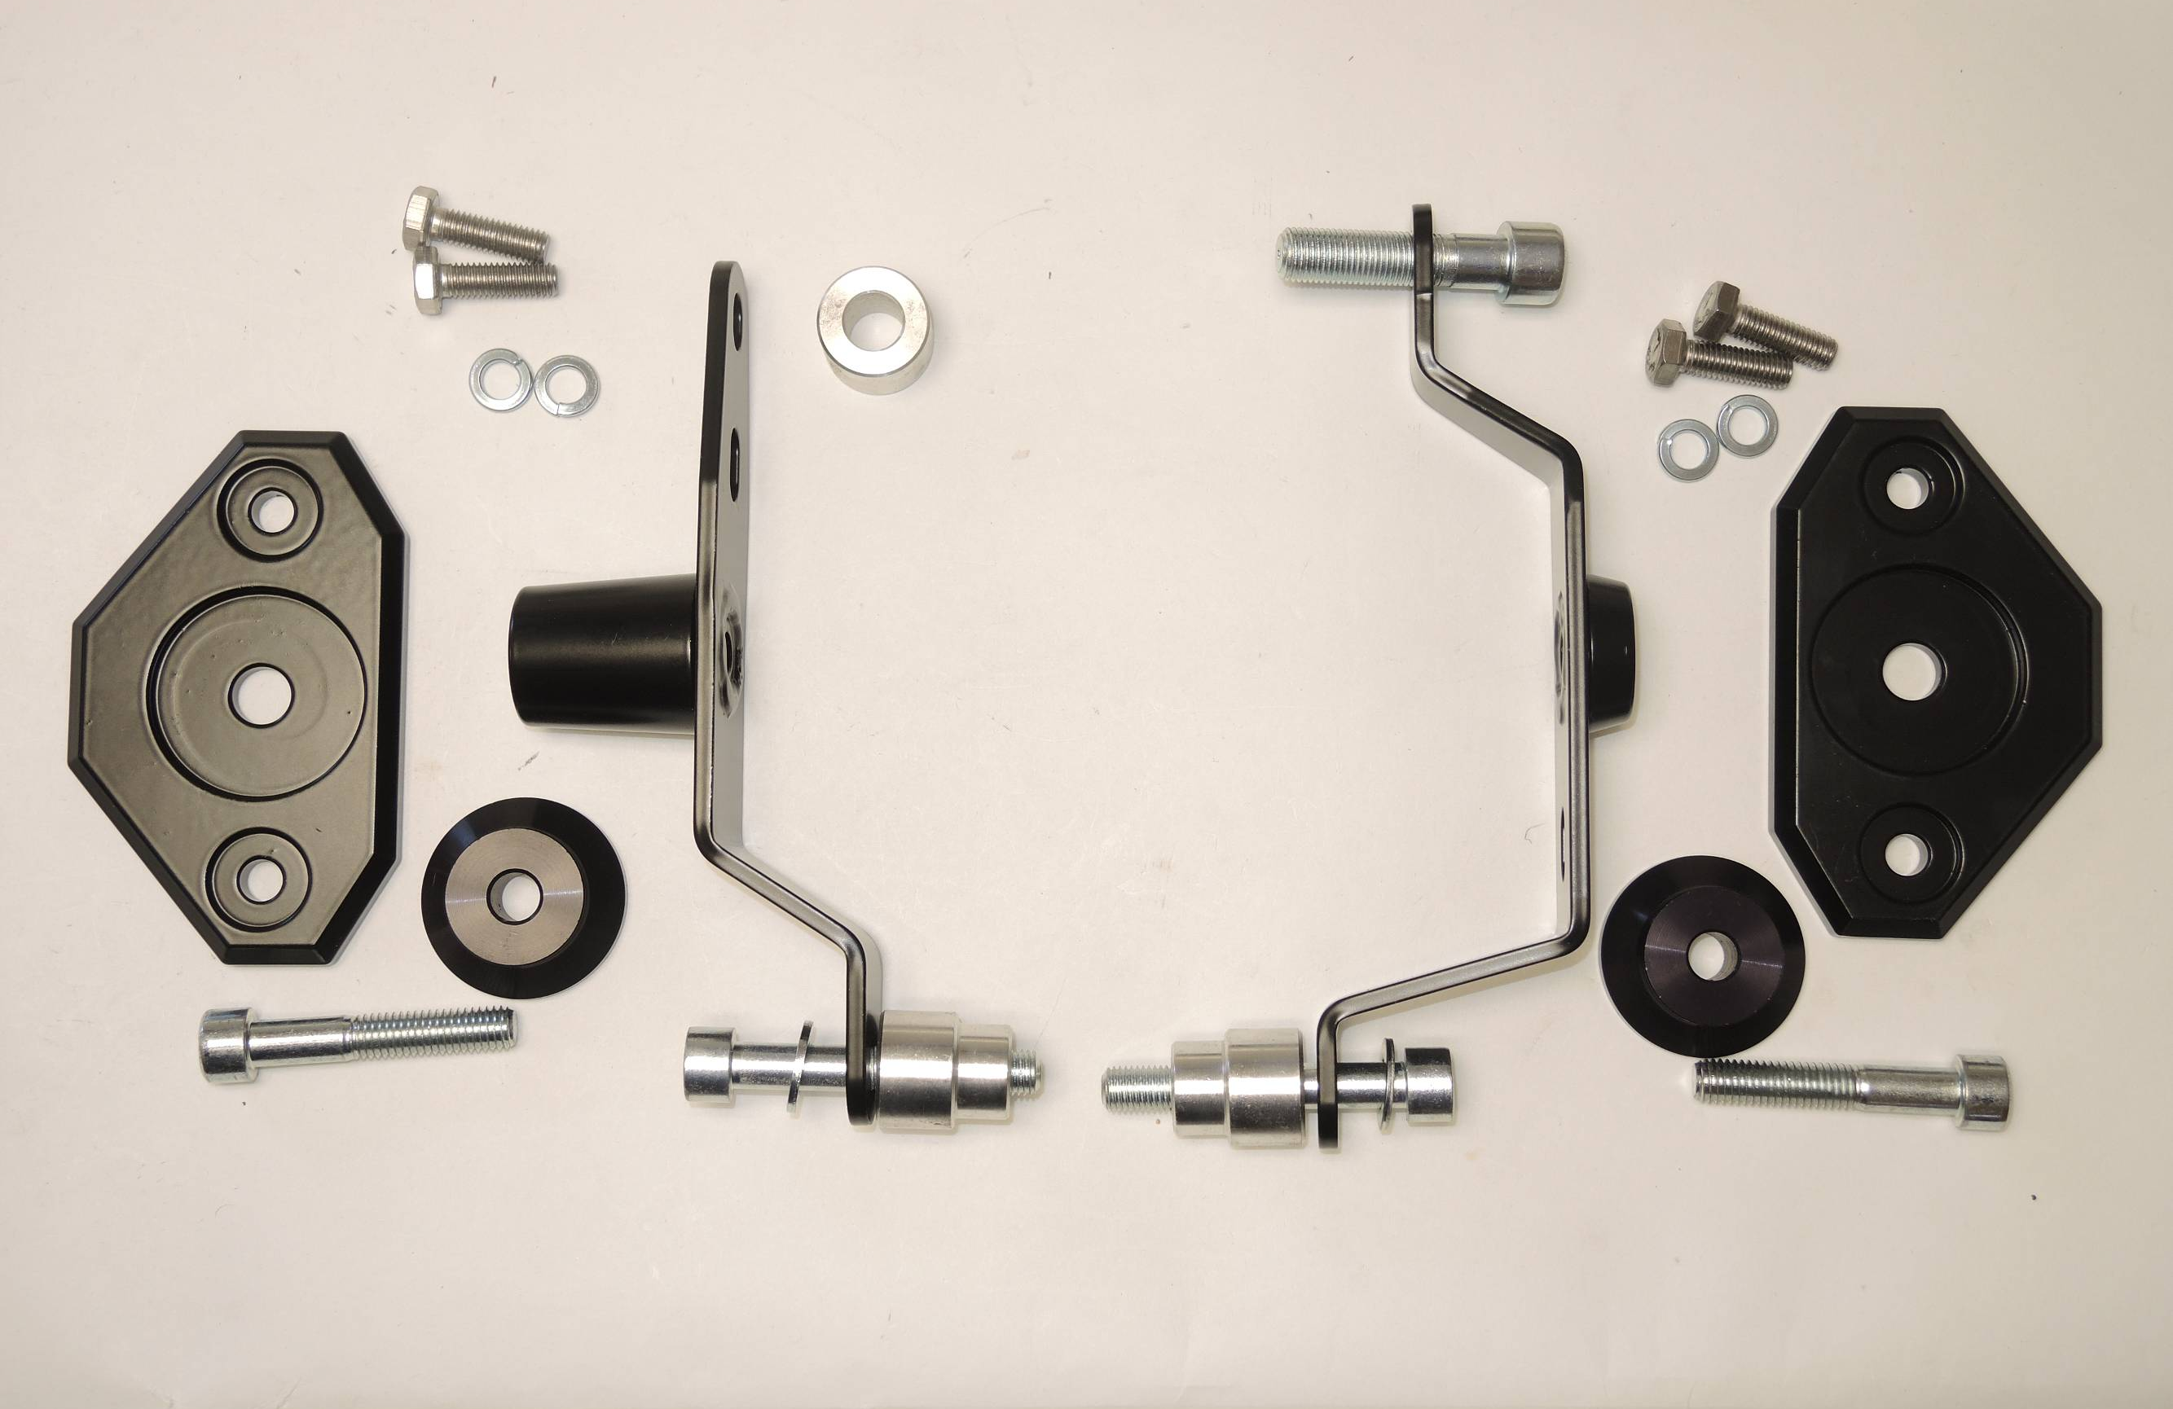
1
7
2
9
9
10
1
10

6

6

8
8

3
2

7
5

4
3
5
4

Left side instructions:

- Remove original bolts M12 and M10 from the frame of motorcycle.
- Mount steel adapter ID1 on the frame of motorcycle. Use cylinder ID2 and original bolt for tightening front part. Use cylinder ID3 and bolt ID4+ID5 for tightening rear part of adapter.
- Place SLD adapter ID6 and cylinder ID8 on bolt ID7 and mount this kit into the steel adapter ID1.
- Mount slider on SLD adapter using two bolts ID9 and washers ID10.

Right side instructions:

- Remove original bolts M12 and M10 from the frame of motorcycle.
- Mount steel adapter on the frame of motorcycle. Use bolt ID7 for tightening front part. Use bolt ID3+ID4 and cylinder ID2 for tightening rear part of adapter.
- Place SLD adapter ID6 and cylinder ID8 on bolt ID5 and mount this kit into the steel adapter ID1.
- Mount slider on SLD adapter using two bolts ID9 and washers ID10.

We recommend to use the glue on all threads (medium strong).

