H45SD
Honda CBR300R 2014-

Montážní kit levá strana: Montážní kit pravá strana:
ID | Description | Cat.no | pcs
1 | Steel adapter | 684 | 1
2 | Dural. Cylinder - 5mm | 16 | 1
3 | Bolt M6x60 | 872 | 1
4 | Dural.cylinder - 25mm | 1159 | 1
5 | Nut M10 | 810 | 1
6 | Washer M6 | 947 | 1
7 | Alu. adapter | 537 | 1
8 | Alu. Cylinder - 70mm | 15 | 1
9 | Bolt M10x90 | 880 | 1
10 | Bolt M8x25 | 815 | 2
11 | Washer M8 | 802 | 2
12 | M10x300x30x30 | - | 1
ID | Description | Cat.no | pcs
1 | Steel adapter | 685 | 1
2 | Dural. Cylinder - 5mm | 16 | 1
3 | Bolt M6x60 | 872 | 1
4 | Dural.cylinder - 25mm | 1159 | 1
5 | Nut M10 | 810 | 1
6 | Washer M6 | 947 | 1
7 | Alu. adapter | 537 | 1
8 | Alu. Cylinder - 70mm | 15 | 1
9 | Bolt M10x90 | 880 | 1
10 | Bolt M8x25 | 815 | 2
11 | Washer M8 | 802 | 2

Instructions:

- Remove bottom fairing of the left side of motorcycle.
- Remove original bolt from frame of motorcycle on the left side.
- Remove bolt M6 from the engine bonnet.
- Insert steel rod (ID12) trough the frame and engine. Put cylinder (ID2) and steel adapter (ID1) on it. Tighten adapter using nut (ID5) and original bolt.
- Insert cylinder (ID4) between steel adapter and engine bonnet.
- Now tighten all bolts and put fairing back.
- Insert bolt (ID9) into alu adapter (ID7) and alu cylinder (ID8).
- Fit this set on the steel adapter (ID1)
- In the end fit slider on the alu adapter using two bolts and washers (ID10 and ID11).
- Repeat same process on the right side.

We recommend to use the glue on all threads (blue colour – medium strong).

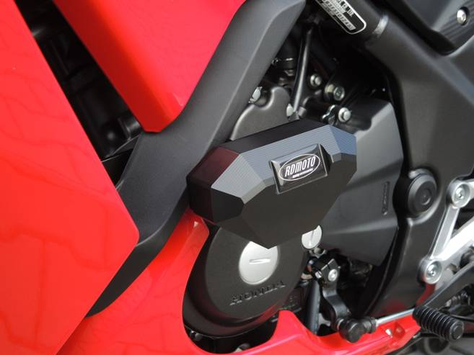
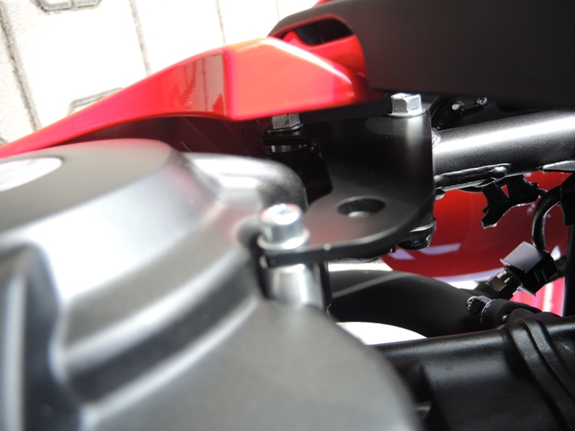

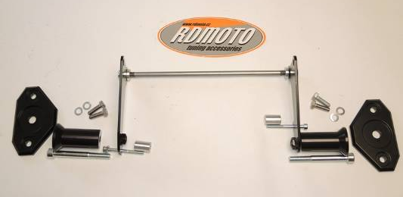
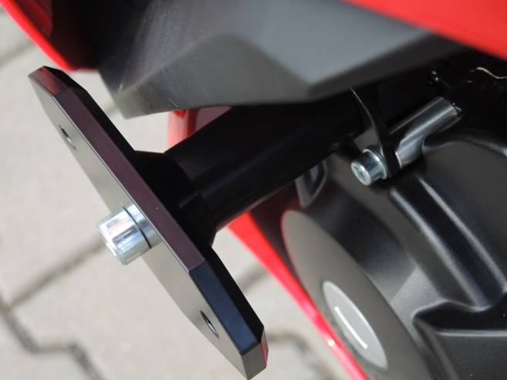
2
1
4
3
1
3
2
4
5
5
7
7
12
8
8
9
9
10,11
10,11

