H45S
Honda CBR300R 2014-

Fitting kit left side: Fitting kit right side:
ID | Description | Cat.N | Qt
1 | Steel holder | 684 | 1
2 | Alu spacer d=5mm | 16 | 1
3 | Bolt M6x60 | 872 | 1
4 | Alu. spacer d=25mm | 1159 | 1
5 | Nut M10 | 810 | 1
6 | Washer M6 | 947 | 1
7 | Alu. adapter | 314 | 1
8 | Spacer d=40 | 4 | 1
9 | Bolt M10x65 | 943 | 1
10 | Bolt M6x25 | 877 | 3
11 | Bolt M4x16 | 876 | 2
ID | Description | Cat.N | Qt
1 | Steel holder | 685 | 1
2 | Alu spacer d=5mm | 16 | 1
3 | Bolt M6x60 | 872 | 1
4 | Alu. spacer d=25mm | 1159 | 1
5 | Nut M10 | 810 | 1
6 | Washer M6 | 947 | 1
7 | Alu. adapter | 314 | 1
8 | Spacer d=40 | 4 | 1
9 | Bolt M10x65 | 943 | 1
10 | Bolt M6x25 | 877 | 3
11 | Bolt M4x16 | 876 | 2
12 | M10x300x30x30 |  | 1

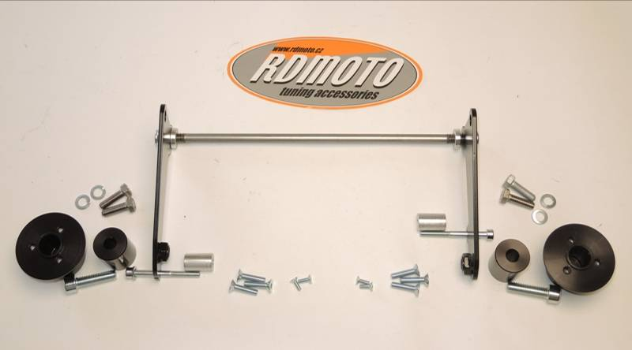

5

2
5
5

1
12
Montáž
4
3
1
4
7
7
6
8

6
8
3
9
9
10
11
11
10

Assembly instruction:
- Dismantle lower fairing out of the bike.
- Dismantle bolt M10 from the chassi on the left side.
- Take out bolt M6 from engine case on the left side.
- Place rod ID.12 trough the engine and chassi. Place alu spacers ID.2 on the rod and after place steel adapter ID.1. Tighten it by nut and for top gripping use orignal bolt.
- For the right side is same assembly.
- Place spacer ID.4 between engine case cover and steel holder. On the bolt ID.3 place washer ID.6 and tighten it.
- For the right side is same assembly.
- Now check and re-thighten all bolts and place fairing back the bike.
- Assembly for left and right sliders is same.
- Bolt ID.9 place through the adapter ID.7 and spacer ID.8. This kit assembly on the steel adapter.
- Place slide rand tighten it by bolts ID.10.
- Insert cover into the slider and tighten it by bolts ID.11.

Notice: During installation, we recommend using glue on the threads (blue color)

