H45
Honda CBR300R 2014-

Fitting kit left side: Fitting kit right side:
ID | Description | Cat.N | Qt
1 | Steel bracket | 684 | 1
2 | Dural.spacer d=5mm | 16 | 1
3 | Bolt M6x60 | 872 | 1
4 | Dural.spacer d=25mm | 1159 | 1
5 | Nut M10 | 810 | 1
6 | Washer M6 | 947 | 1
7 | Steel box | X1 | 1
8 | Dural. spacer d=60mm | 6 | 1
9 | Bolt M10x100 | 885 | 1
ID | Description | Cat.N | Qt
1 | Steel bracket | 685 | 1
2 | Dural.spacer d=5mm | 16 | 1
3 | Bolt M6x60 | 872 | 1
4 | Dural.spacer d=25mm | 1159 | 1
5 | Nut M10 | 810 | 1
6 | Washer M6 | 947 | 1
7 | Steel box | X1 | 1
8 | Dural. spacer d=60mm | 6 | 1
9 | Bolt M10x100 | 885 | 1
10 | M10x300x30x30 | - | 1

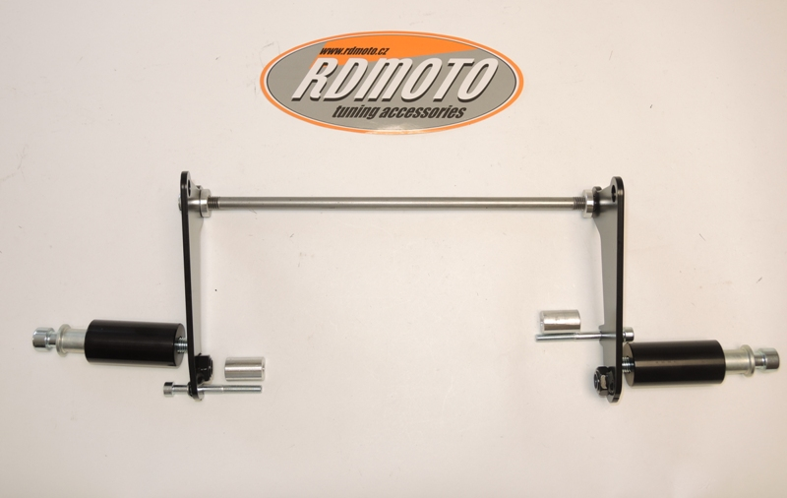
2
1
4
3
1
3
2
4
5
5
7
7
6
6
8
8
9
9
10

Instruction to assembly:
- Remove the fairing bolts and gently ease fairing away from frame.
- Remove the orifinal bolts M10 from frame.
- Remove bolt M6 from engine case (arrow on the picture).
- Through the frame and engine insert steel rod ID.10. Insert dural. sapcer ID.2 between the frame and steel bracket. Now place steel adapter and make assembly, for upper gripping use original bolt.
- Same assembly process make on the right side.
- Between the engine case and steel bracket insert dural.cylinder ID.4. Tighte it by bolt with washer ID.3 and ID.6.
- Same assembly process make on the right side.
- Now tighten all the screws and fit the fairing back on the bike..
- Assembly process protectors for the right and left side is the same..
- Into the protector insert steel box ID.7 and bolt ID.9. Under the protector put dural.spacer ID.8.
- This kit moutnig on the steel bracket.

Note: During installation, we recommend using glue on the threads (blue color).

